**MATRIX COLLEGE OF MANAGEMENT**

**TECHNOLOGY & HEALTH**

**Montreal, Quebec.**





##### Final Year Project Report

**On**

**“Install Virtual Network / Test Web Application”**

**CODE: 420-ZT2-GX**

###### **Submitted by**

**Vikas Kishorbhai Khokhariya [1951660]**

**Bhumiben Mahendrakumar Patel [1952476]**

**Akhilesh Reddy Adala [1952257]**

**[Semester (Summer 2019)]**

**Submitted to**

**Christobell Cuya**

**Hansy Ross Salvant**

# Department of Computer Science Technology

**“Install Virtual Network / Test Web Application”**

**CODE: 420-TZ1-GX**

###### **Submitted by**

**Vikas Kishorbhai Khokhariya [1951660]**

**Bhumiben Mahendrakumar Patel [1952476]**

**Akhilesh Reddy Adala [1952257]**

**[Semester (Summer 2019)]**

# Under the Guidance of

**Christobell Cuya**

**Hansy Ross Salvant**

**A final year project submitted in partial fulfillment of the requirement for the**

**Diploma in Computer Science Technology**

**Matrix College of Management, Technology & Health**

**Montreal, Quebec.**

**DECLARATION**

I affirm that the project work titled **“Install Virtual Network / Test Web Application”** Being submitted in partial fulfillment for the award of Diploma in Computer Science Technology is the original work carried out by me. It consists of no part of any other project work submitted for award of any other degree or diploma, either in this or any other college.

I certify that the declaration made above by the candidate is true.

ACKNOWLEDGEMENT

We have taken much efforts in this project, it would not have been possible without the kind support and help by the Matrix Collage organizations and I would have to extend my sincere thanks to all of them.

We highly appreciative to Christobell Cuya and Hansy Ross Salvant for the valuable guidance and have continuous supervision as well as for providing all important information regarding the project and also their valuable support for completing the project.

We would like to express our gratitude towards members of Matrix Collage organization which were Vadym Koval, Tanvi Soman, Mykien Trinh and our parents for their kind cooperation and encouragement which helps to completion of our project in this Pandemic Situation.

Our special thanks and appreciations to my colleagues who helped us in developing the project and people who have willingly helped us out of their abilities.

ABSTRACT

The Project involves to Set up a Network environment that includes a Router (SVR-SO-A 192.168.21.1), Web Server (SVR-WS-A 192.168.21.2) and Client Machine (192.168.21.3).

The Main objective of this project is to host the website on the webserver to connect it to database, where the data will be added from website. Therefore the website is to be tested with various test cases in order to accomplish.

**TABLE OF CONTENTS**

**TOPICS PAGE**

**Chapter 1 : Project Overview 8**

1.1 Introduction8

1.2 Networking Structure 9

1.2.1 Router 9 1.2.2 Web Server 9

1.2.3 Client Machine 9

1.3 Network Diagram 10

**Chapter 2 : Installation 11**

2.1 Installation of Virtual Box 11

2.2 Installation of Router (SVR-SO-A) 15

2.3 Installation of Web Server (SVR-WS-A) 25

2.4 Installation of Client Machine 33

**Chapter** **3 : System Configurations 42**

3.1 IP Configuration 42

3.1.1 IP Configuration of Router (SVR-SO-A) 42

3.1.2 IP Configuration of Web-Server (SVR-WS-A) 46

3.1.3 IP Configuration of Client Machine 8.149

3.2 Network Setup and Configurations 51

3.2.1 Network Setup and Configurations of Router (SVR-SO-A) 51

3.2.1.1 Add Roles and Features 51

3.2.1.2 Add Inbound Rules 55

3.2.1.3 Add Outbound Rules 61

3.2.1.4 Add Routing and Remote Access 65

3.2.2 Network Setup and Configurations of Web-Server

(SVR-WS-A) 70

3.2.2.1 Add Roles and Features 70

3.2.2.2 Add Inbound Rules 70

3.2.2.3 Add Outbound Rules 70

3.2.2.4 Add Routing and Remote Access 70

**Chapter 4 : Networking Utility 71**

4.1 Ping Operations in Router 71

4.2 Ping Operations in Web-Server 73

4.3 Ping Operations in Client Machine 75

**Chapter 5 : Web Platform Installation 77**

5.1 Install Web Platform 77

5.2 Add Roles and Features 83

5.3 Download phpMyAdmin in Web-Server 87

5.4 Accessing web Application 93

**Chapter 6: Test cases 95**

6.1 Positive Test Cases 95

6.2 Negative Test Cases 103

**Chapter 7: Reference 129**

**Chapter 1: Project Overview**

**1.1 Introduction**

The project is about creating the virtual environment using virtual box and to create network among the machines which we have installed in virtual box. With this we have tested the web application.

The main aim of creating this project is to get overall idea about the Virtual Environment and how it’s working. And it help us to understand the configuration between different machines which we have already installed in Virtual box. Moreover we have established networking among those machines. In addition, we have learnt how to connect database and deploy web application in this virtual environment.

In this Virtual environment, we have installed total three machines and every machine has its own role. The first machine is SVR-SO-A 192.168.21.1, which is acts as a router. The second machine is SVR-WS-A 192.168.21.2, which is working as a Web Server. And the third machine is Client 192.168.21.3. Every machine act as differently. Router act as network provider. Web server is providing service to client to access web application. From client machine, we can access the perform testing.

**1.2 Networking Structure**

This networking structure describes how the virtual environment has been created. For that we have installed virtual box and then we have installed three machines. These all machines are working as following.

**1.2.1 SVR-SO-A (Router)**

A router is used to receive and move incoming [packets](https://www.computerhope.com/jargon/p/packet.htm) to its own network or another [network](https://www.computerhope.com/jargon/n/network.htm). It may also be used to convert the packets to another network interface, [drop](https://www.computerhope.com/jargon/d/drop.htm) them, and perform other actions relating to a network.

**1.2.2 SVR-WS-A (Web Server)**

A **Web server** is a physical or Logical dedicated to run services to serve the needs of other computers or virtual Machines. Depending on the service that is running, it could be a file server, database server, home media server, print server, or web server.

A Web server is a program that uses HTTP (Hypertext Transfer Protocol) to serve the files that form Web pages to users, in response to their requests, which are forwarded by their computers' HTTP clients.

**1.2.3 Client**

A **client** is a computer hardware device or software that accesses a service made available by a server. The server is often (but not always) located on a separate physical computer. Clients can access resources such as files, songs, video collections, or some other service from a central computer called a server.

**1.3 Network Diagram**

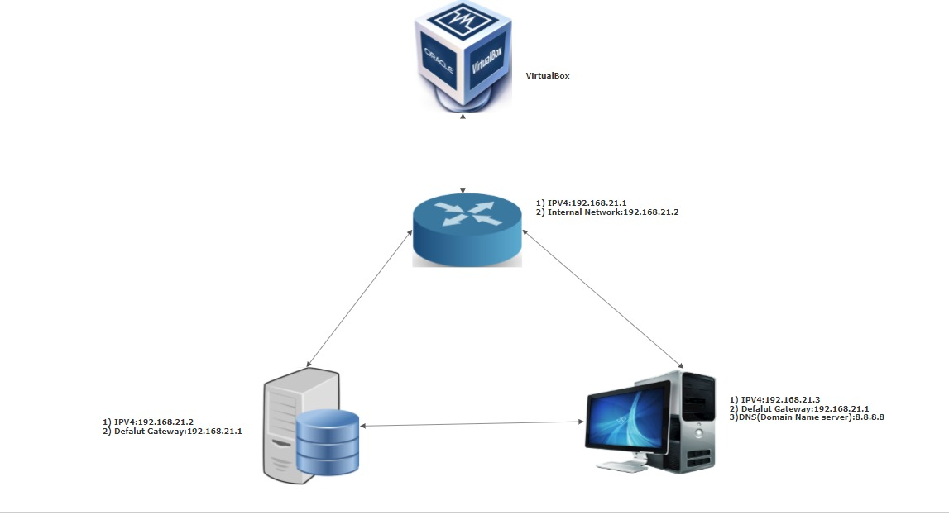

**Chapter 2: System Creation**

**2.1 Installation of Virtual Box**

A virtual machine (VM) is an operating system (OS) or application environment that is installed on software, which imitates dedicated hardware. The end user has the same experience on a virtual machine as they would have on dedicated hardware.

**Steps To Install Virtual Box:**

Step 1: Download Virtual Box from its official Website:

<https://www.virtualbox.org/wiki/Downloads>

Step 2: Install the Virtual Box

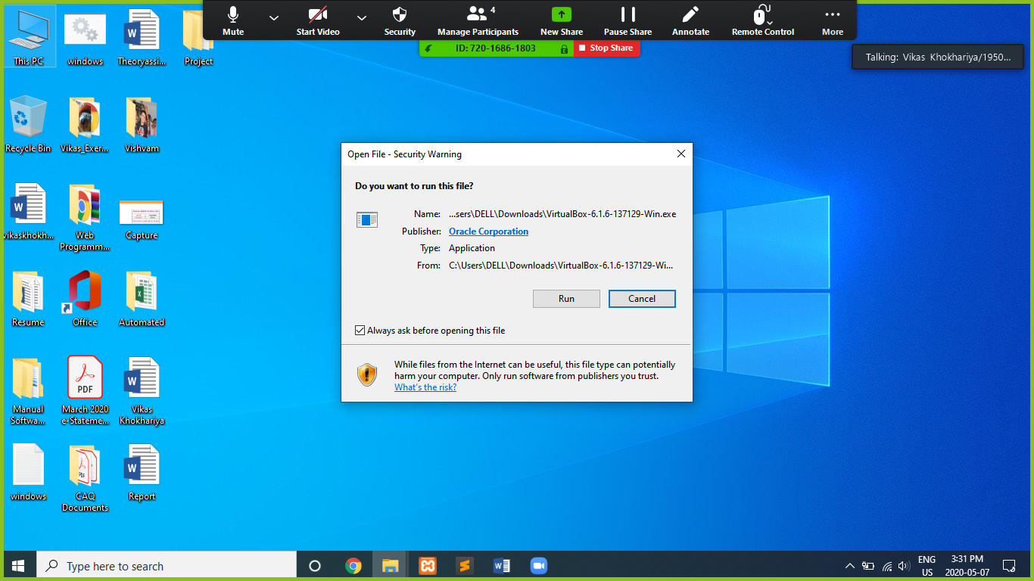

Step 3: Installation Process

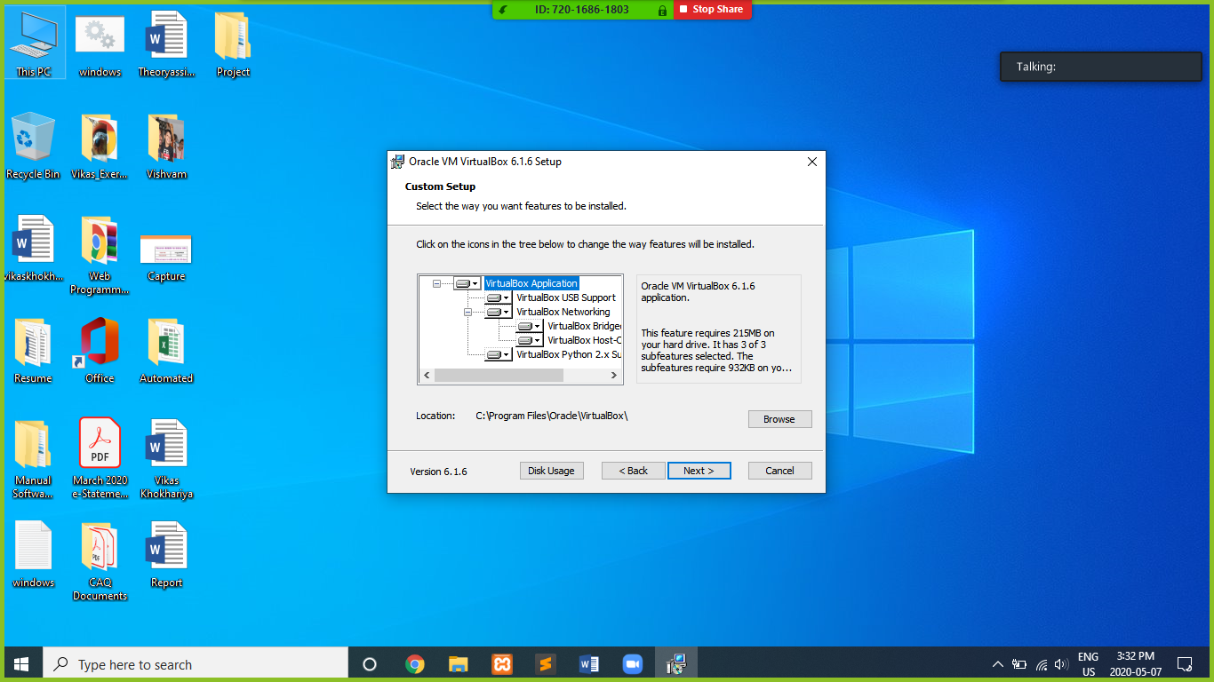

Step 4: Continue to install

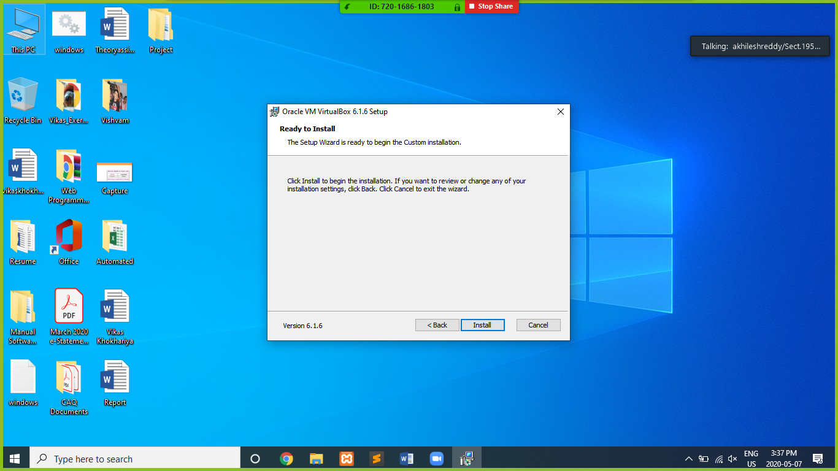

Step 5: Installation Completed

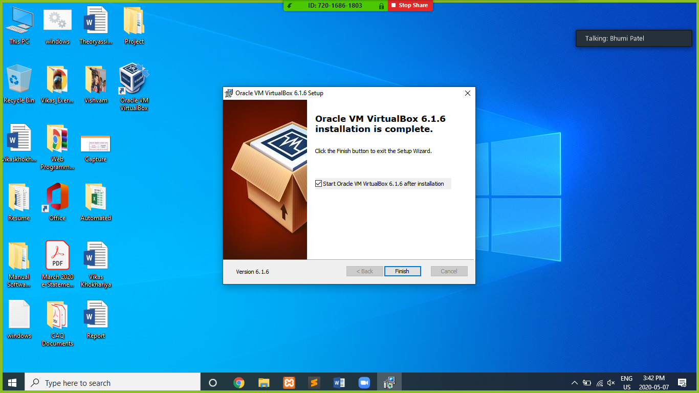

Step 6: Virtual Box Installation is done.

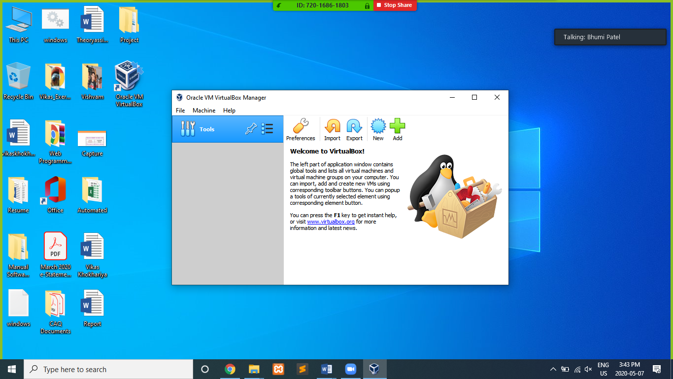

**2.2 Steps to Create Router (SVR-SO-A)**

Router is working as main part of our Virtual system which provides connection to all other systems. Here, the name of our router is SVR-SO-A. Which is forwarding the data to other system by using IP Address to the router. The IP address of Router will become default gateway of other system.

For Configuration of router, we need to configure two adapters.

1. **NAT(Network Address Translation)**

NAT allows the router to provide the private connection to the other computers through IP address.

1. **Internal Network**

Sometimes we need VMs to be internally connected to each other and completely isolated from the outside/external network. For that we need to create a internal network on virtual box and then connect the VMs on it.

**Steps To Install SVR-SO-A**

Step 1: Provide name of System according to the requirements.

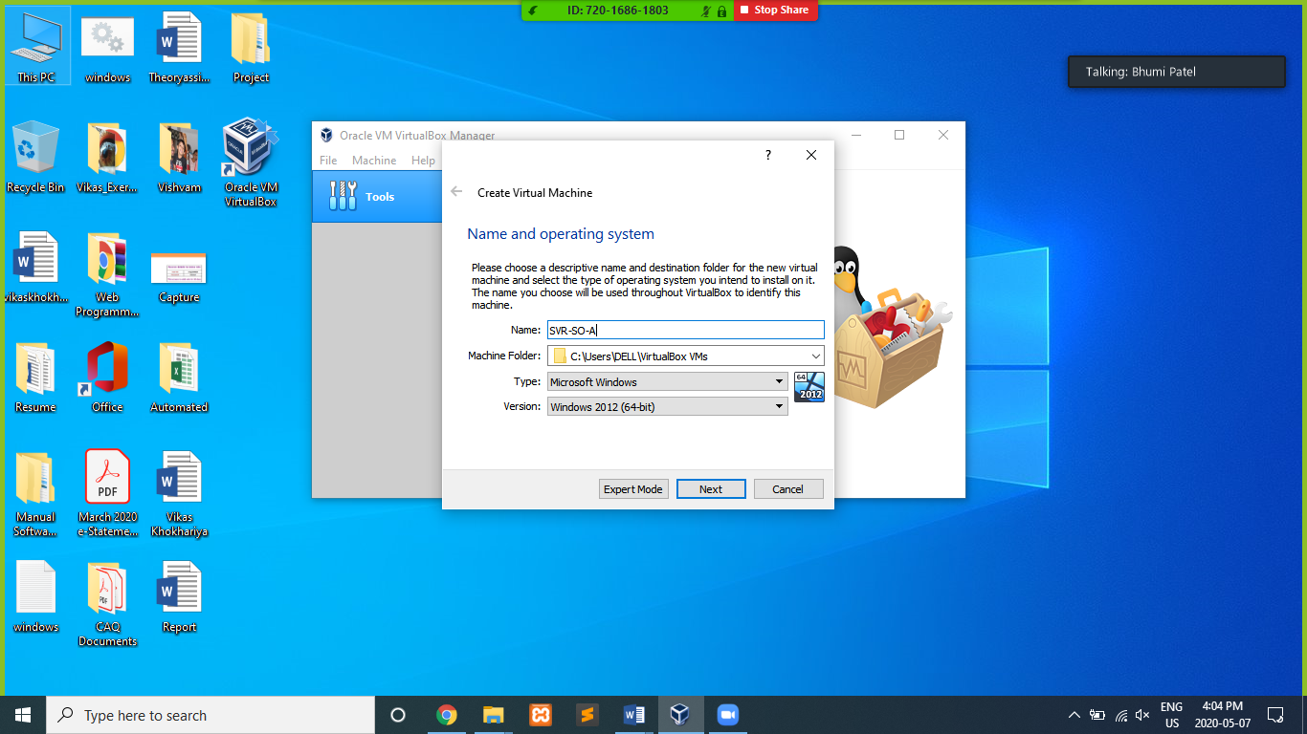

Step 2: Choose memory capacity as system needed.

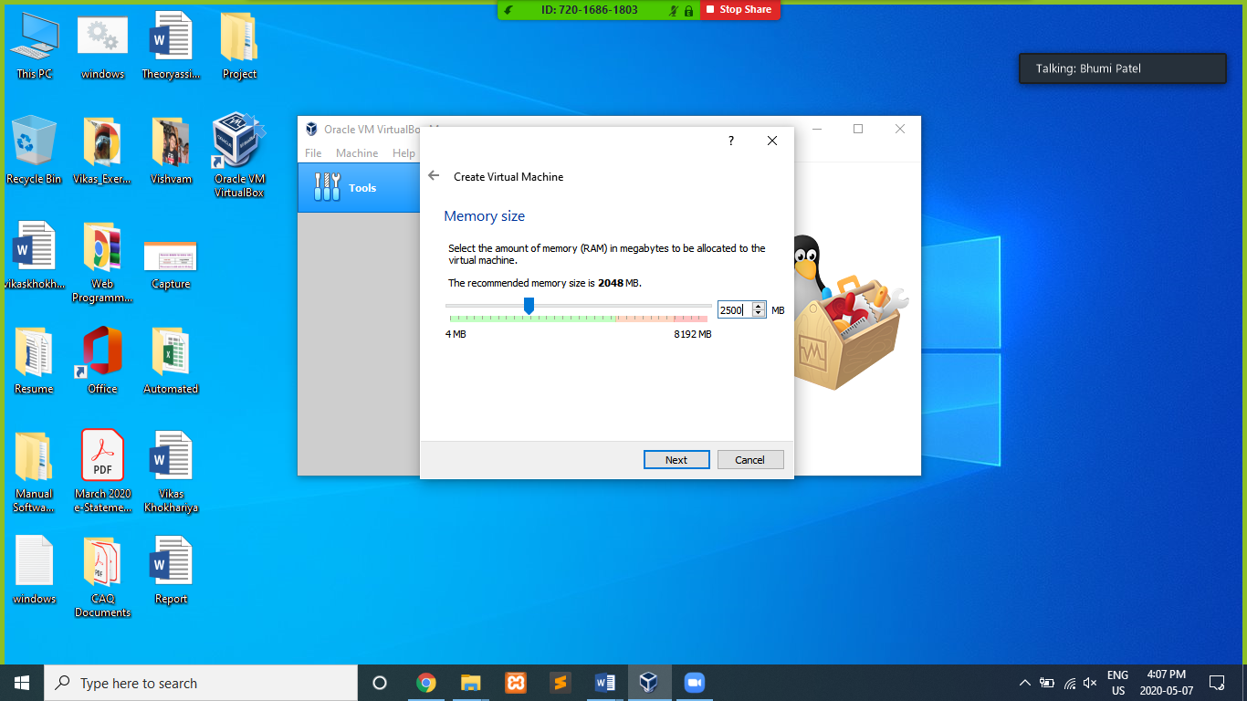

Step 3: Create a virtual hard disk.

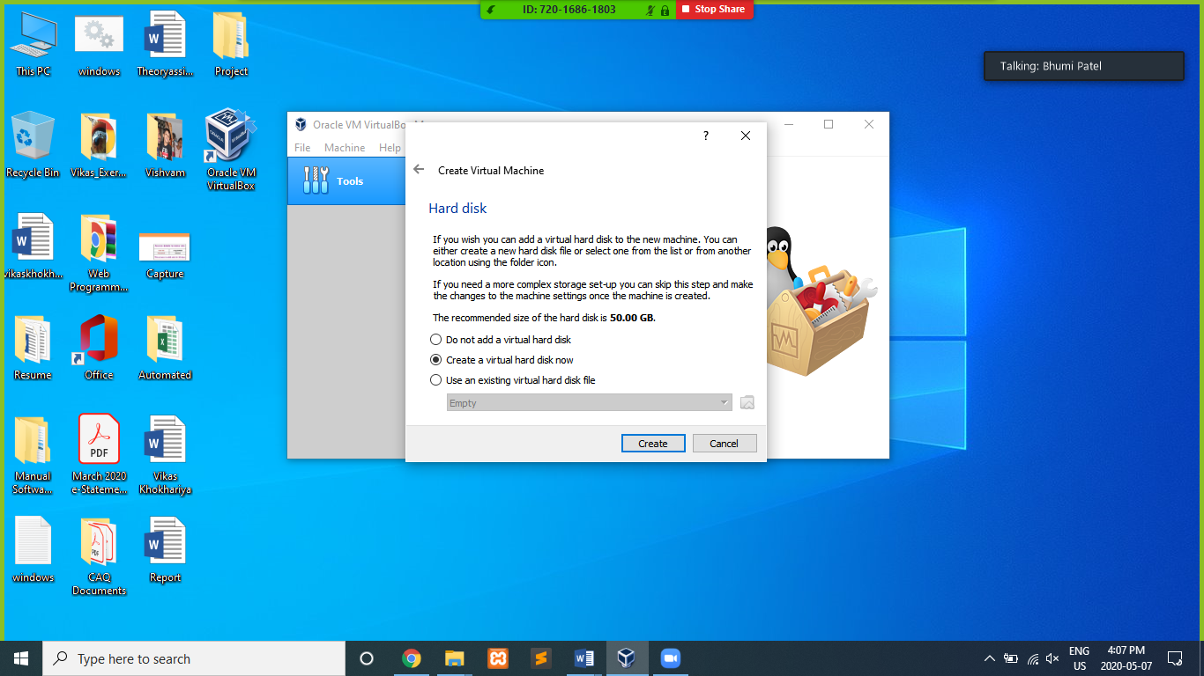

Step 4: Choose File Type VHD (Virtual Hard Disk)

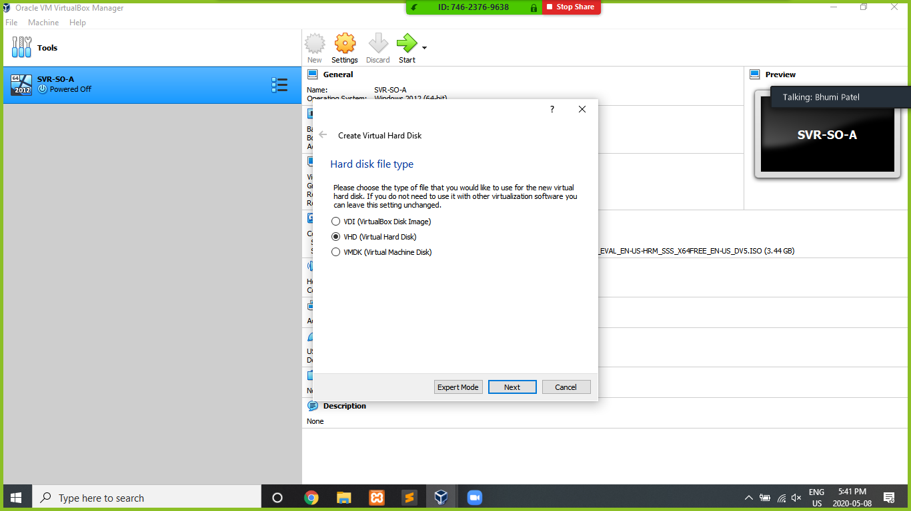

Step 5: Create a virtual hard disk and should be allocated dynamically.

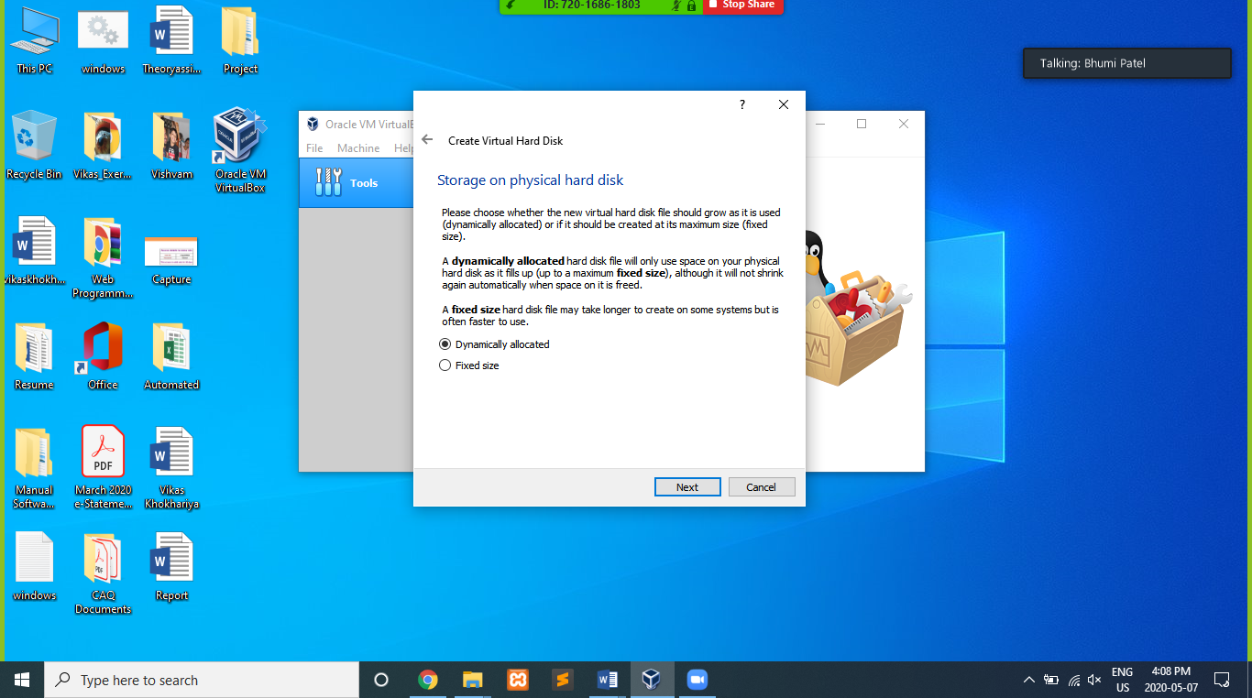

Step 6: Choose disk location and size of Disk.

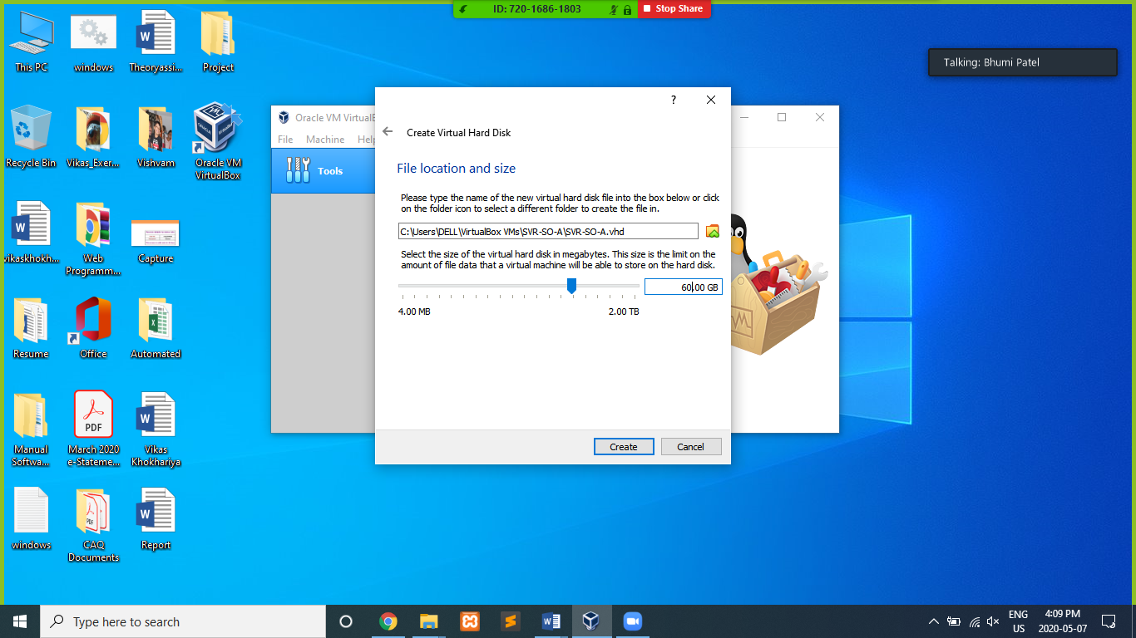

Step 7: Created Router (SVR-SO-A)

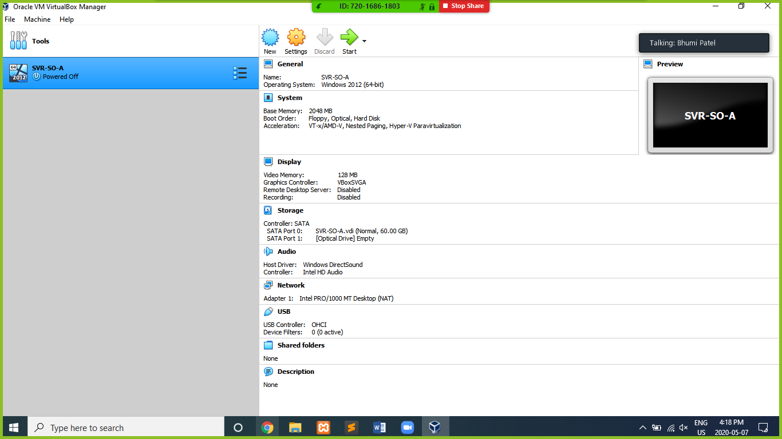

Step 8: Install the windows server 2012 on Router.

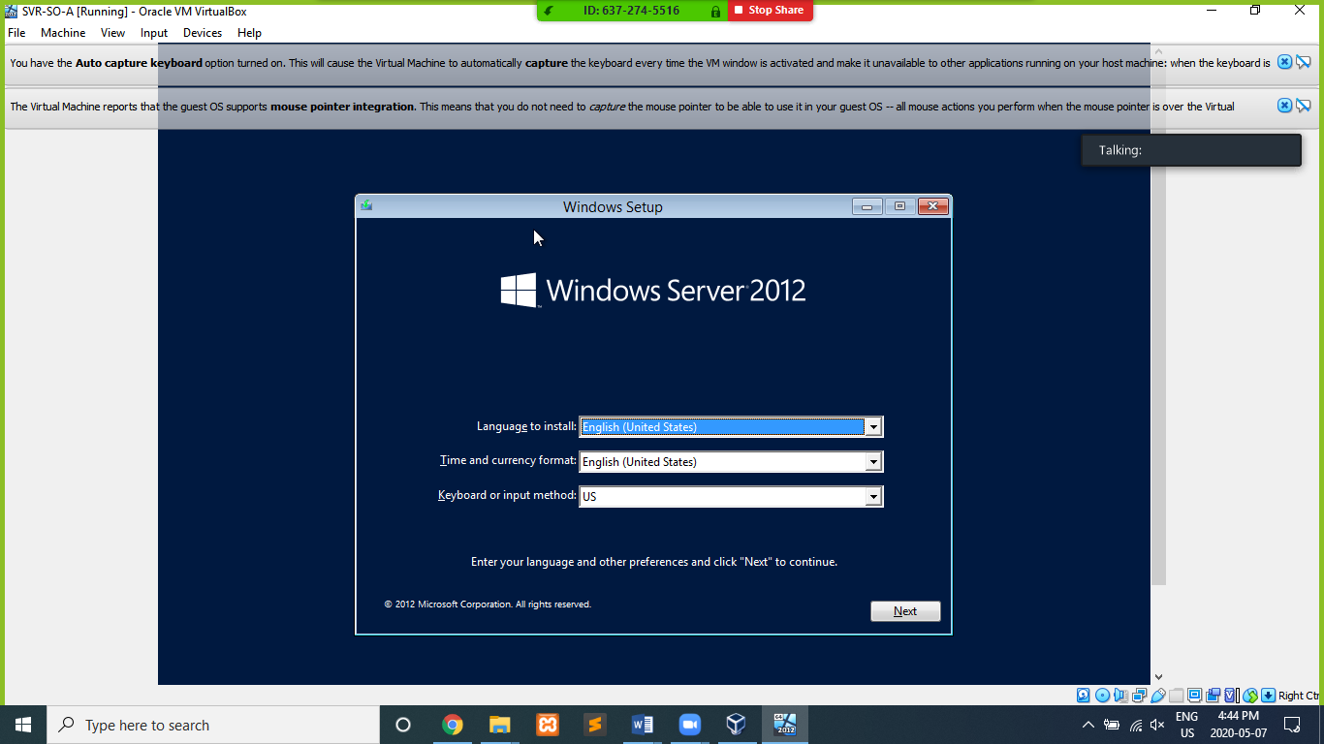

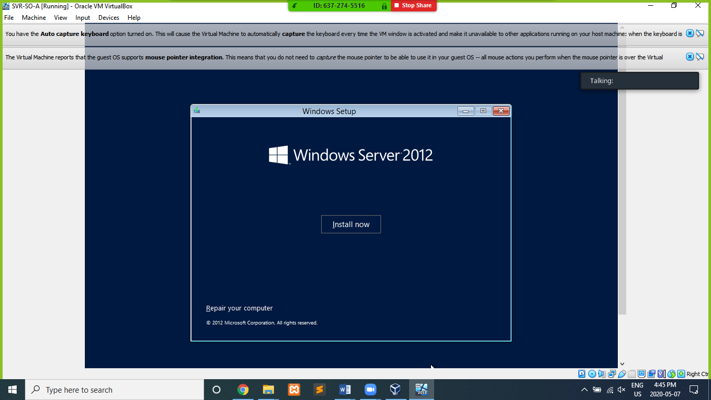

Step 9: Select Operating System you want to install

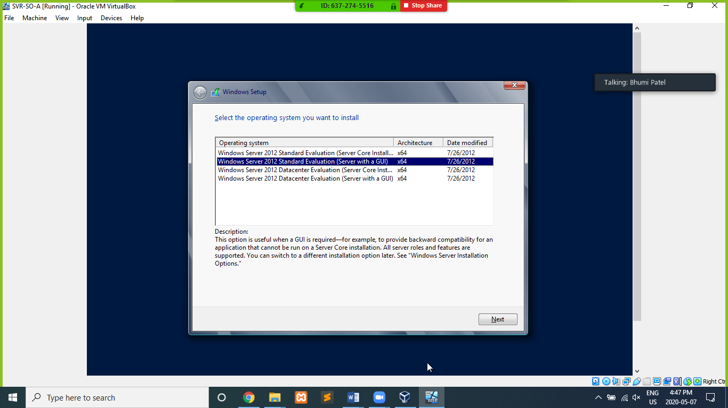

Step 10: Install which type you want.

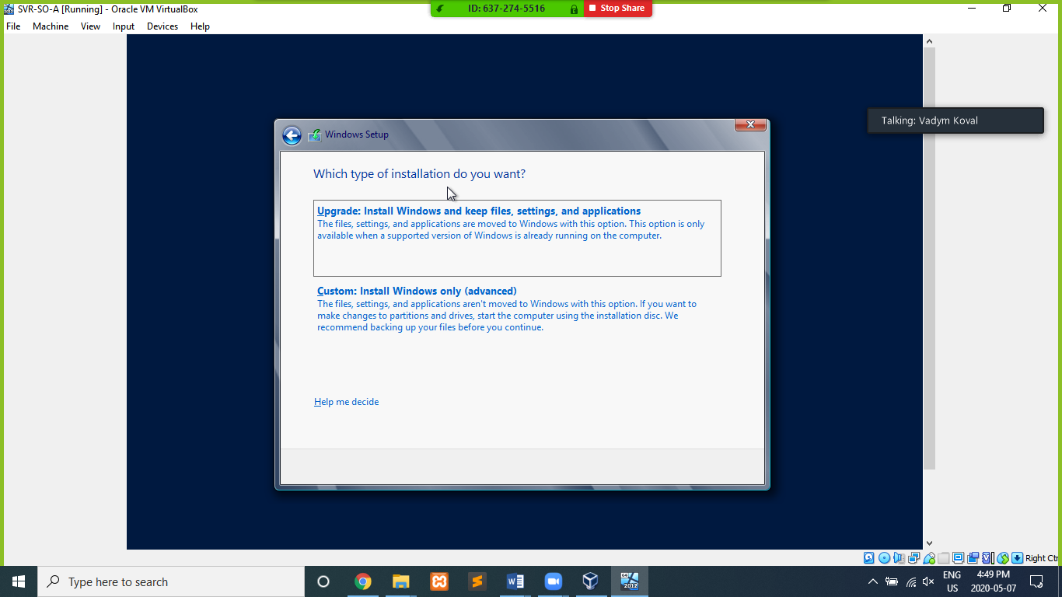

Step 11: Choose memory capacity and location as system needs.

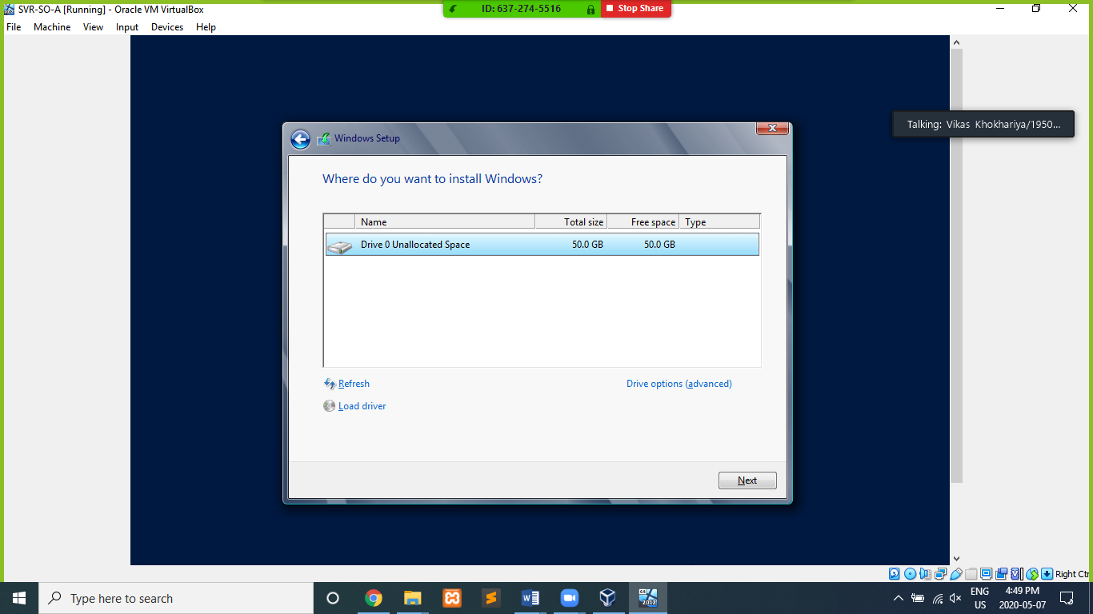

Step 12: Installing Operating System

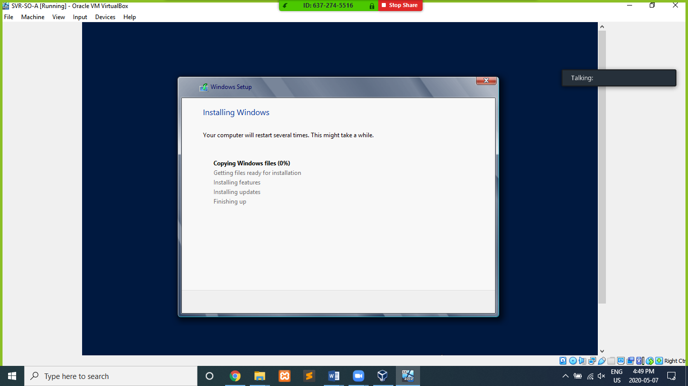

Step 13: Create username and Password. 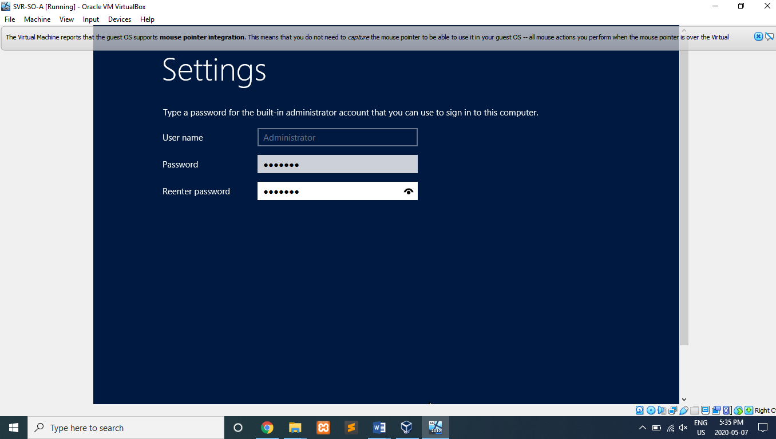

Step 14: Installation Completed.

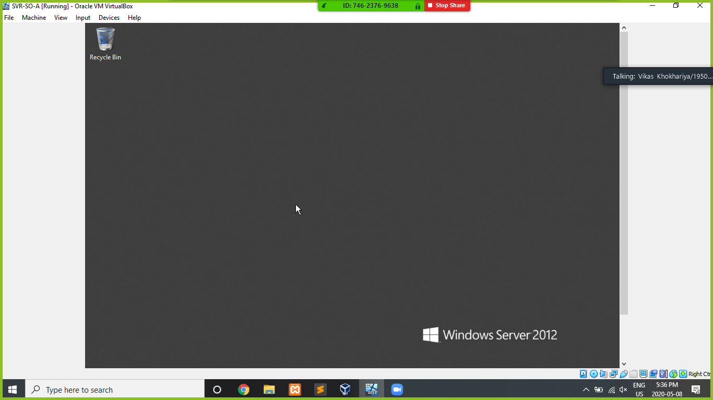

Step 15: Go to Network and set Adapter 1 as NAT.

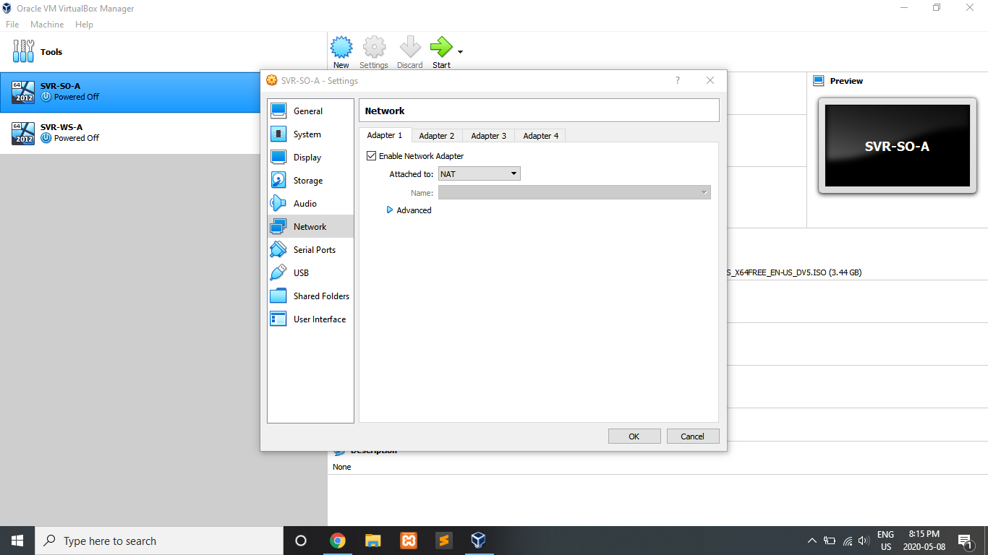

Step 16: Go to Network and set Adapter 2 as Internal Network.

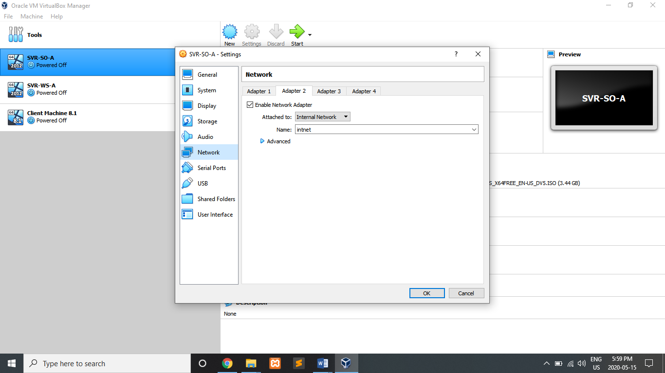

**Steps to Create of Web Server (SVR-WS-A)**

Step 1: Provide name according to the requirements.

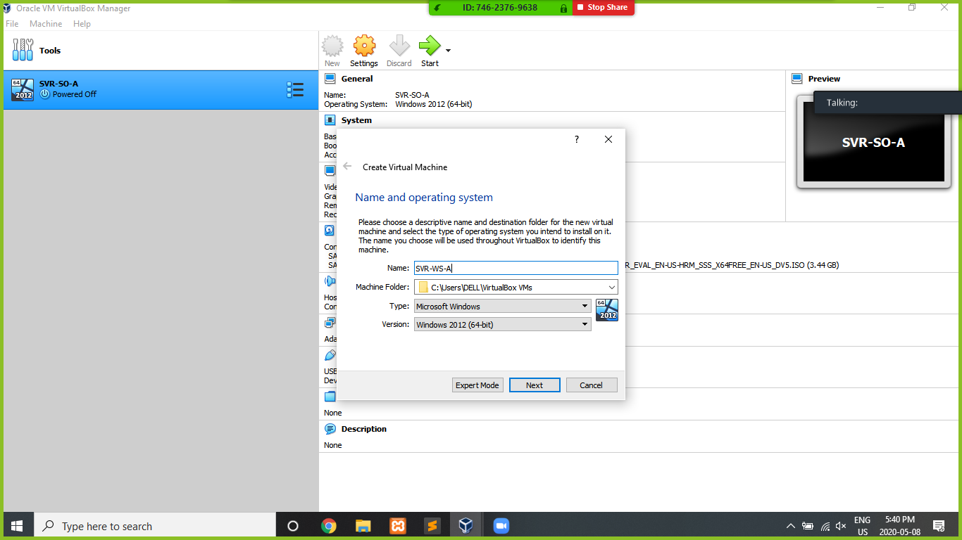

Step 2: Allocate Memory Size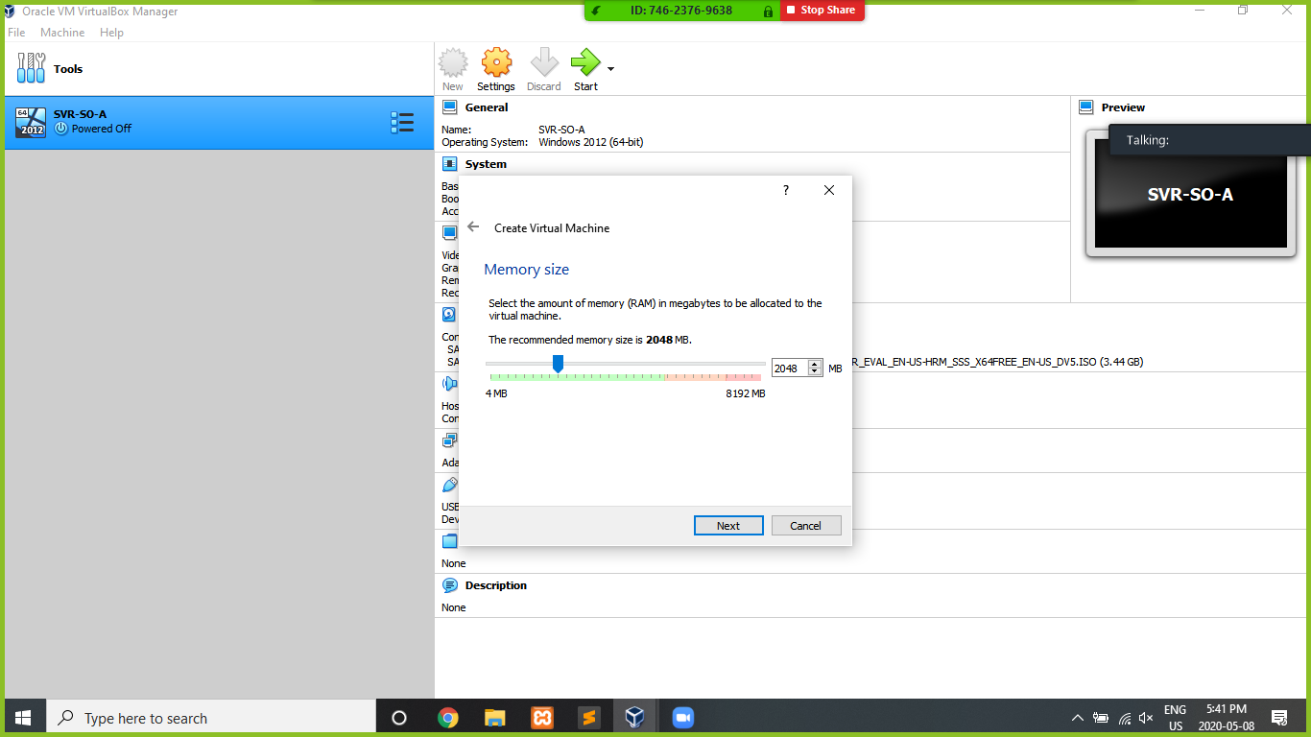.

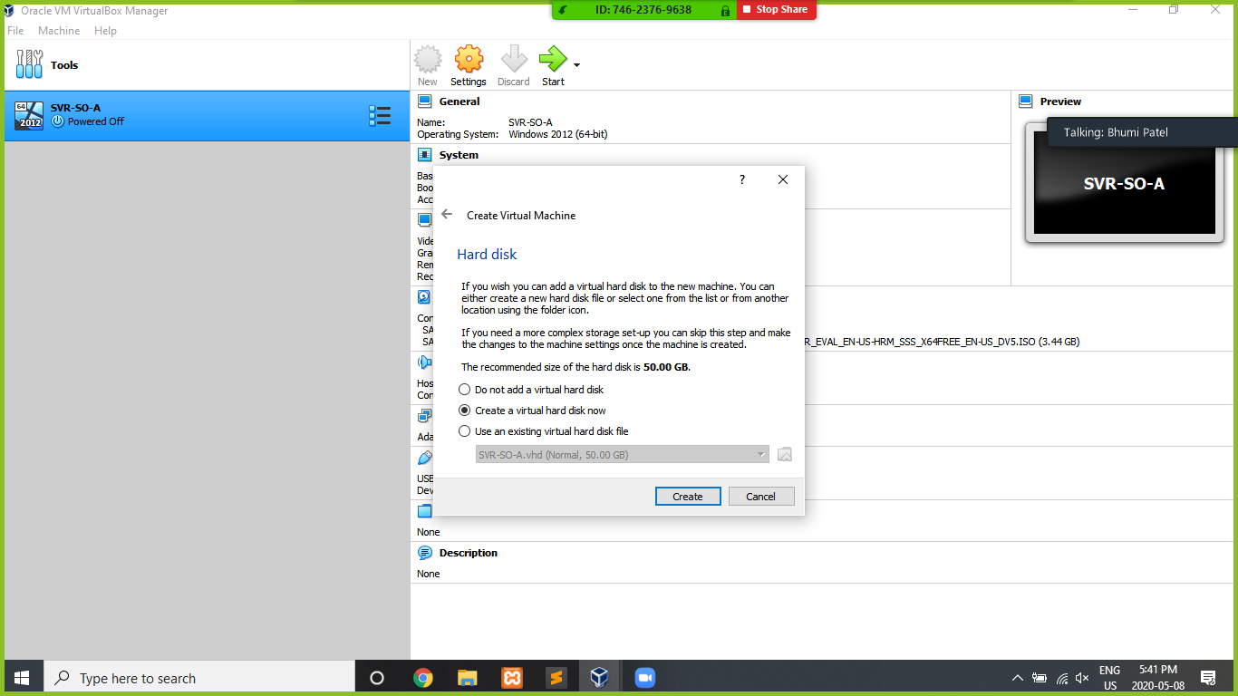Step 3: Create Virtual Hard Disk

Step 4: Select VHD (Virtual Hard Disk)

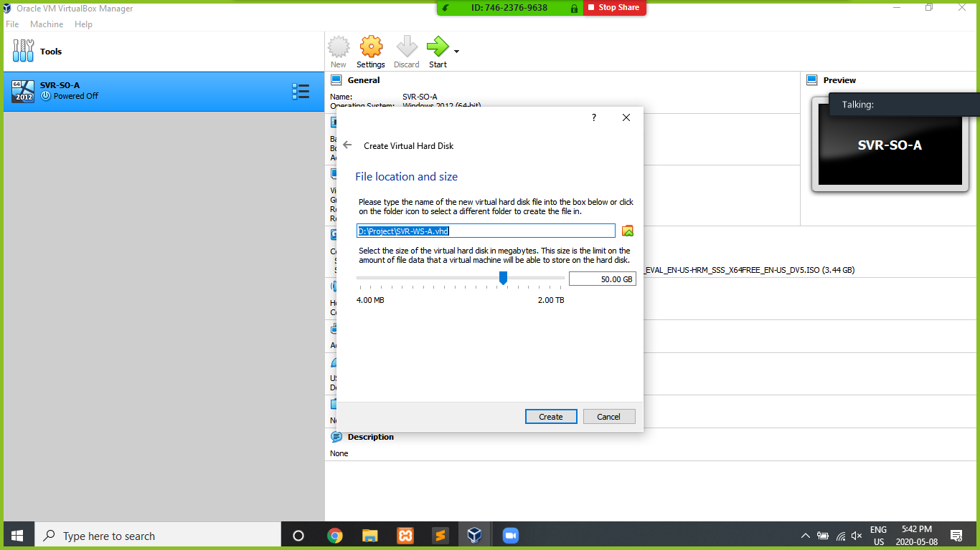

Step 5: Create a virtual hard disk and should be allocated dynamically.

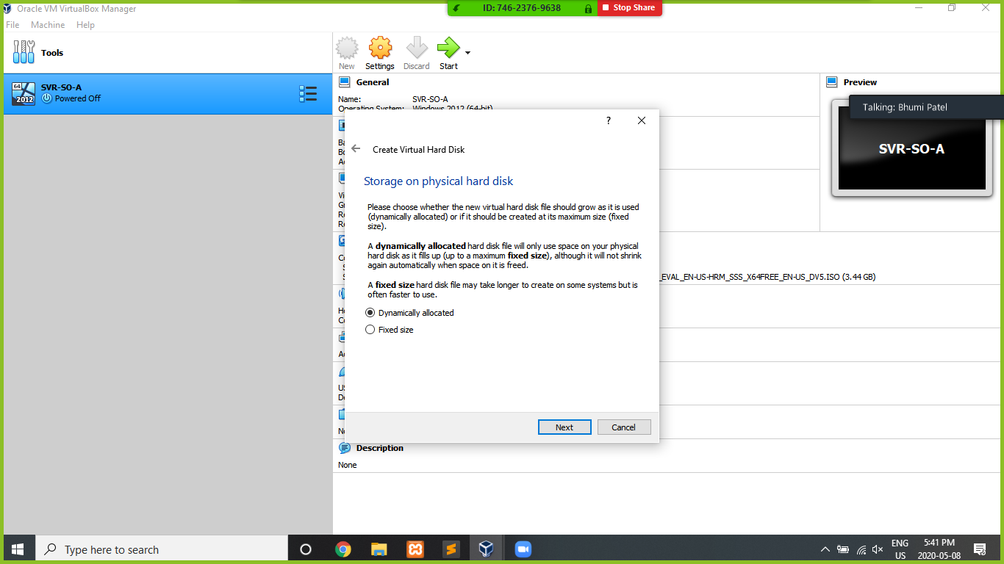Step 6: Allocate Location and Size

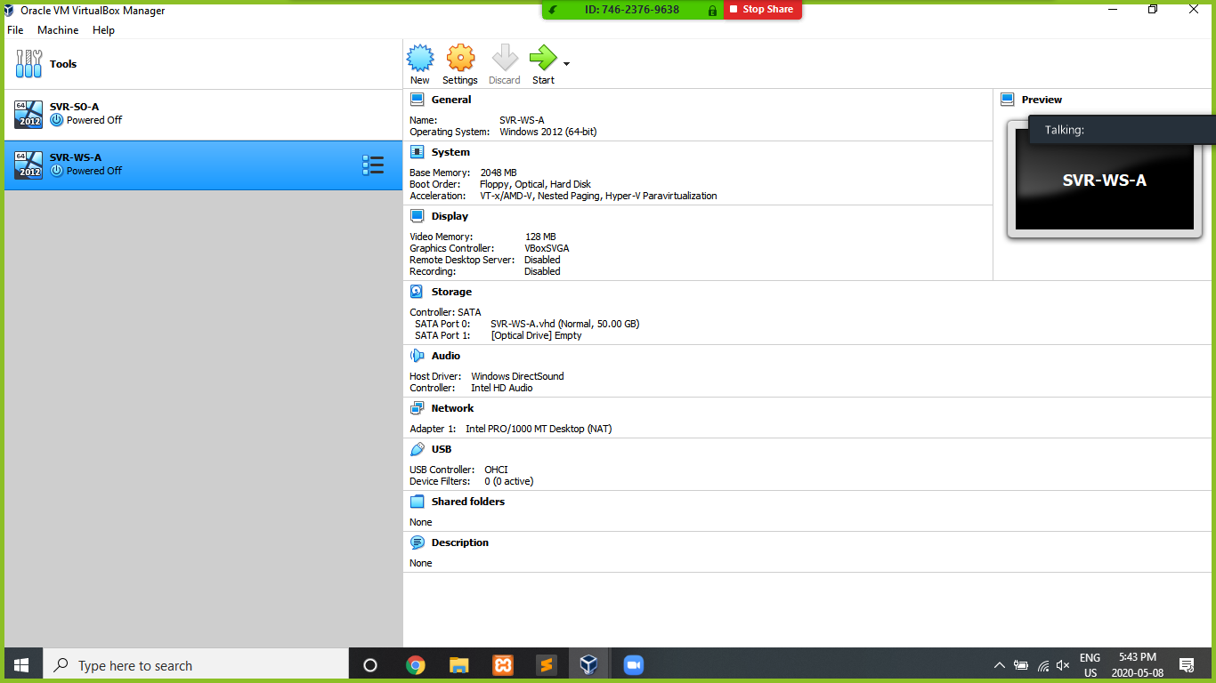Step 7: Created Web Server (SVR-WS-A)

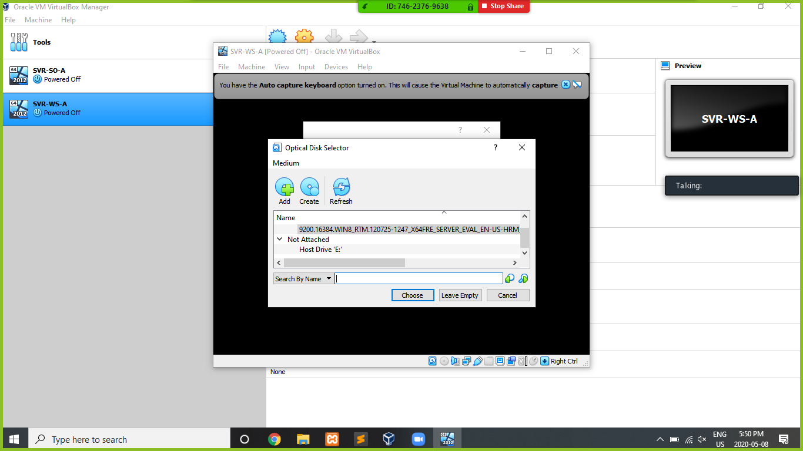Step 8: Add ISO File

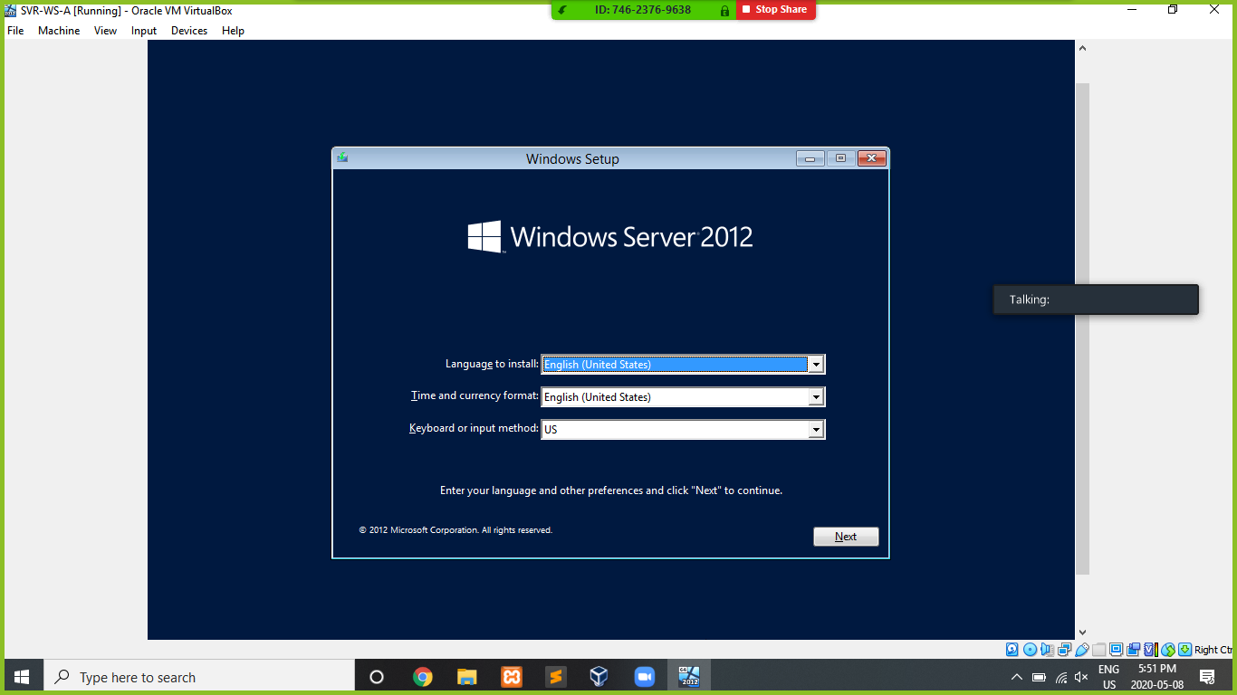Step 9: Install the windows server 2012 on Router.

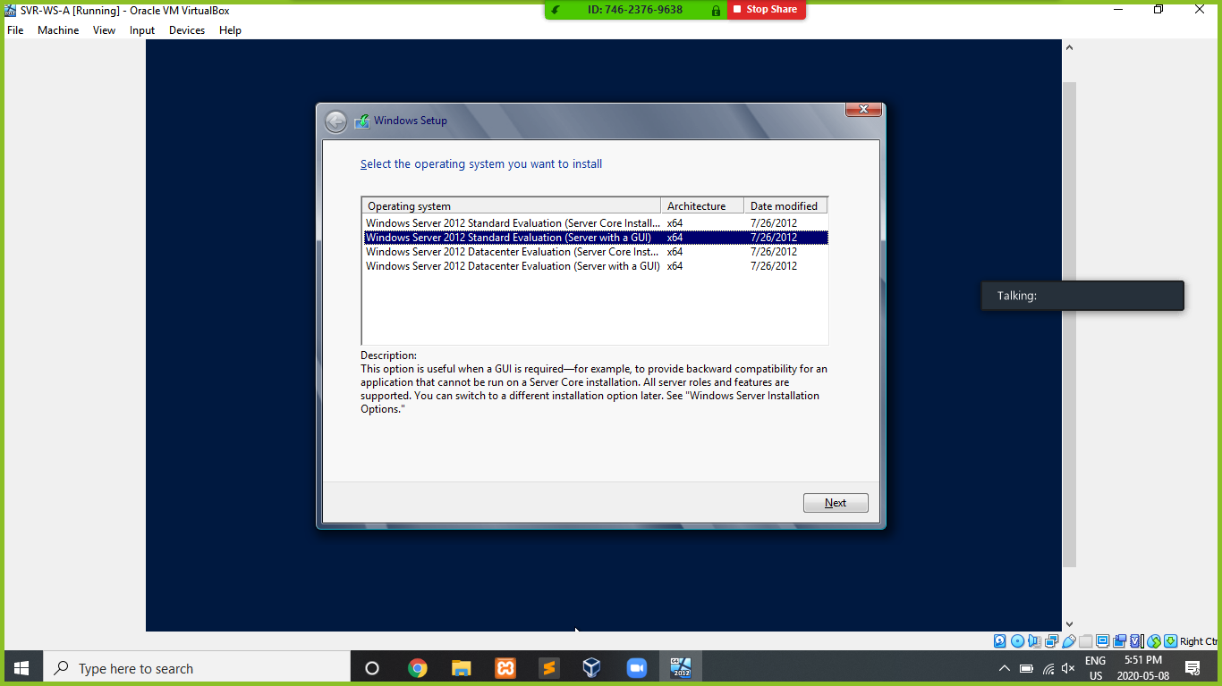Step 10: Choose Operating System To Install.

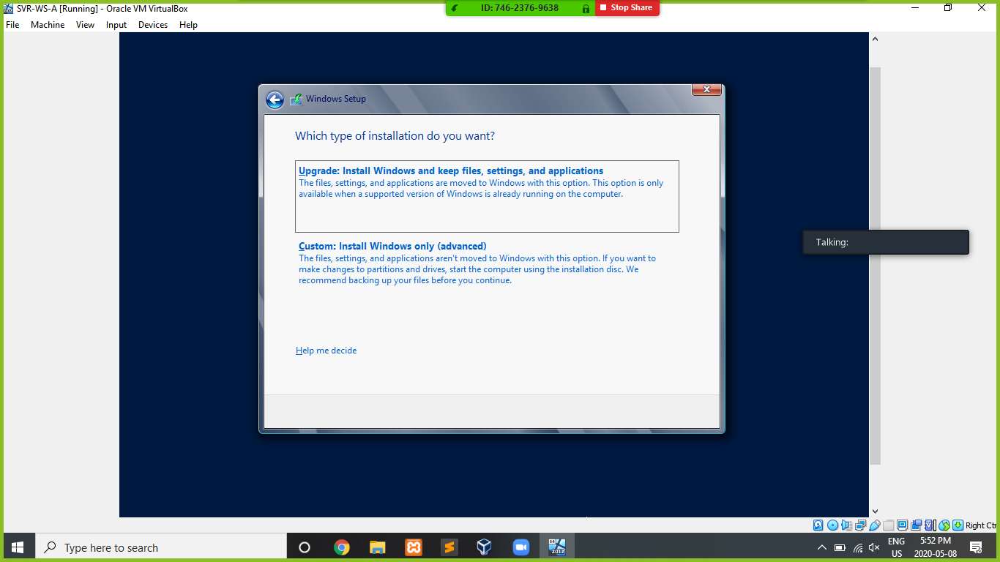Step 11: Install which type you want

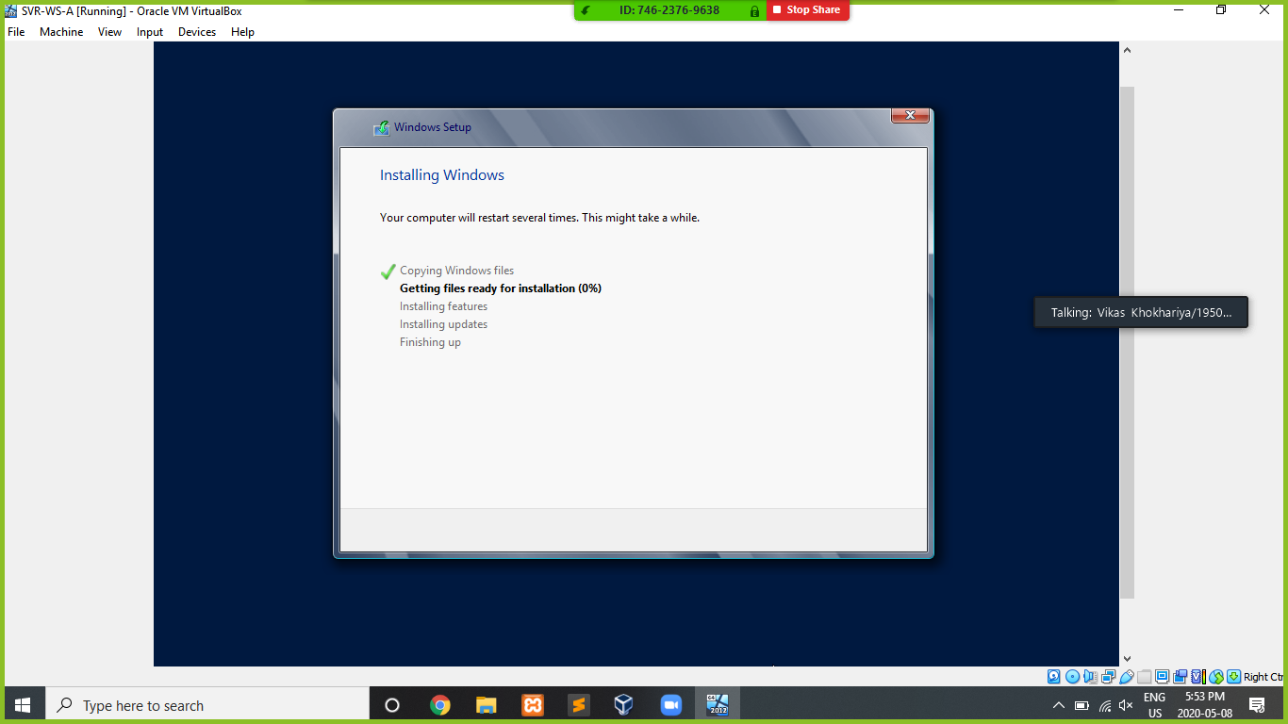Step 12: Installing Window

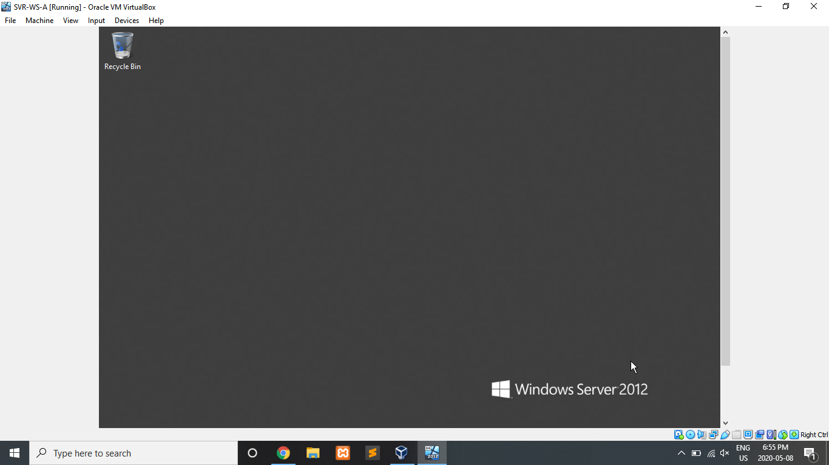Step 13: Installation Done.

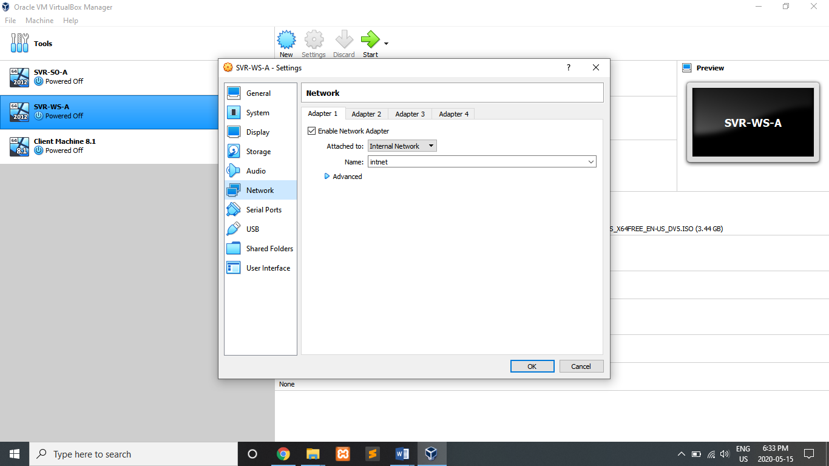Step 14: Go to Network and set adapter 1 to Internal Network

**Steps to Create of Client Machines**

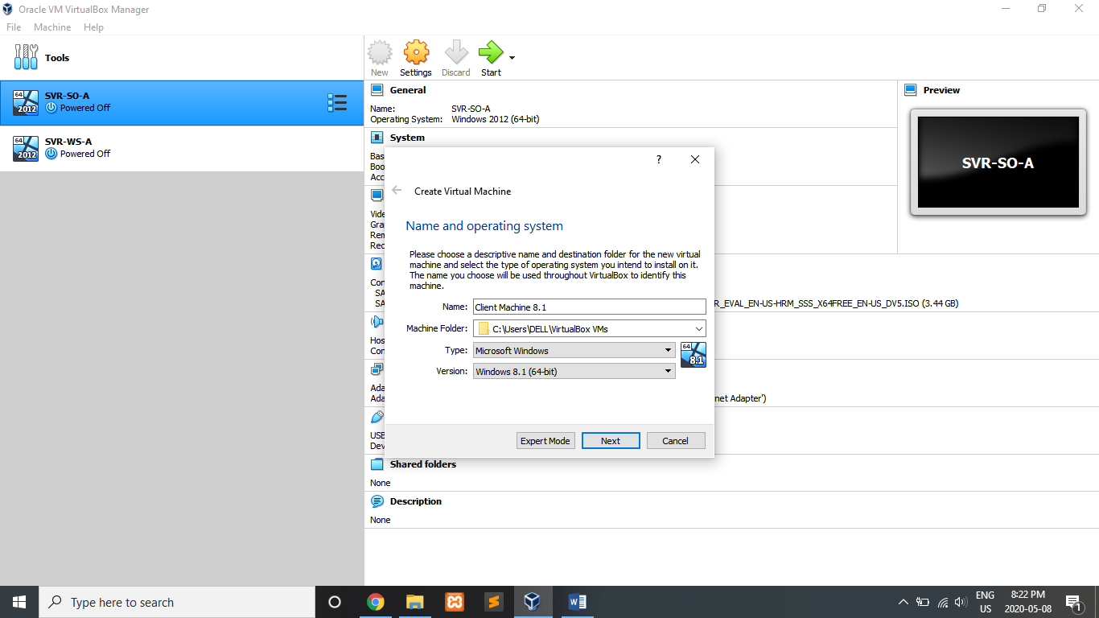Steps 1: Provide name according to the requirements.

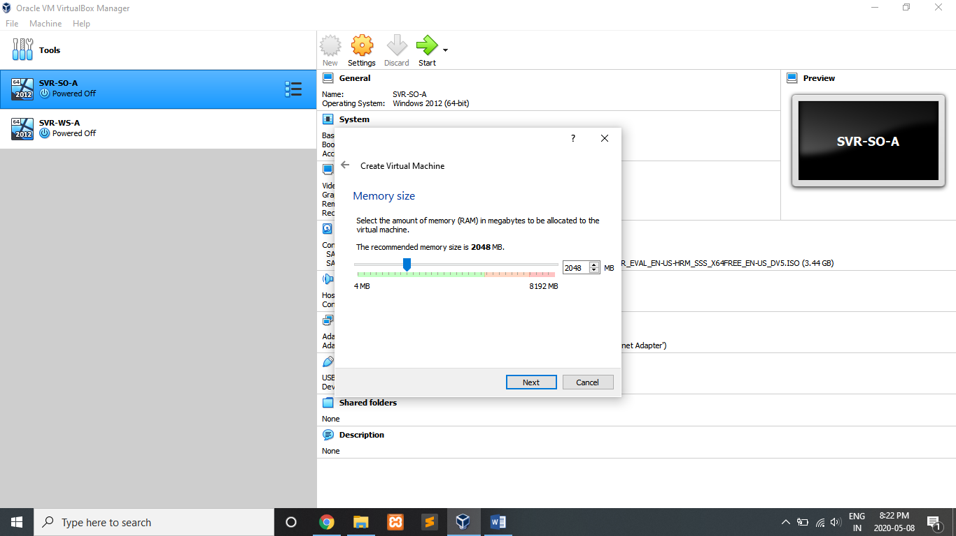Step 2: Choose memory capacity as system needs.

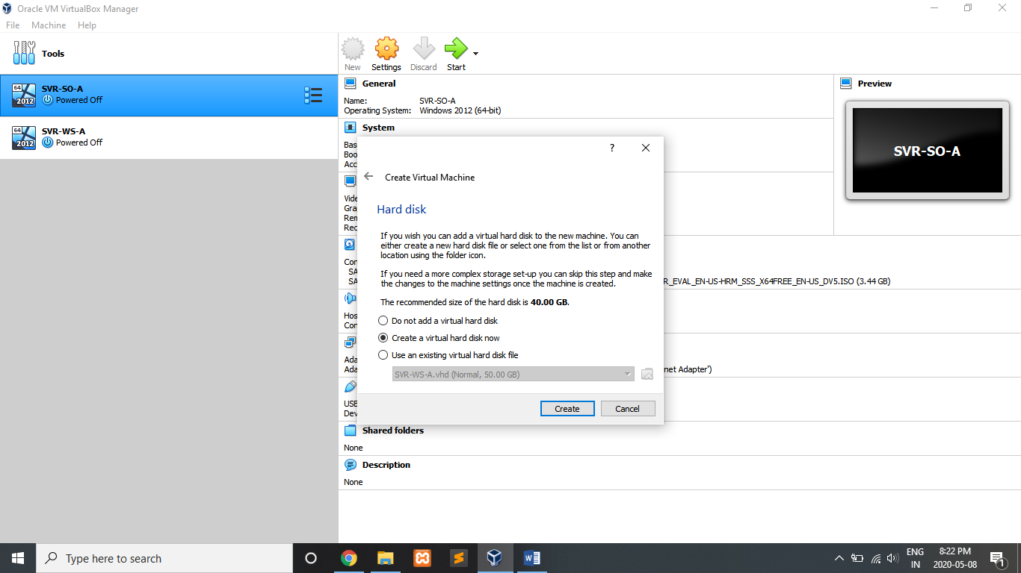Step 3: Create a Virtual Hard Disk

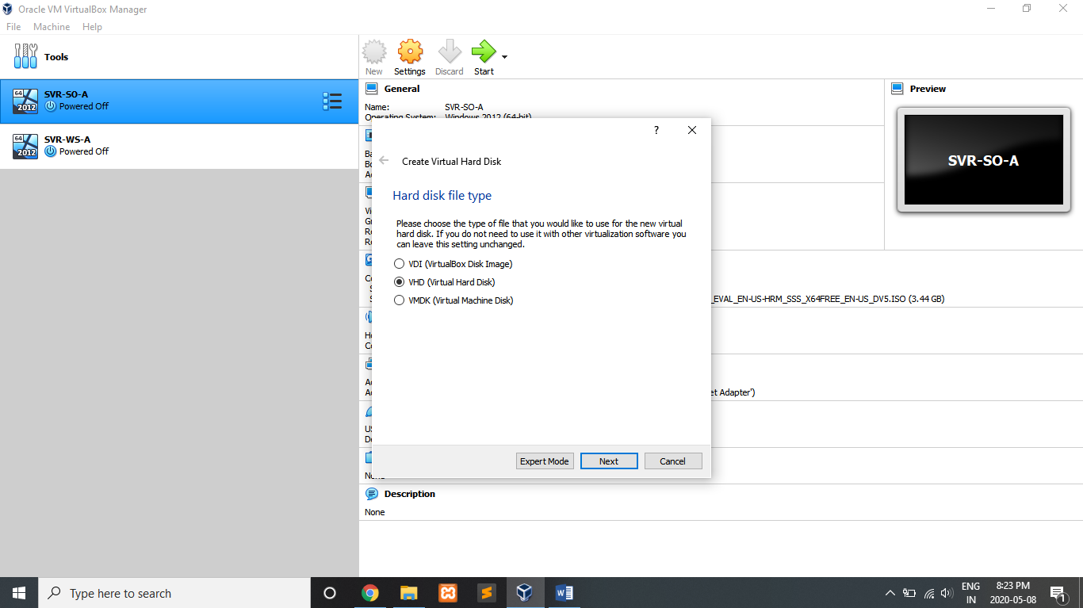Step 4: Choose file type VHD (Virtual Hard Disk)

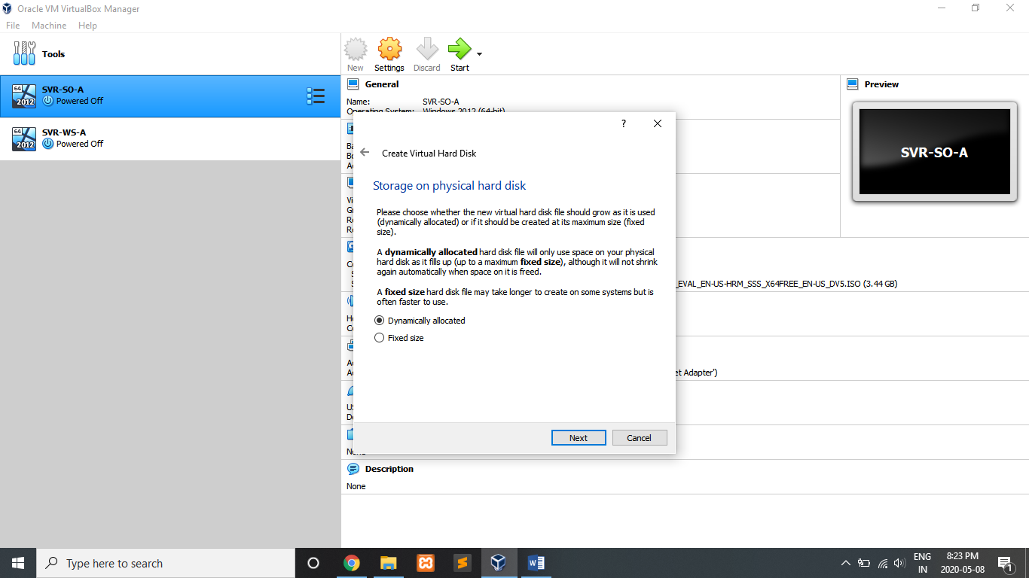Step 5: Create a Virtual Hard Disk and should be allocated dynamically.

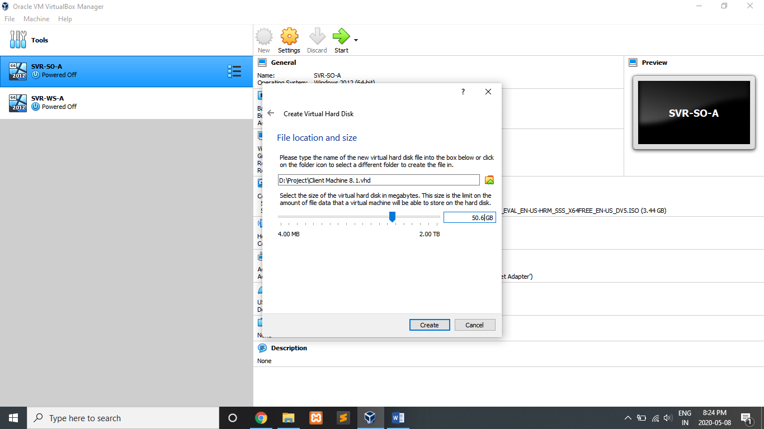Step 6: Choose Disk location and size

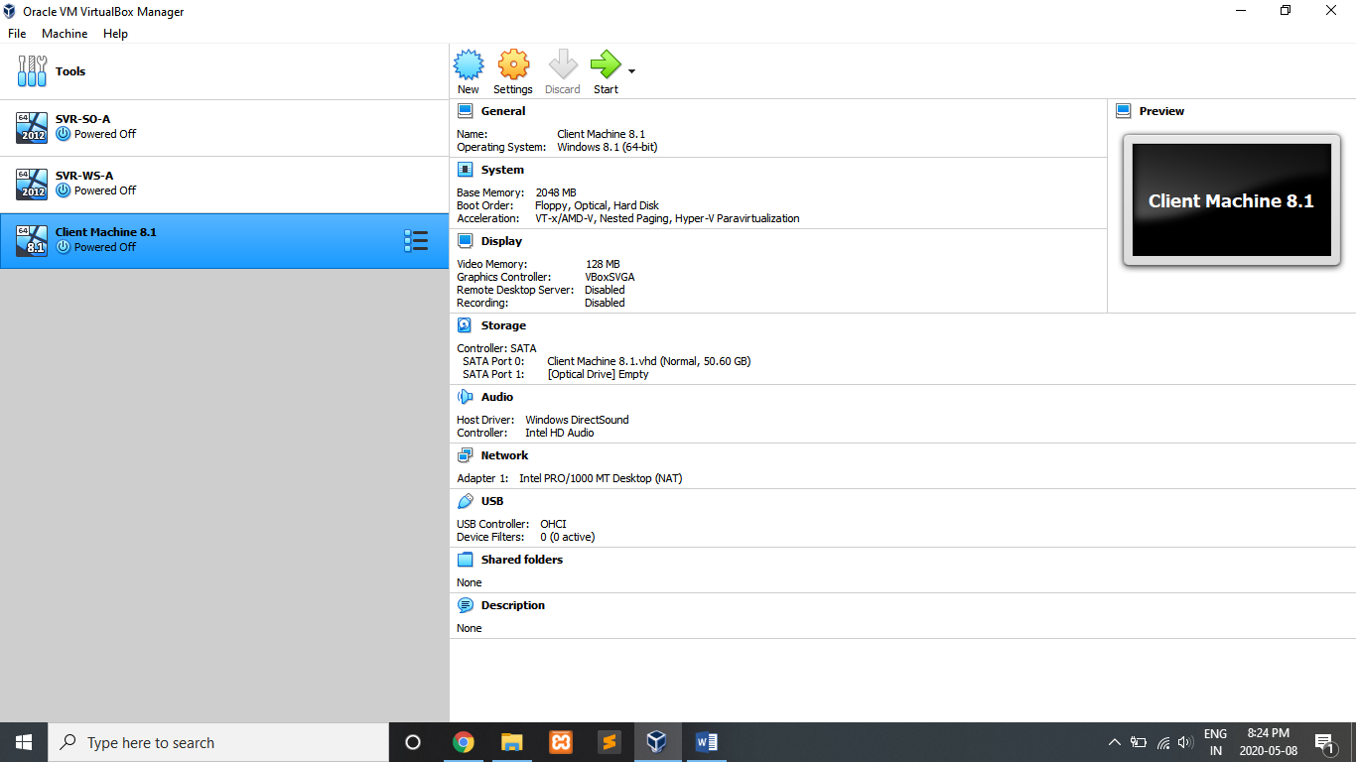Step 7: Created Client Machine

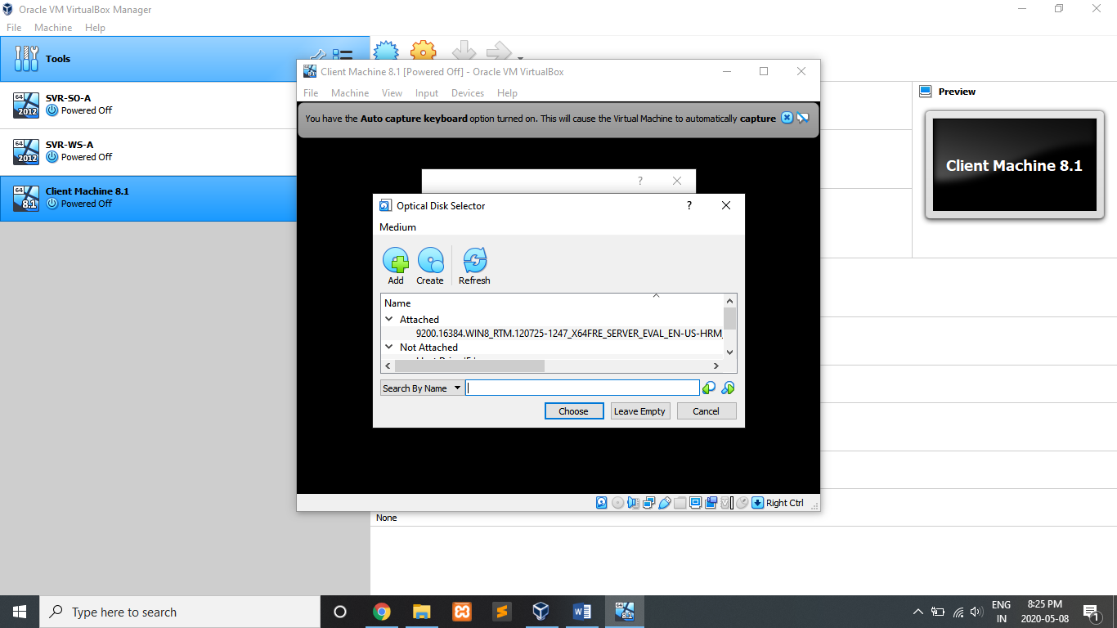Step 8: Add ISO file

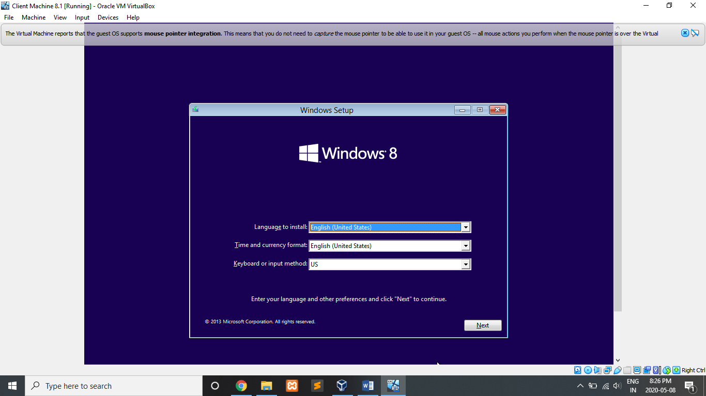Step 9: Install the Windows 8

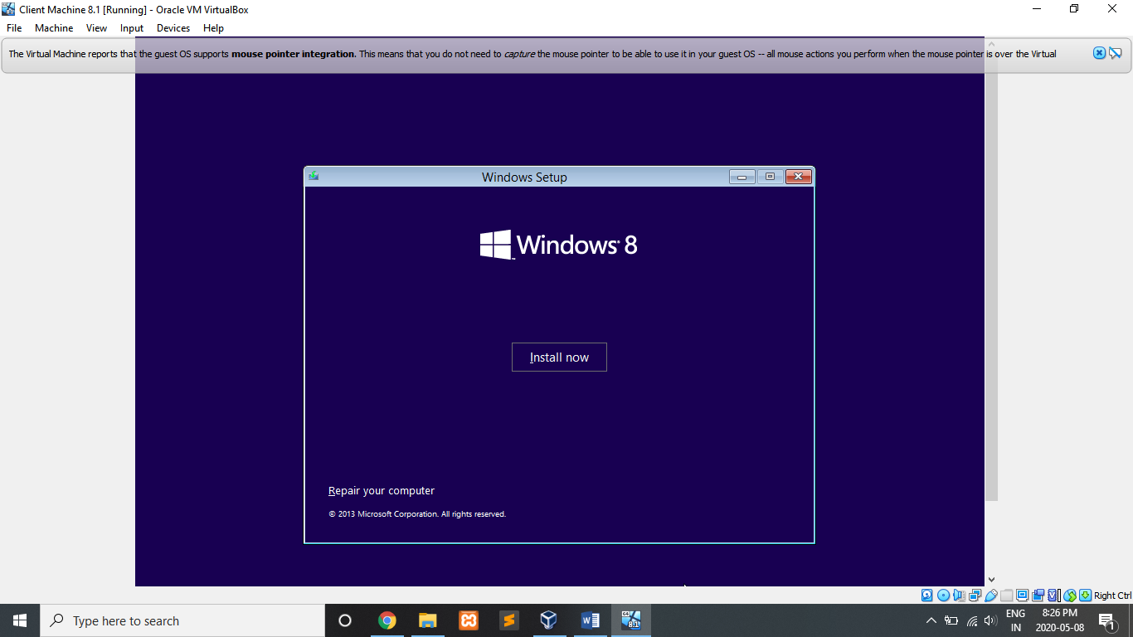

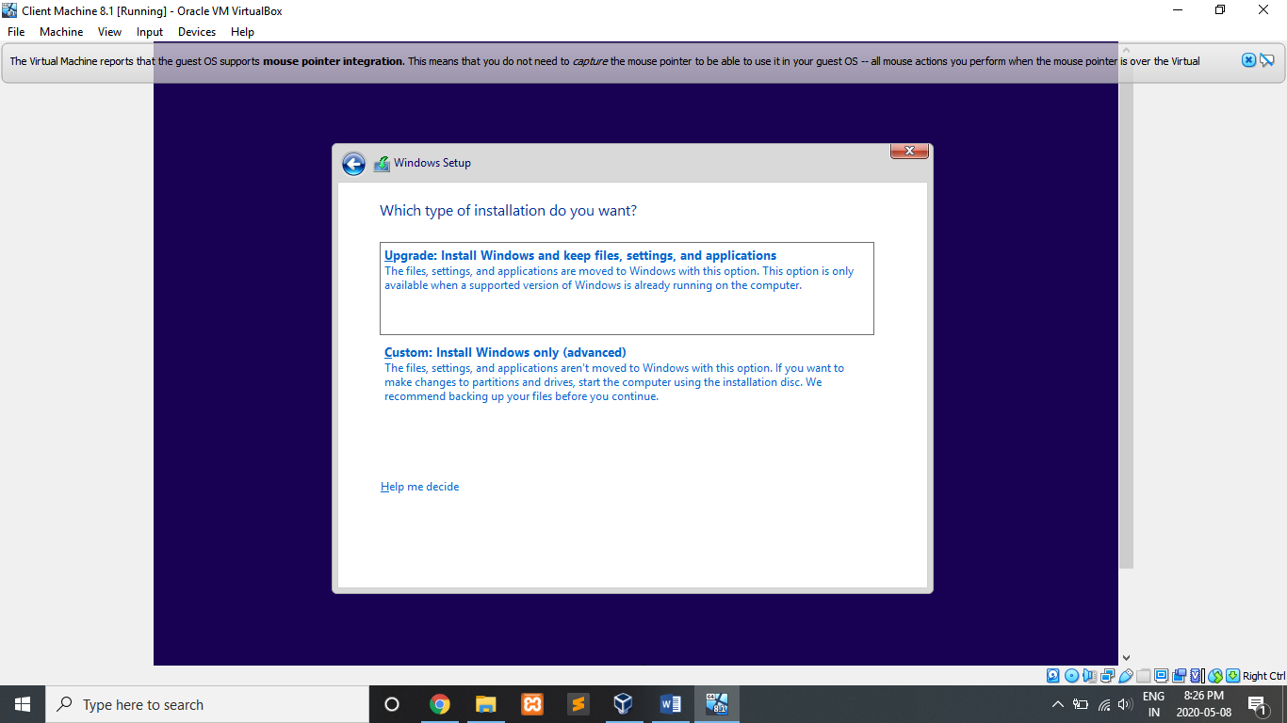Step 10: Install which type you want

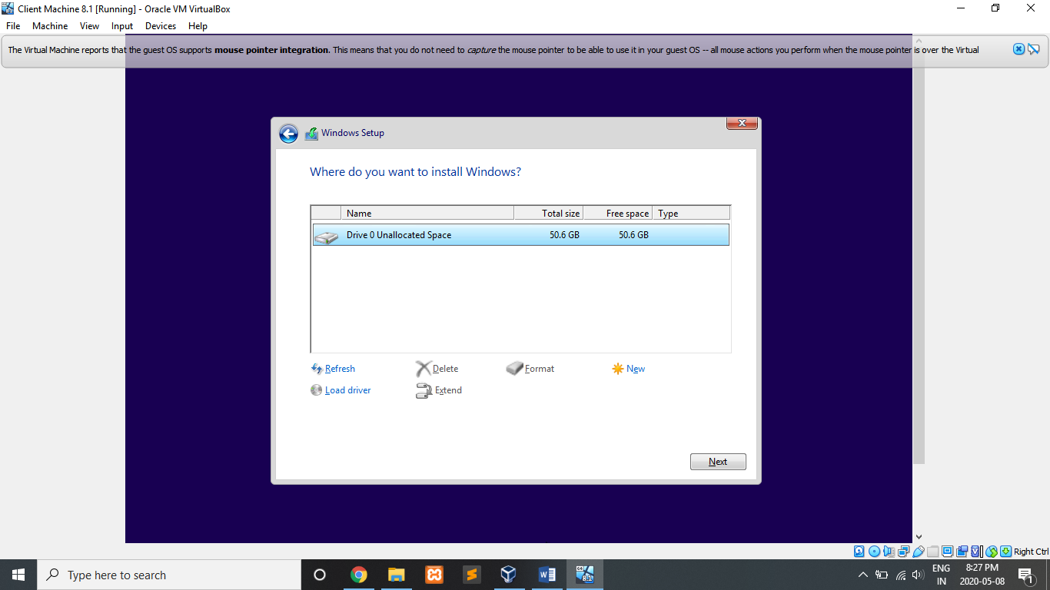Step 11: Choose memory capacity and location as system needs

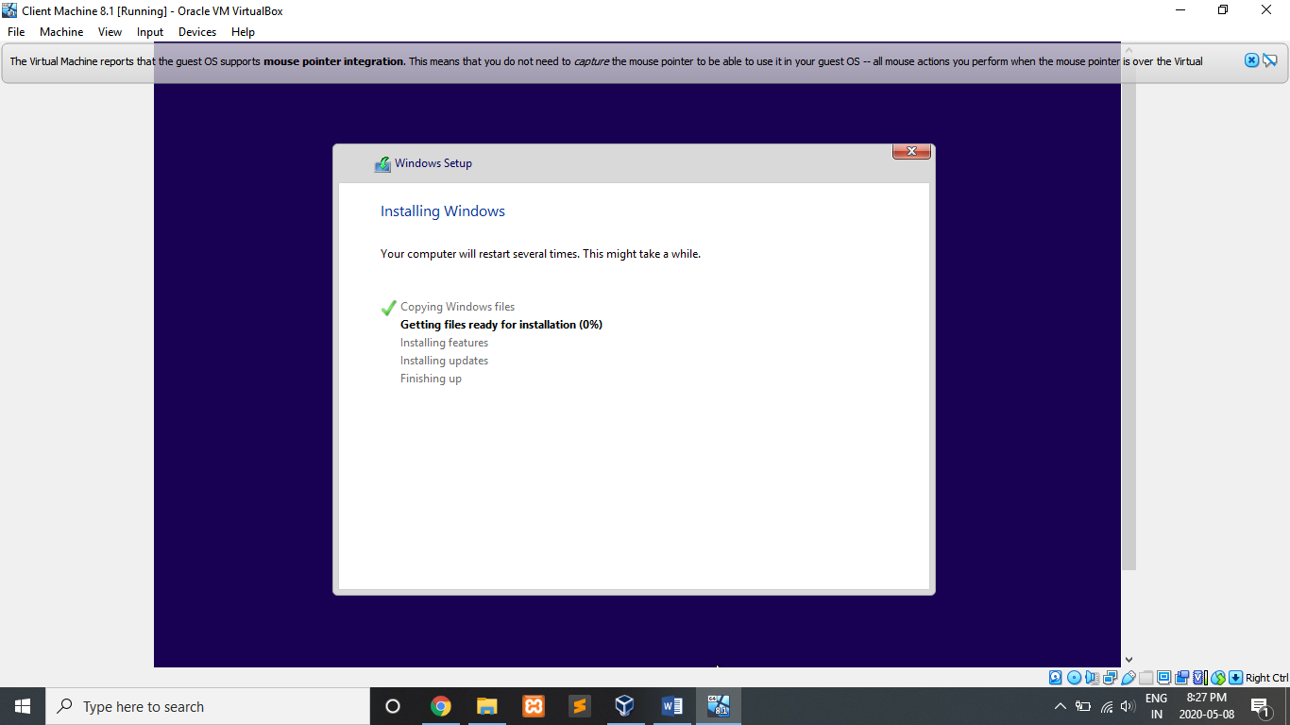Step 12: Installing

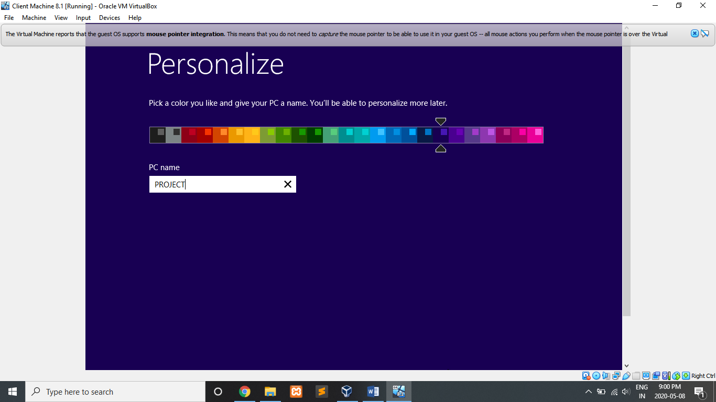Step 13: Create PC name – Project

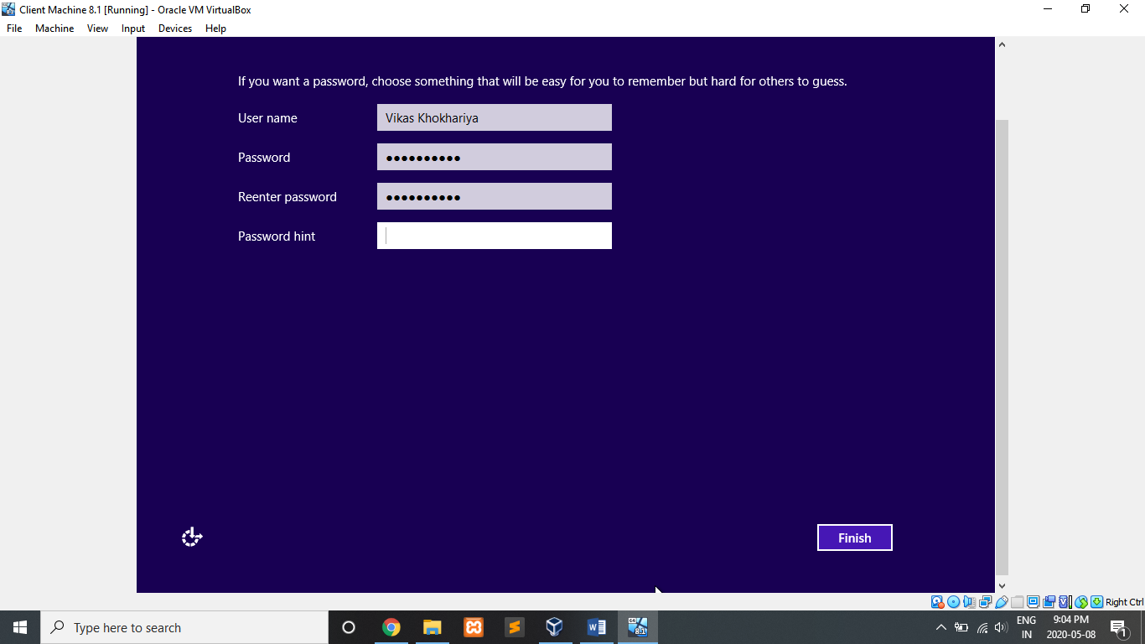Step 14: Create username and password

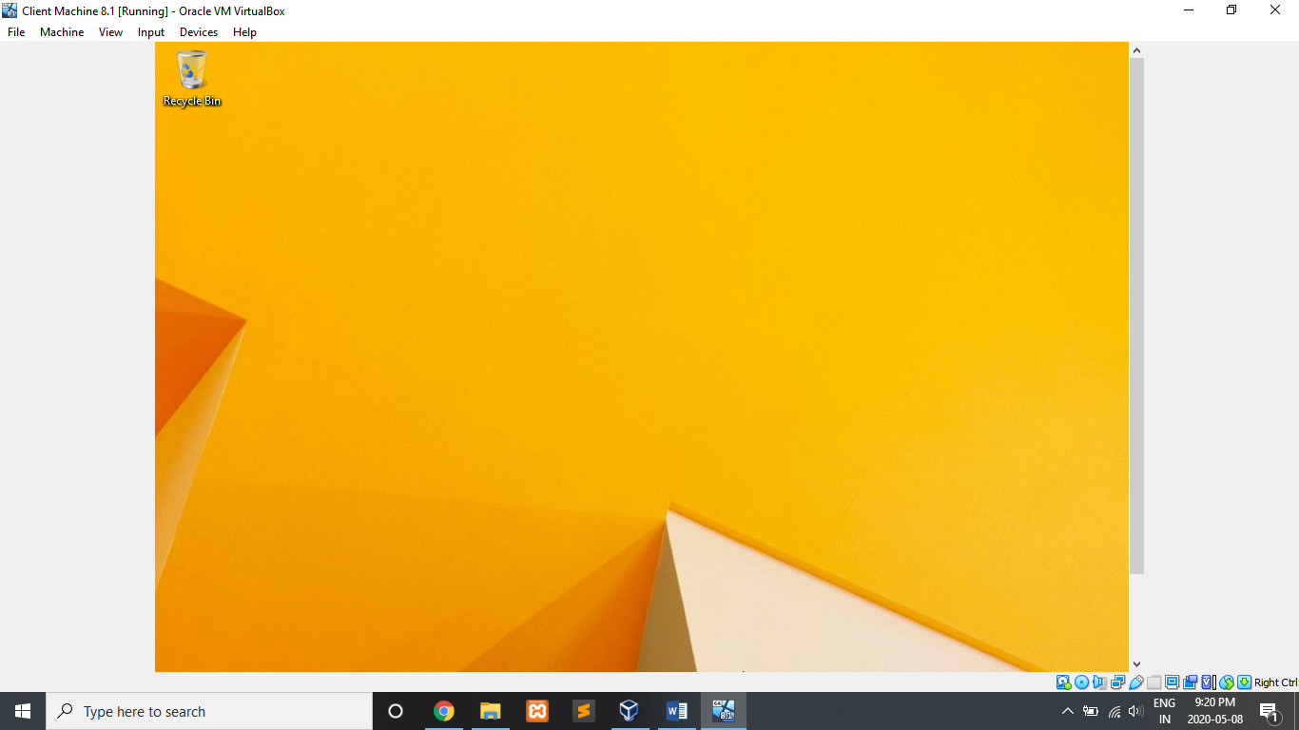Step 15: Installation Completed

**Chapter** **3 : System Configurations**

**3.1 IP Configuration**

**3.1.1 IP Configuration of Router (SVR-SO-A)**

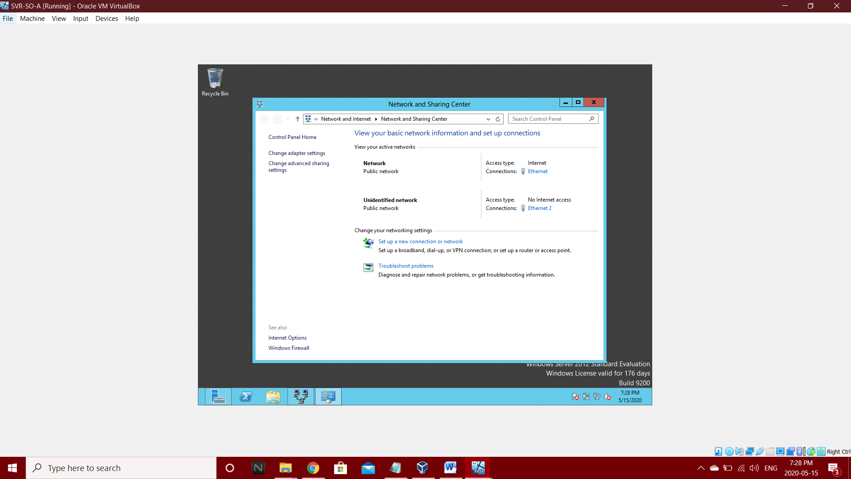Step 1: Go to Network and sharing Center

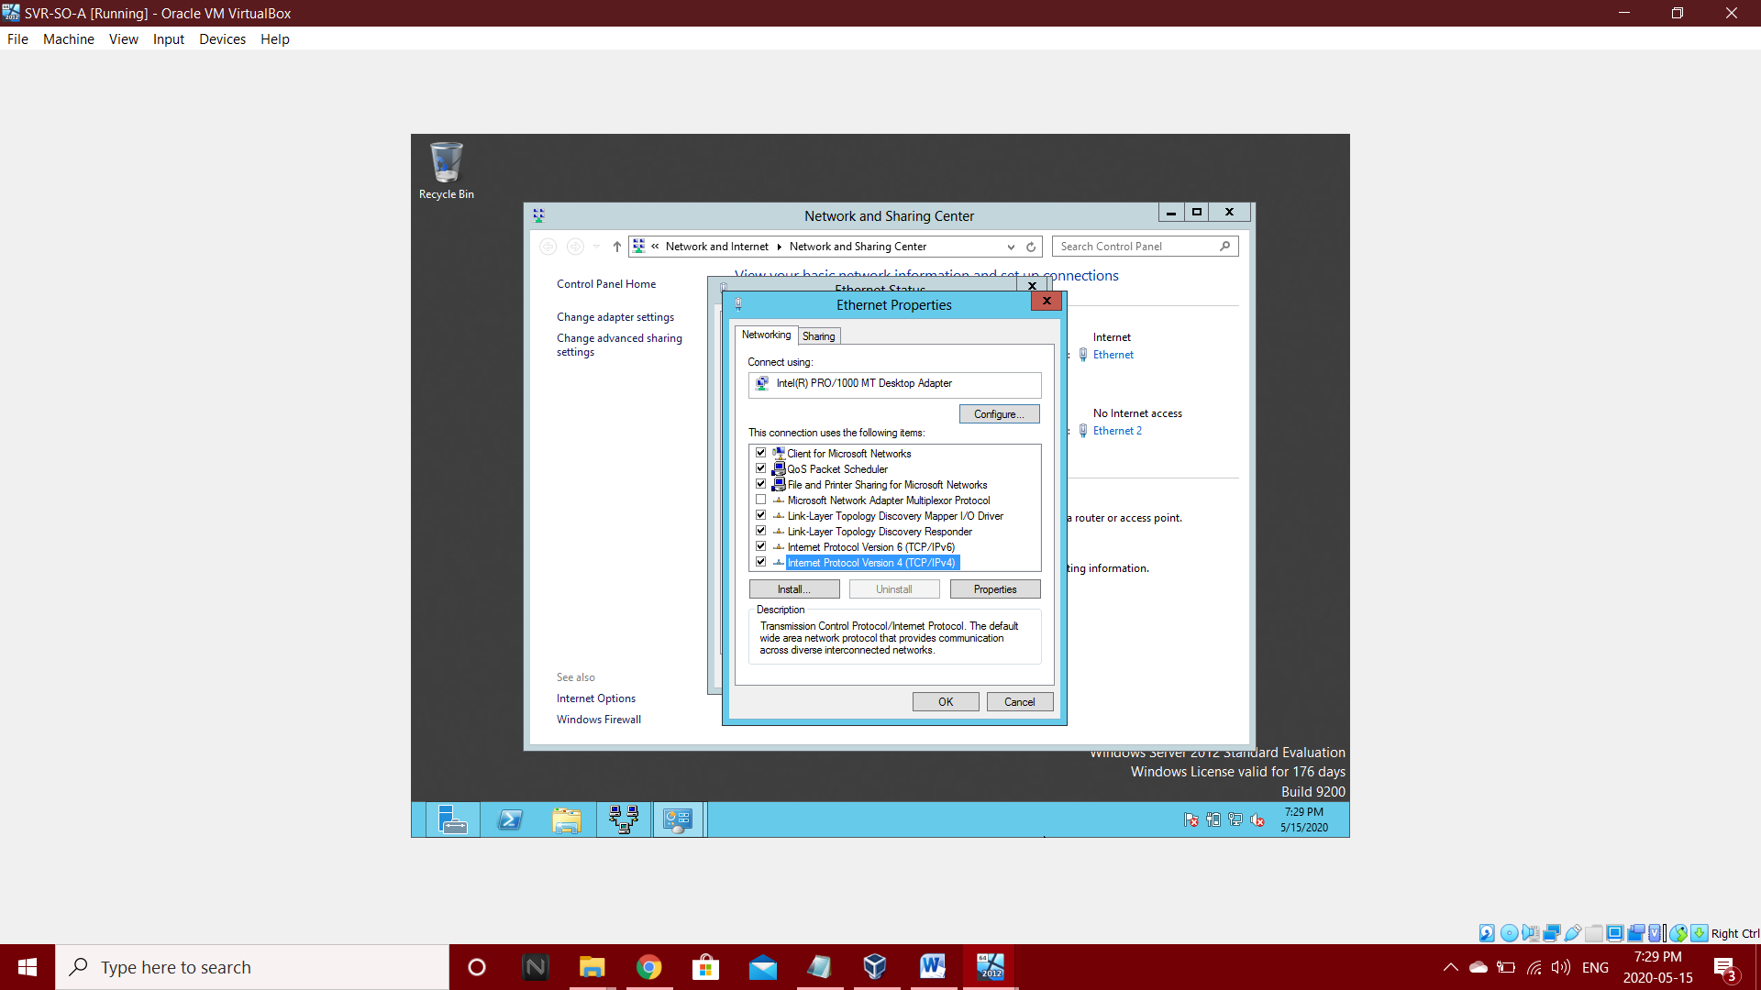Step 2: Go to Ethernet and then select Internet Protocol version 4(TCP/IPv4)

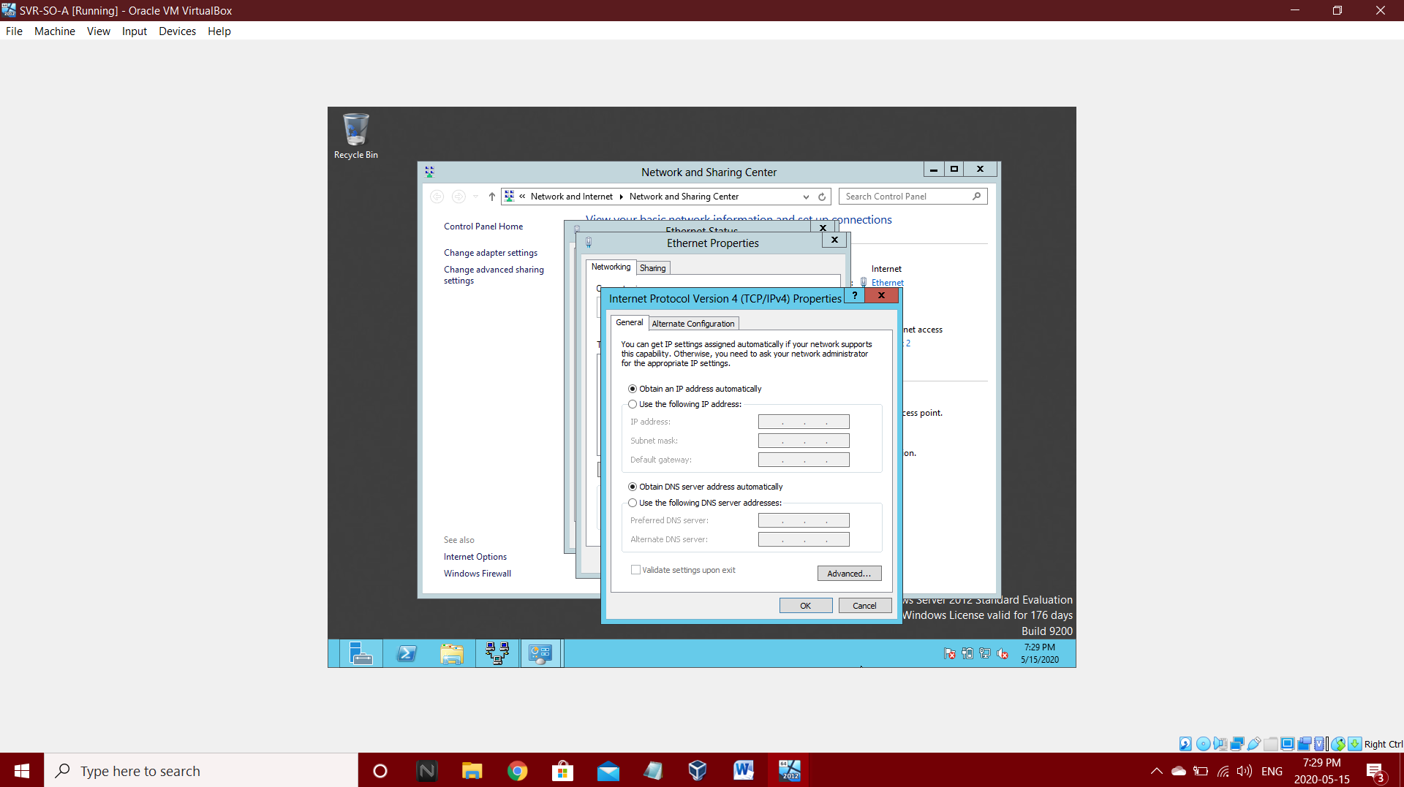Step 3: select obtain an IP address automatically

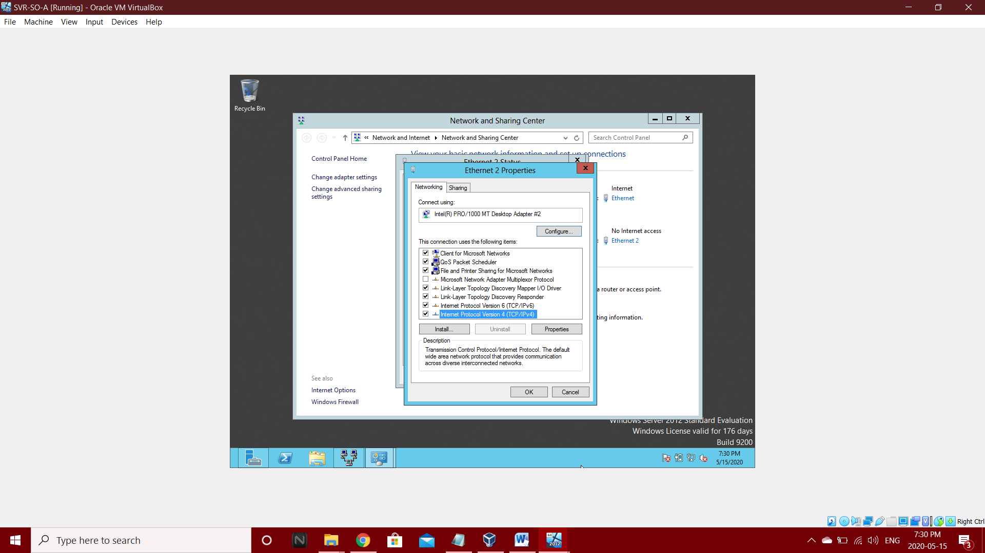Step 4: Select Ethernet 2 and select Internet protocol Version 4(TCP/IPv4)

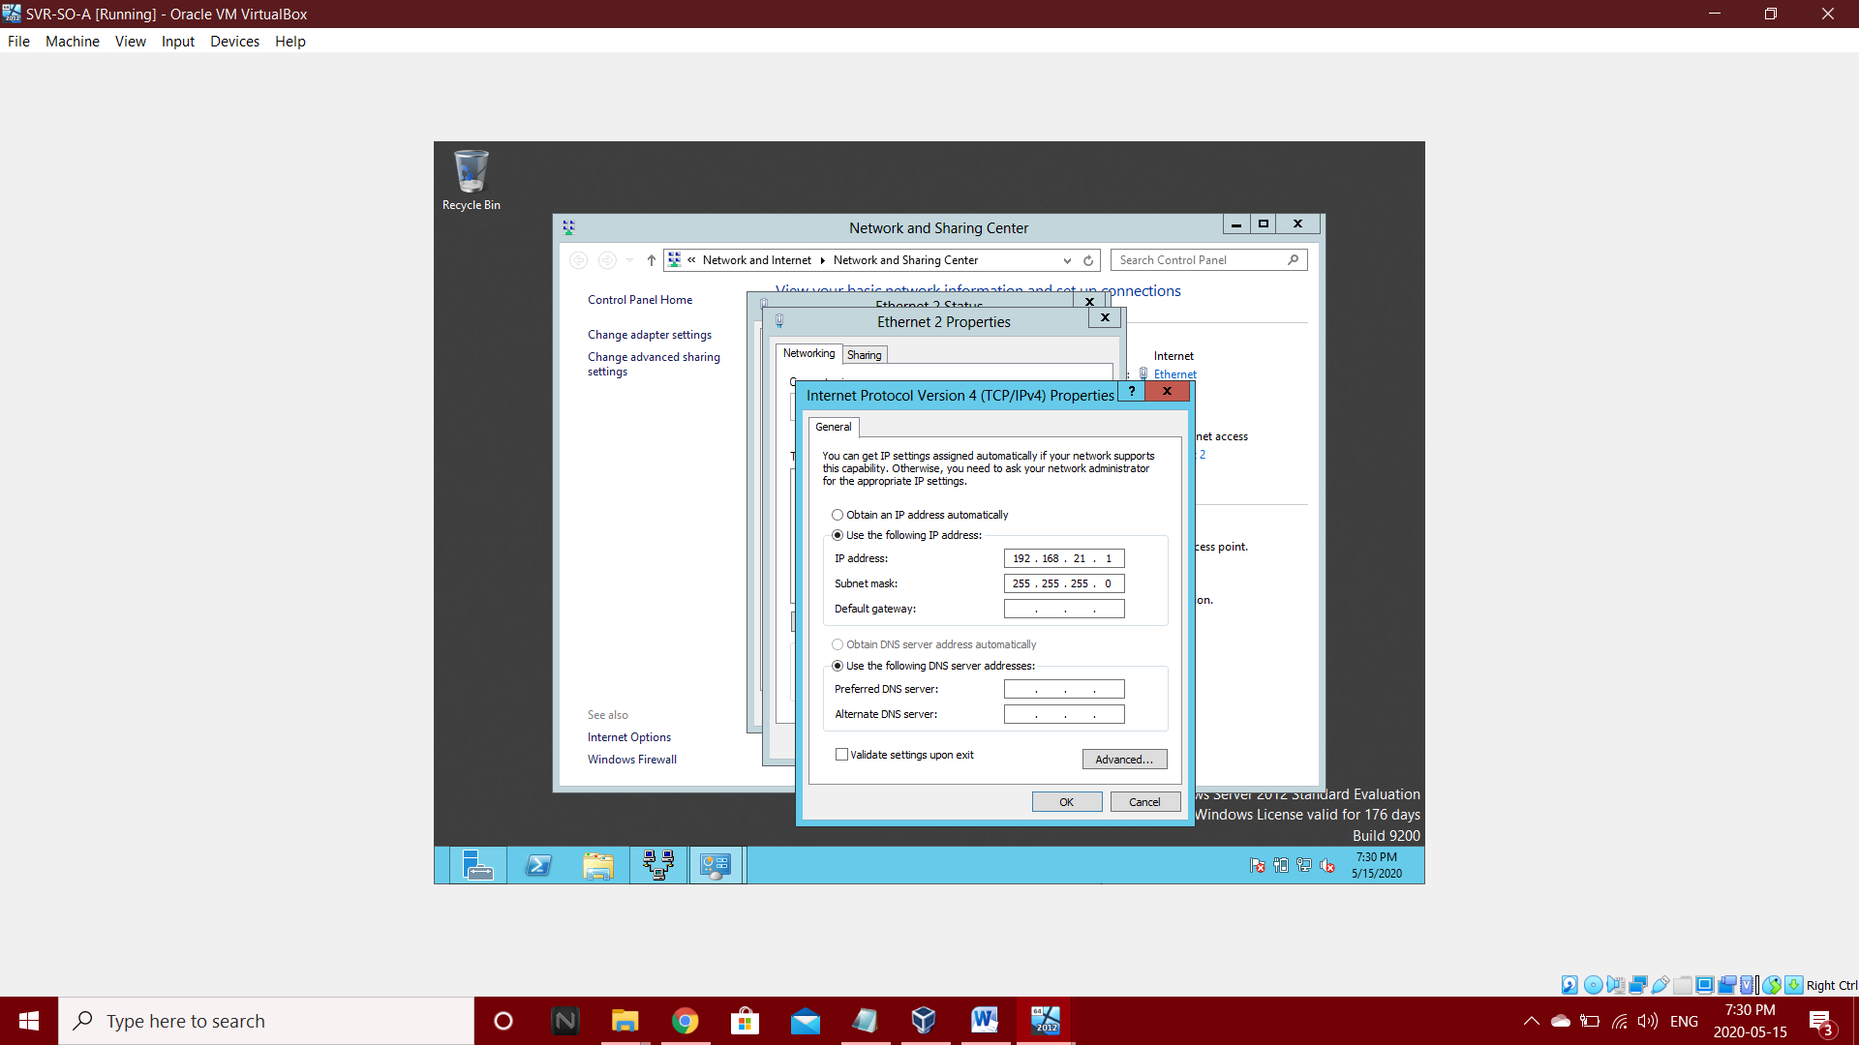Step 5: Select Use the following IP address and enter IP address – 192.168.21.1

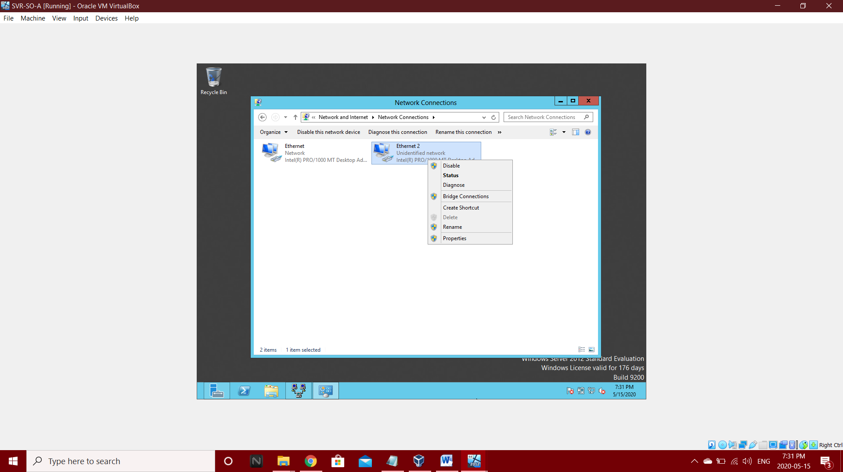Step 6: Disable and Enable Ethernet 2

**3.1.2 IP Configuration of Web-Server (SVR-WS-A)**

As we did in SVR-SO-A same we should in SVR-WS-A too.

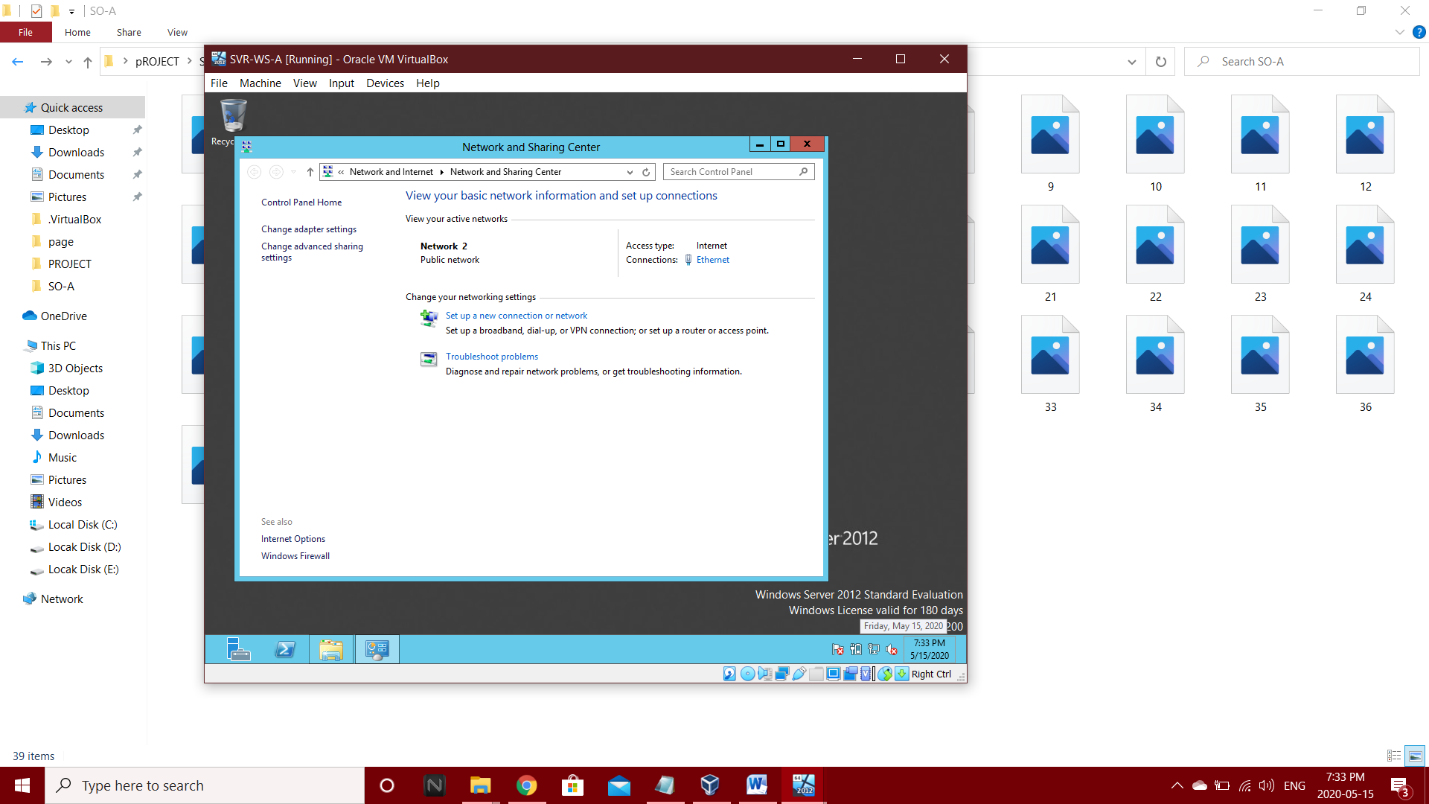Step 1: Go to network and sharing center.

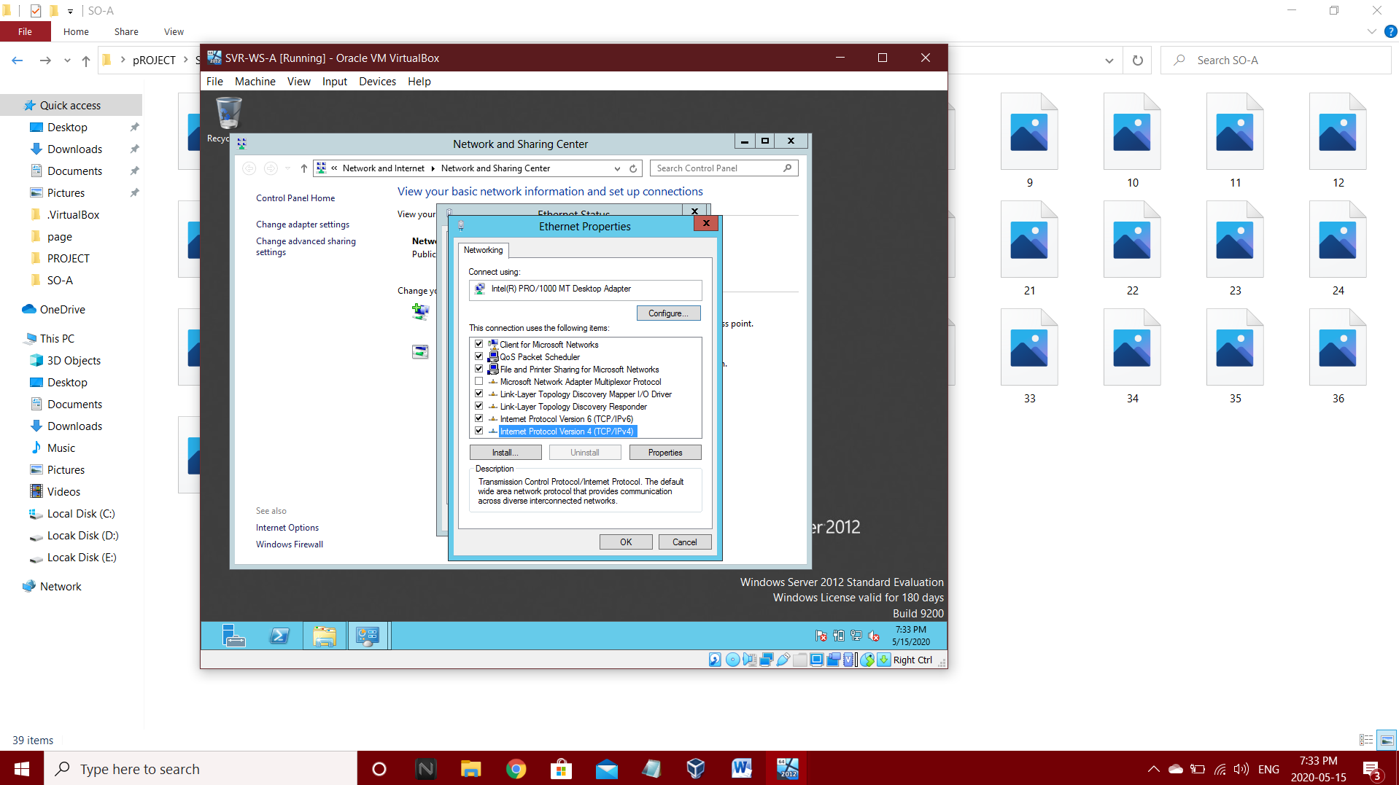Step 2: Select Ethernet and go to Internet Protocol version 4(TCP/IPv4)

Step 3: Choose use the following IP address and enter 192.168.21.2 in IP address and 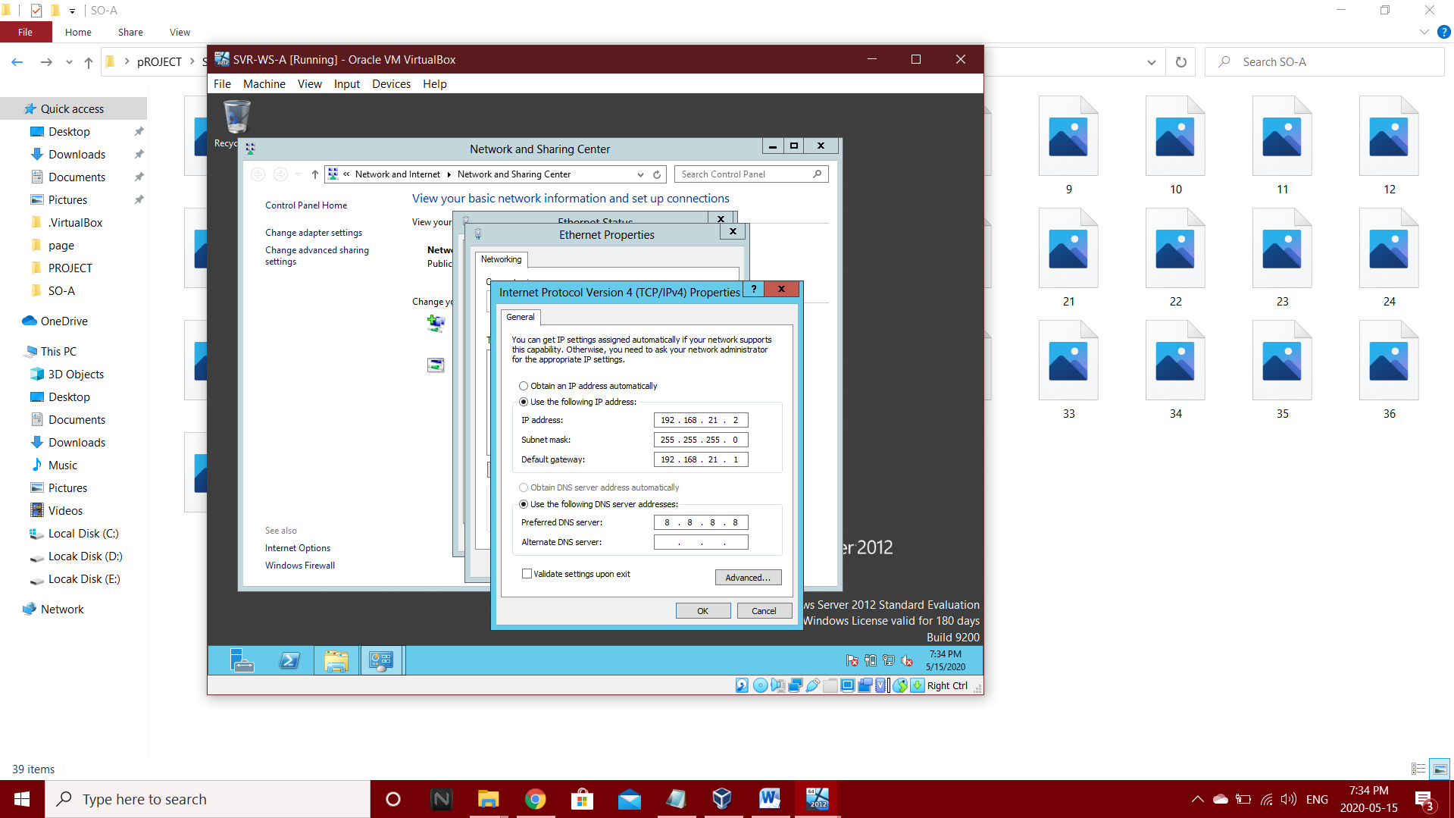192.168.21.1 in Default Gateway and in Preferred DNS Server enter 8.8.8.8.

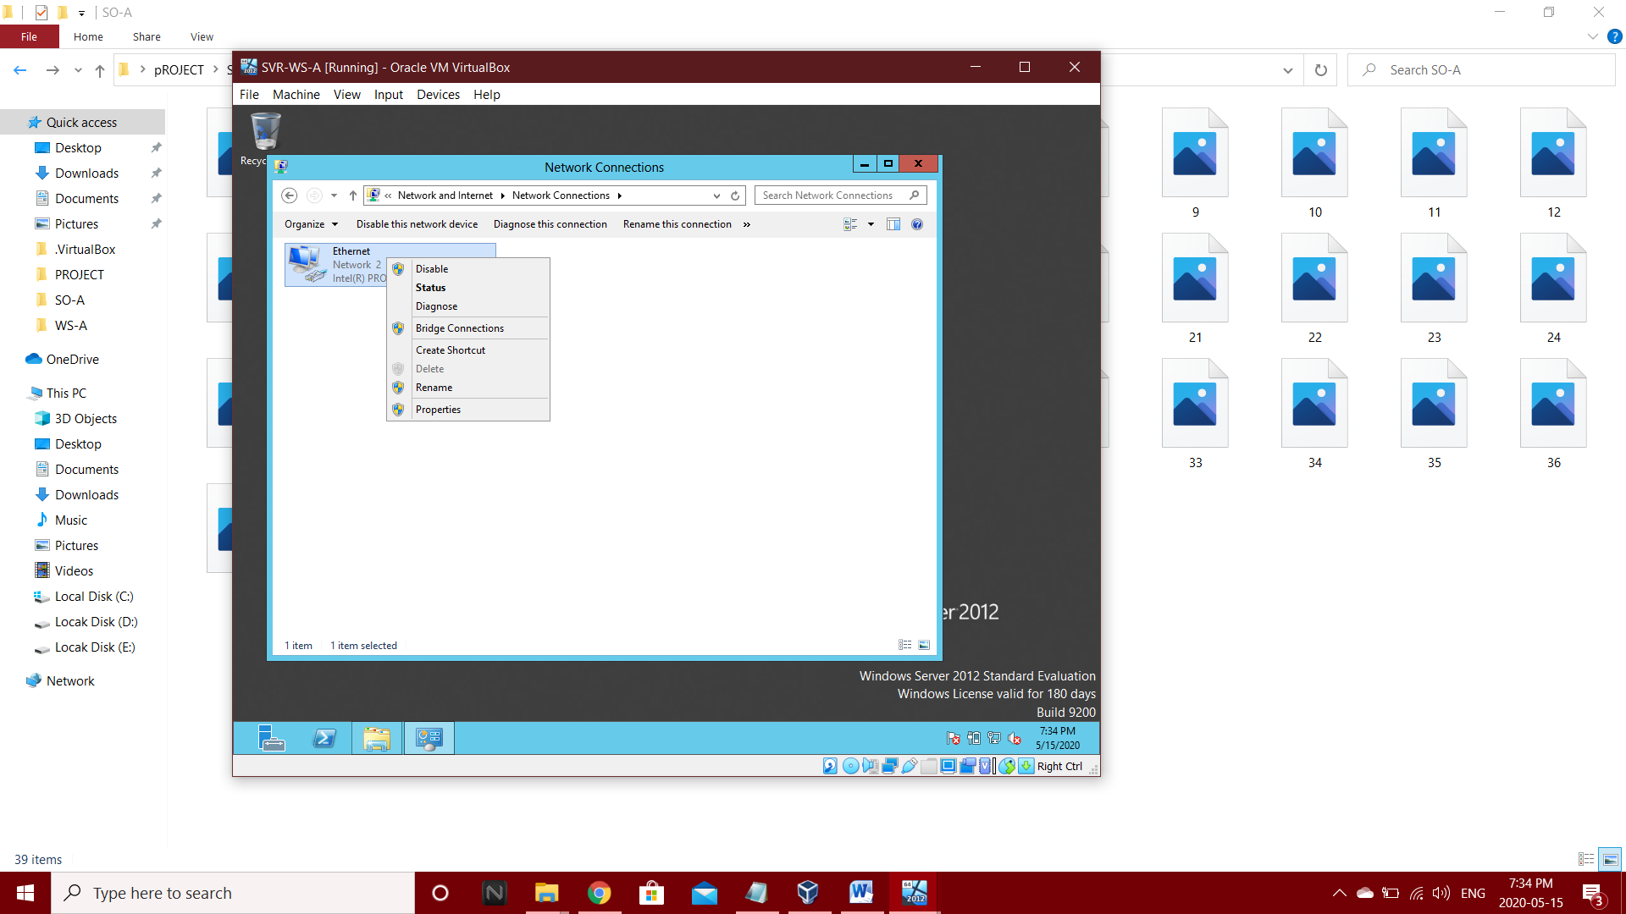Steps 4: Disable and Enable the Ethernet.

**3.1.3 IP-Configuration of Client Machine 8.1**

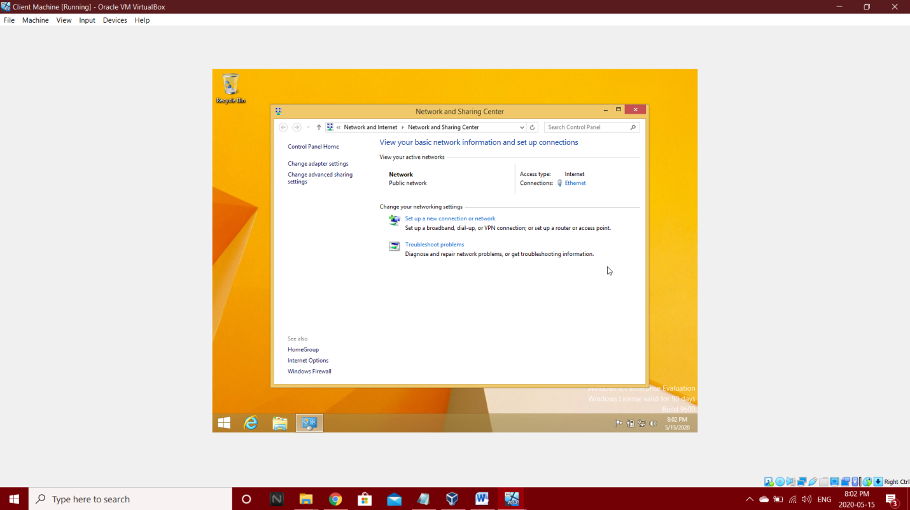Step 1: Go to network and sharing center

Step 2: Select Ethernet and go to Internet Protocol version 4(TCP/IPv4) and Choose use the 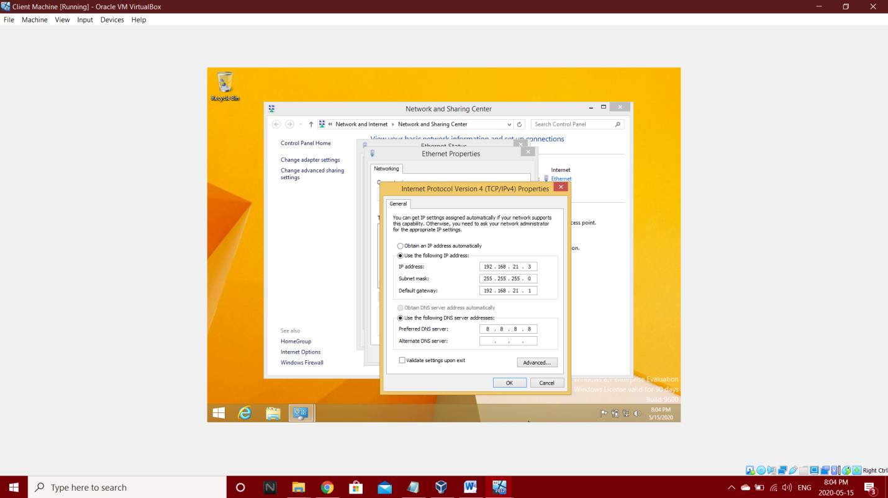following IP address and enter 192.168.21.3 in IP address and 192.168.21.1 in Default Gateway and in Preferred DNS Server enter 8.8.8.8.

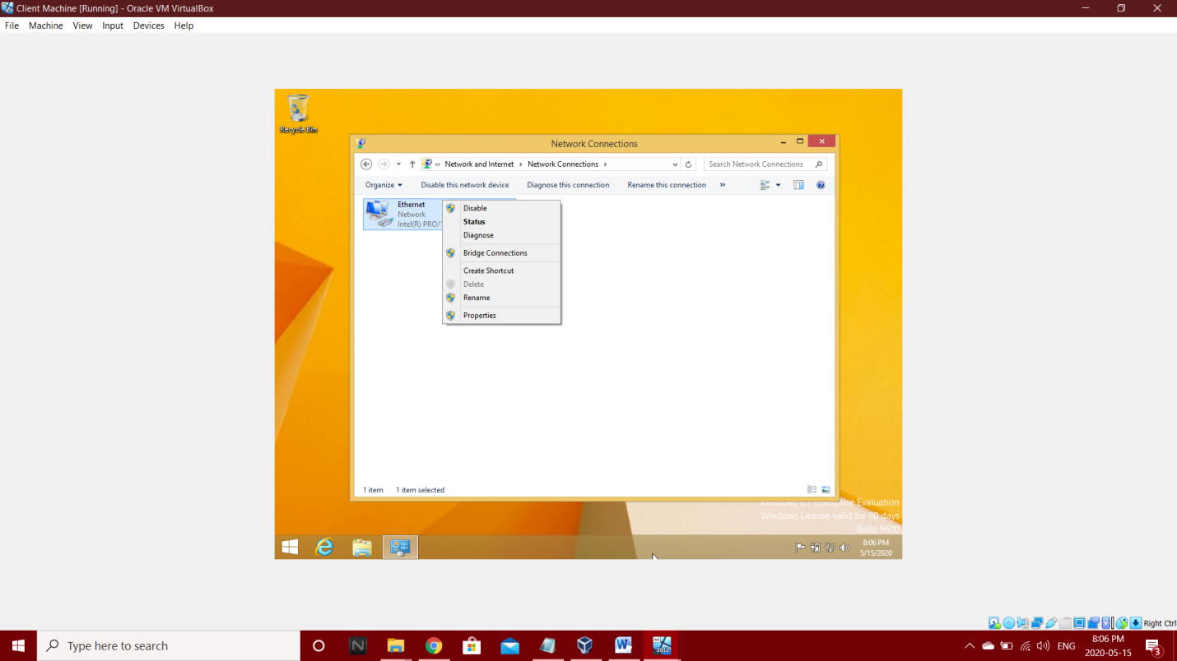Step 3 - Disable and Enable the Ethernet.

**3.2 Network Setup and Configurations**

**3.2.1 Network Setup and Configurations of Router (SVR-SO-A)**

**3.2.1.1 Add Roles and Features:**

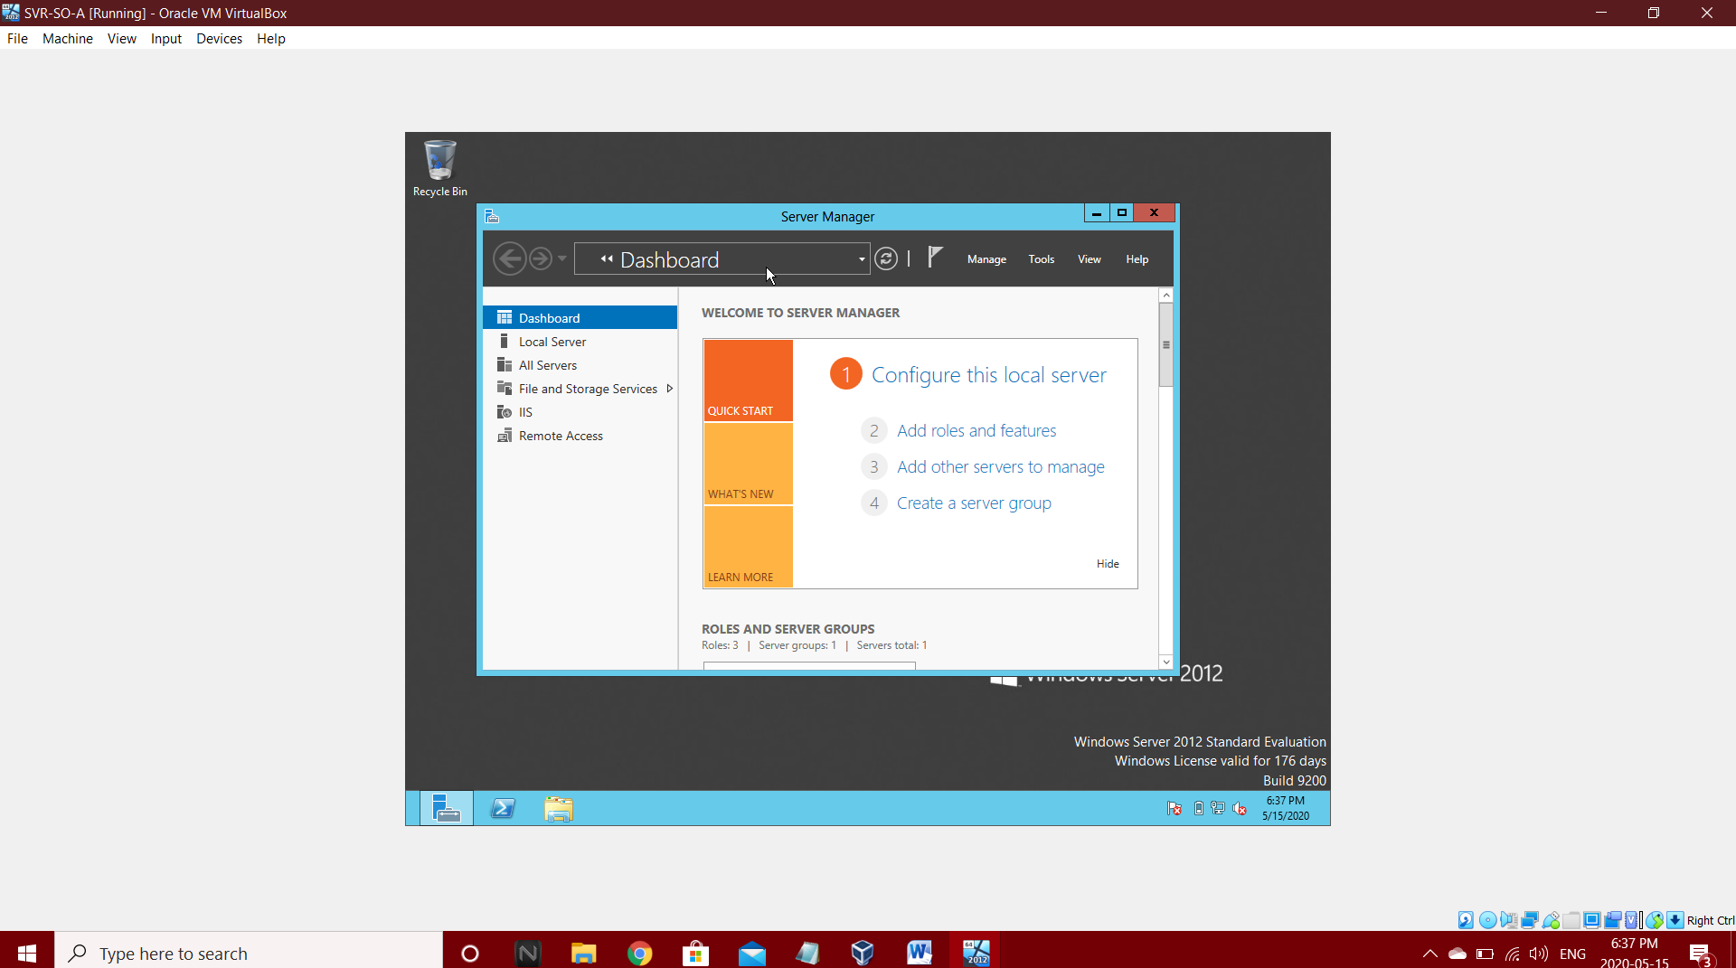Step 1: Go to Dashboard and select Add roles and features

Step 2: Setup Add Roles and features (Before you begin)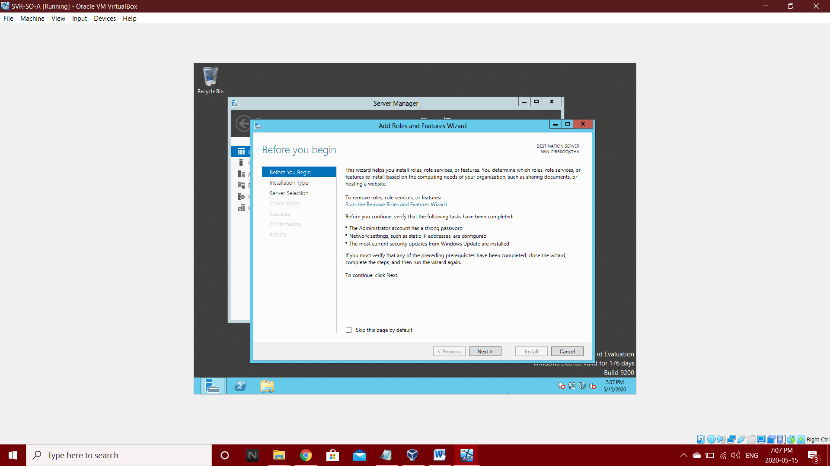

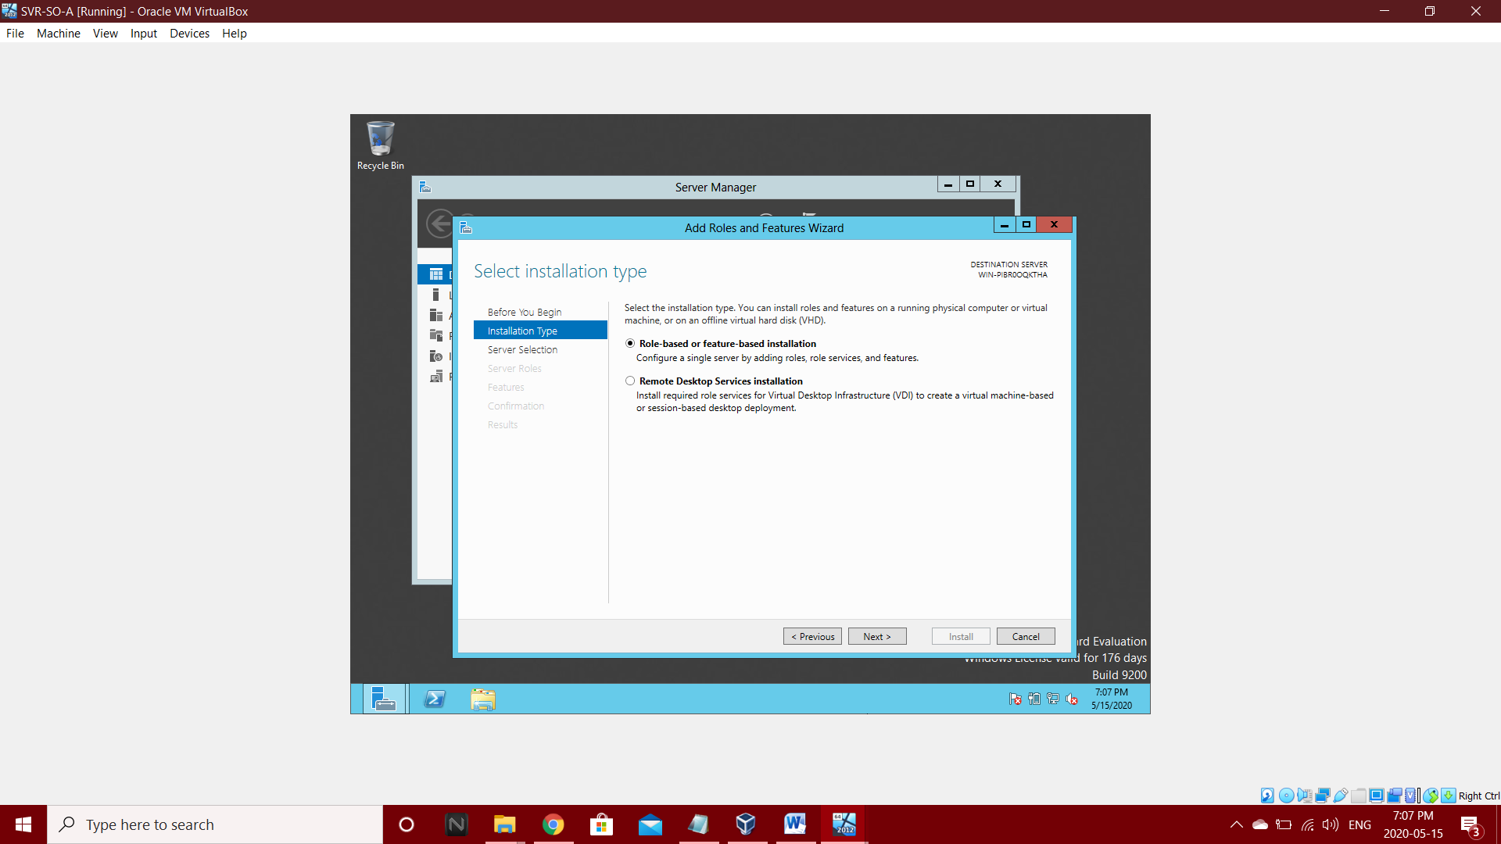Step 3: Select Role-based and press next

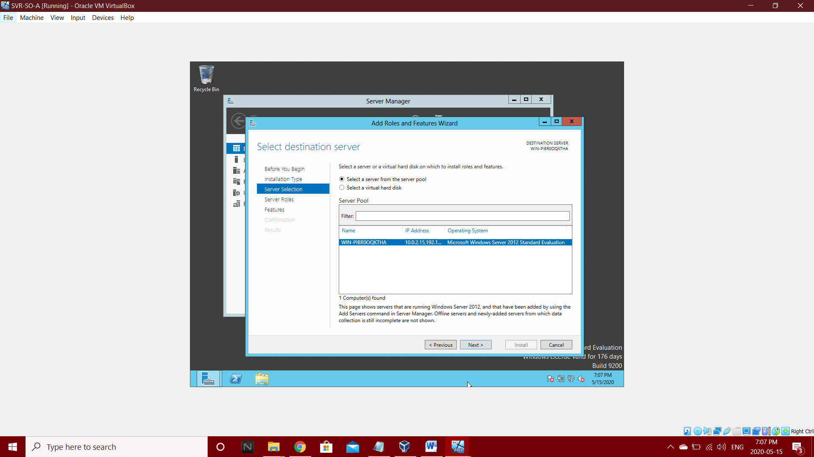Step 4: Select a server from the server pool and press next

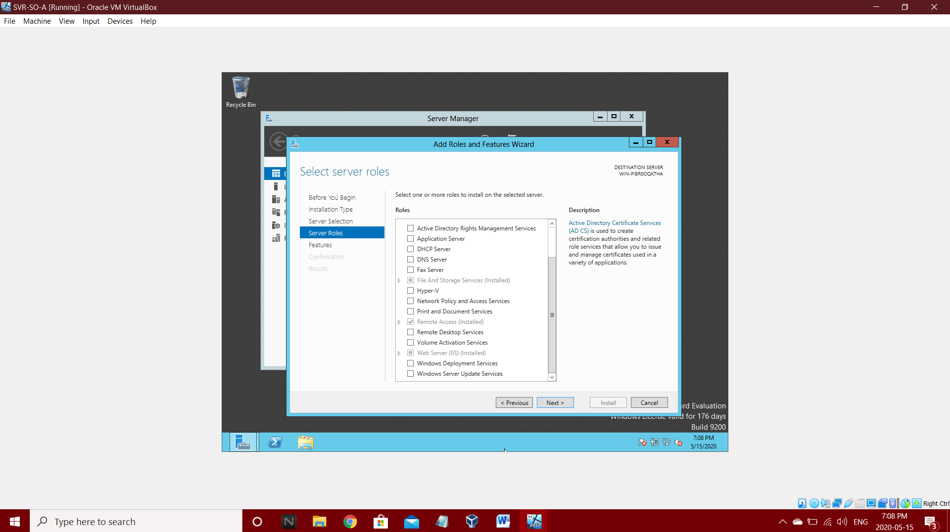Step 5: Select Next

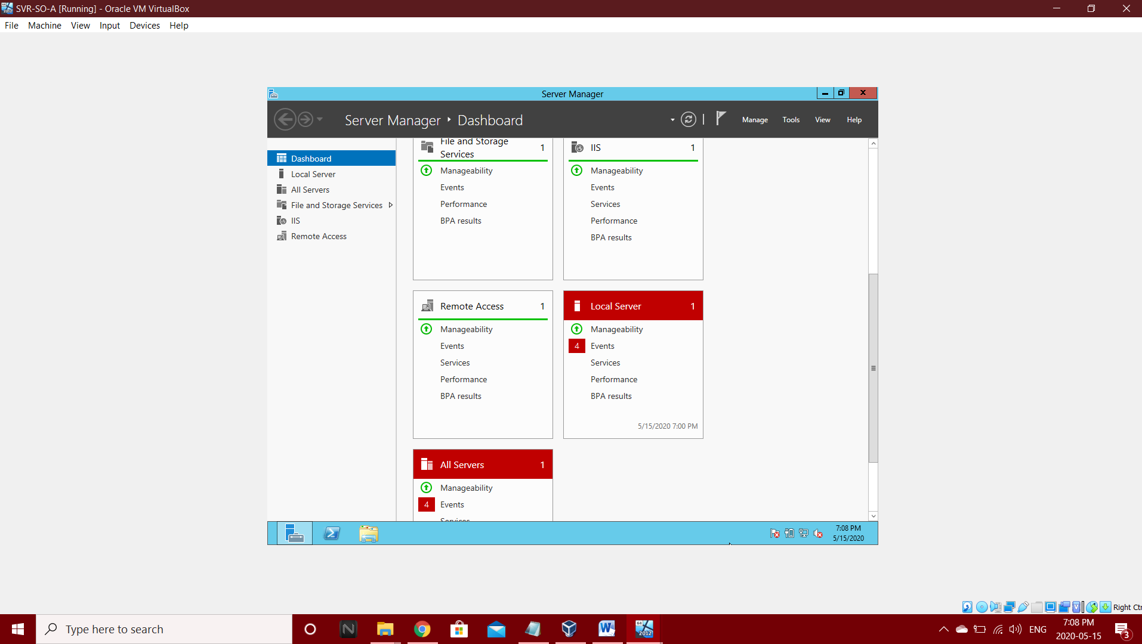Step 6: Competed Dashboard

Step 7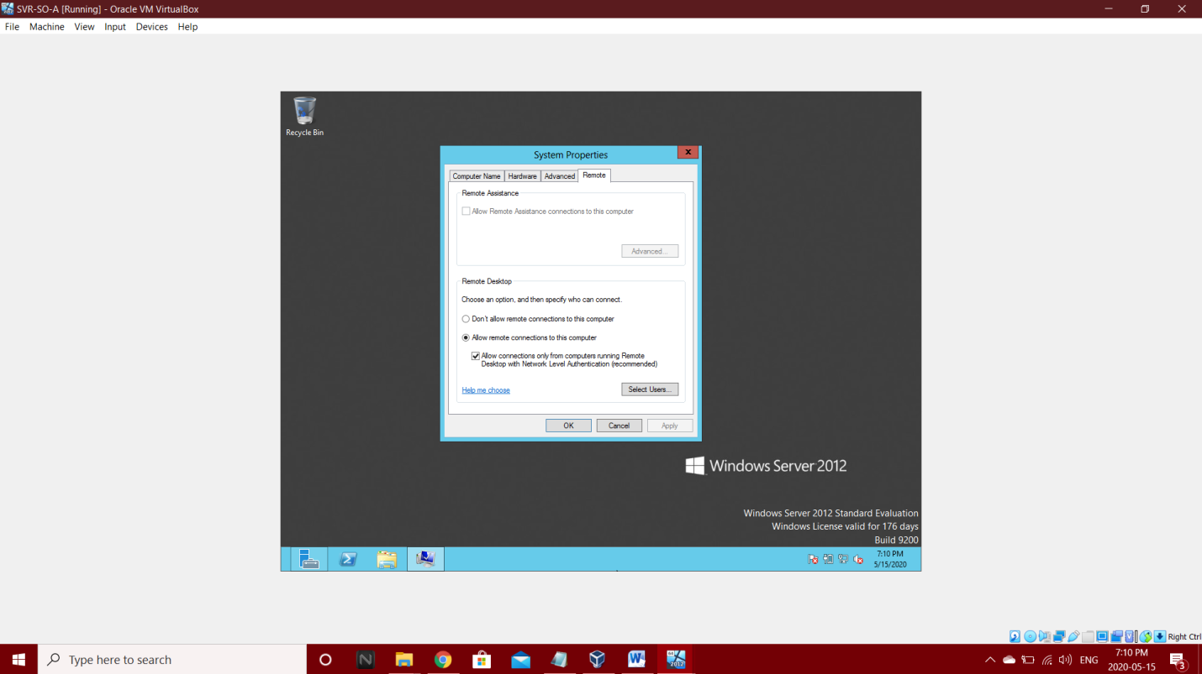: Allow remote connections

**3.2.1.2 Add Inbound Rules**

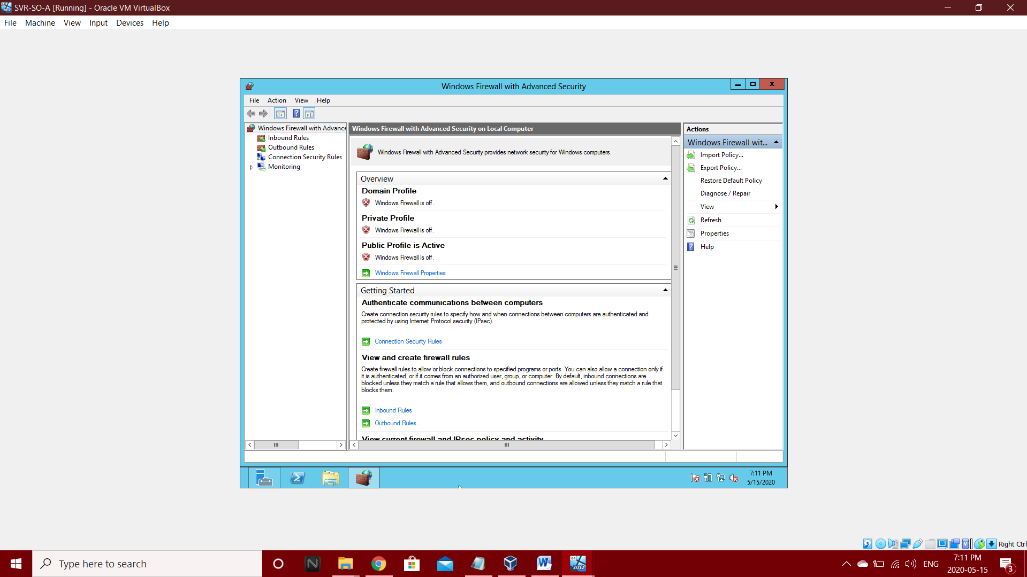Step 1: Inbound Rules

Step 2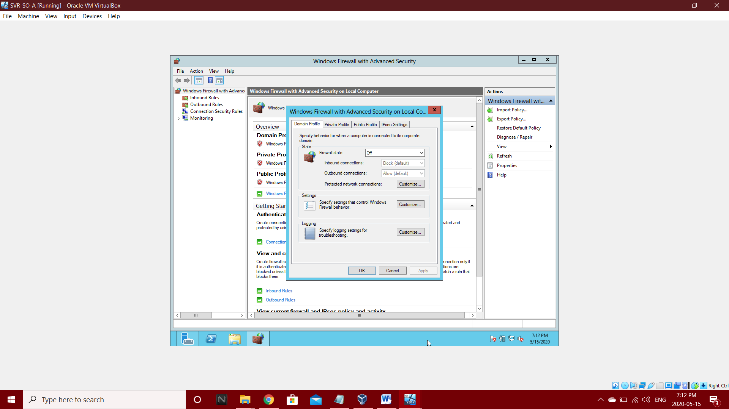: select Ok in Domain Profile

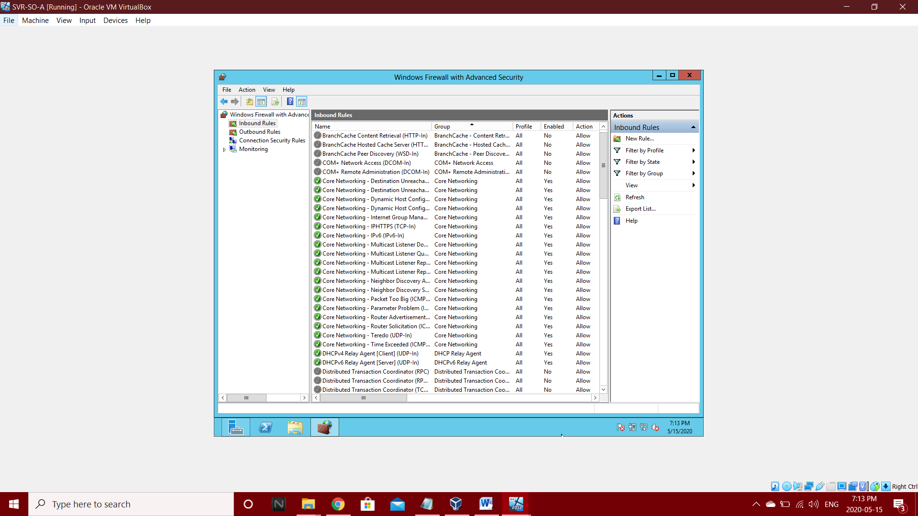Step 3: Select Inbound Rules

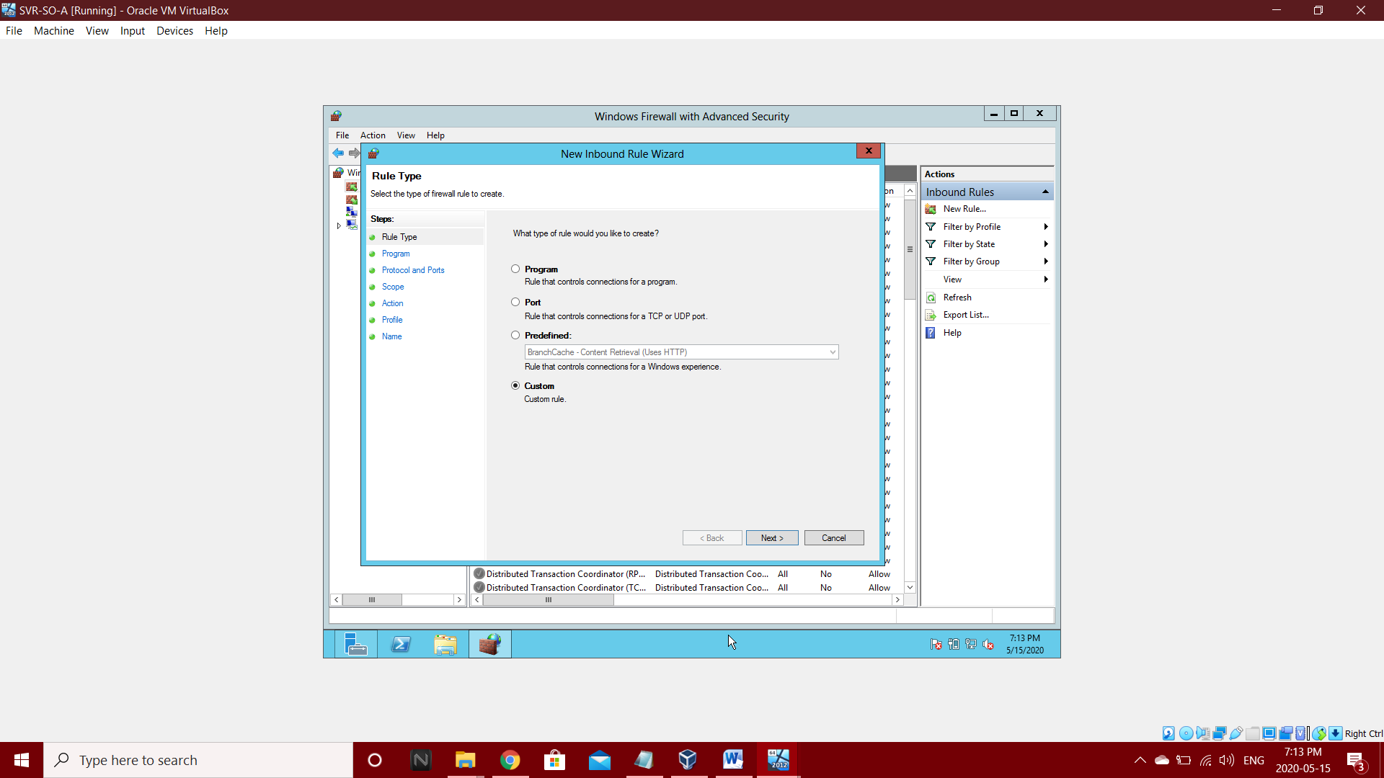Step 4: Select New Inbound Rule and select Custom

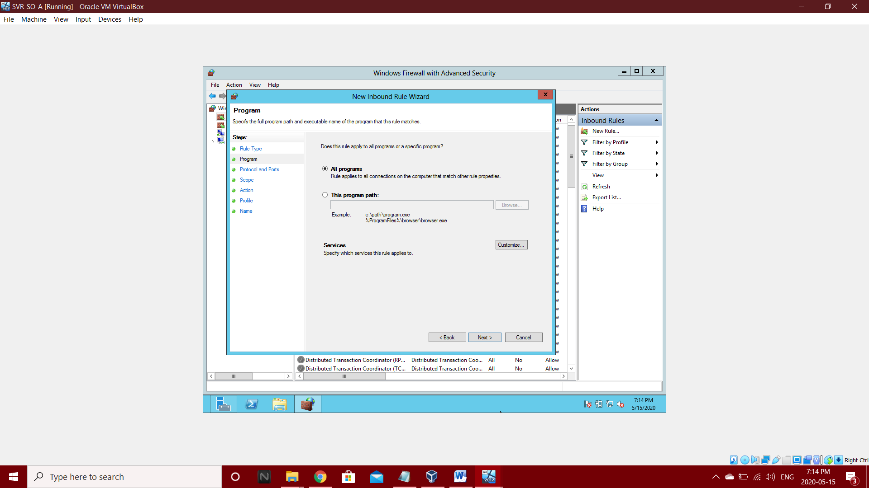Step 5: Select all programs and go to Next

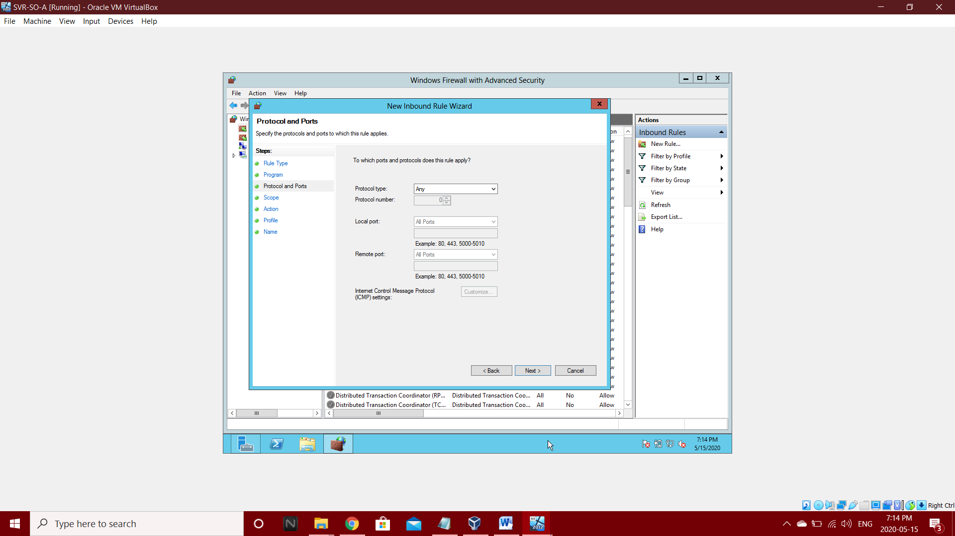Step 6: Go to Next in Protocol and ports

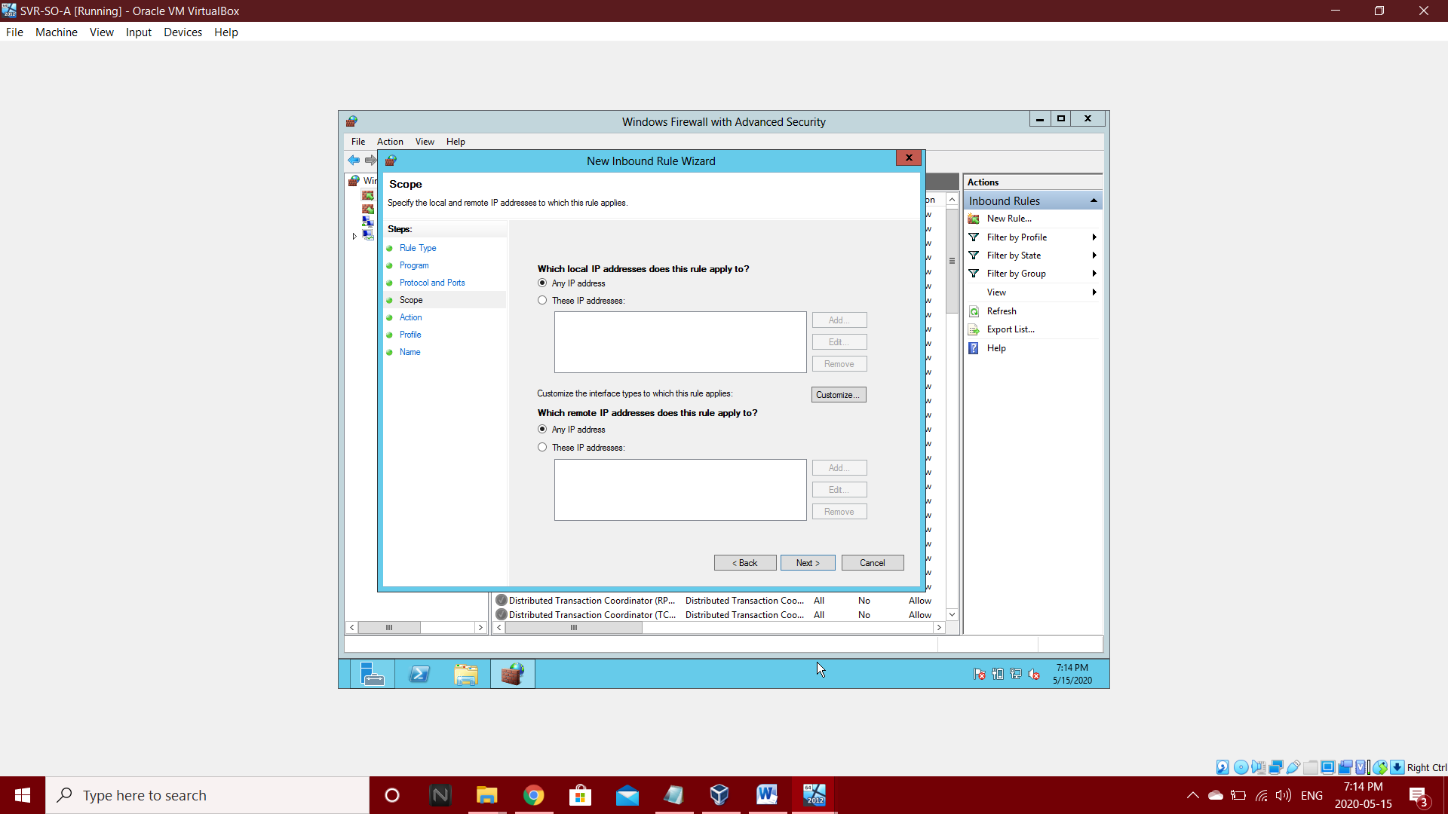Step 7: Select Any IP Address in Scope and go for Next.

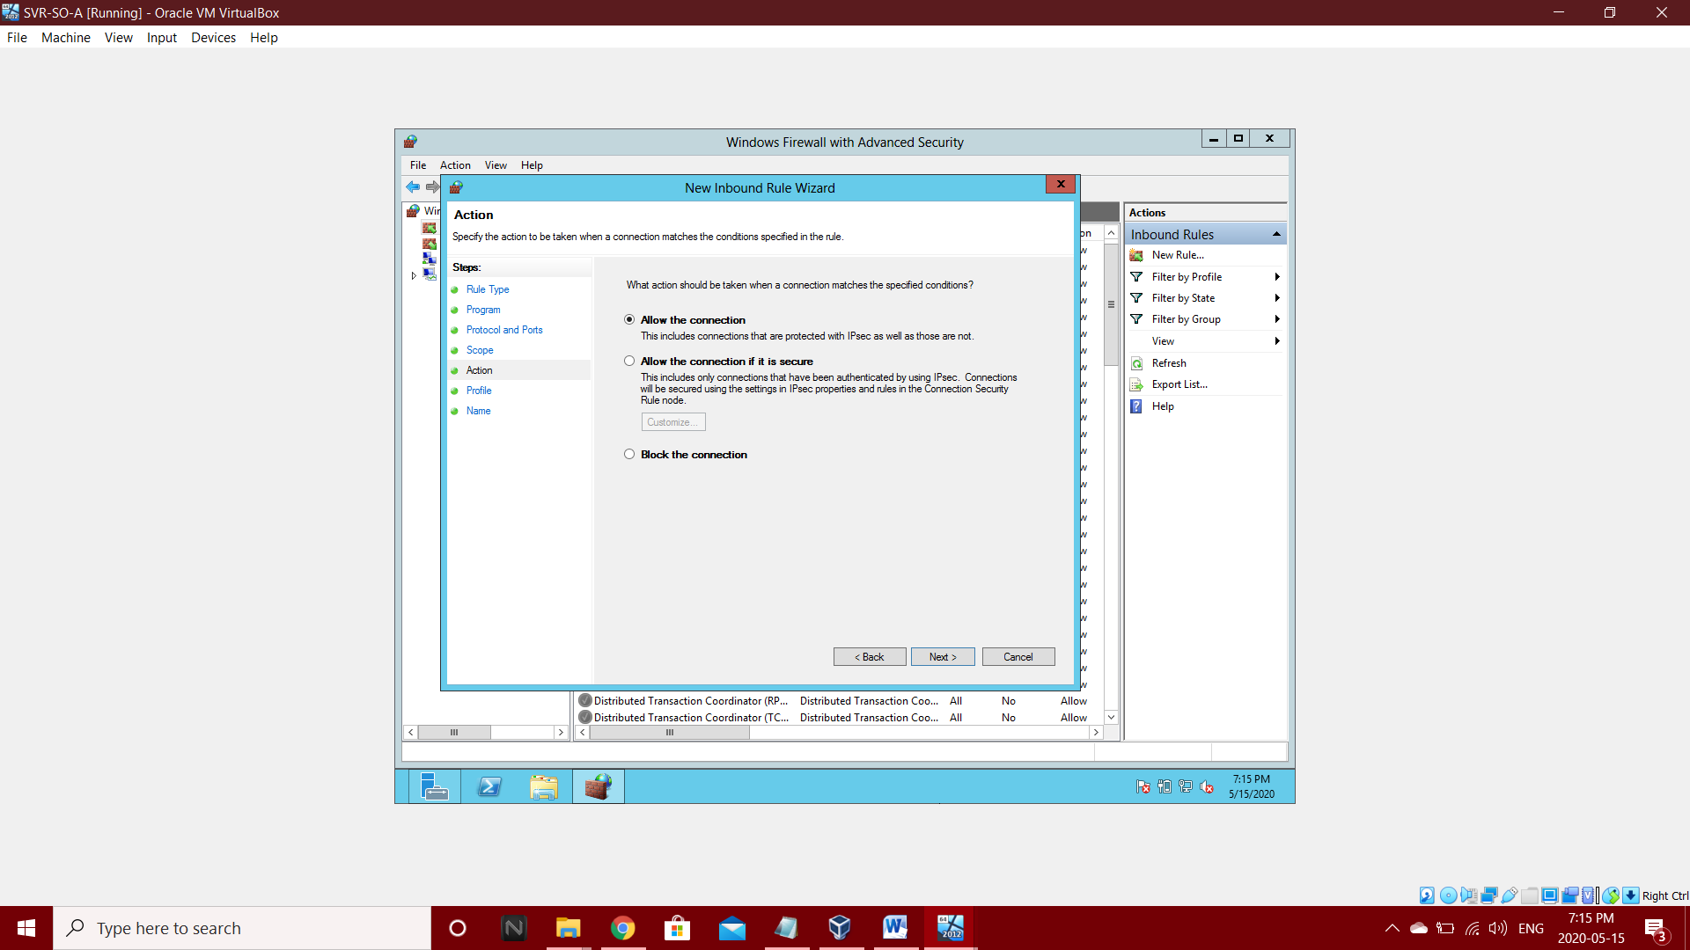Step 8: Select allow the connections in Action and go to next

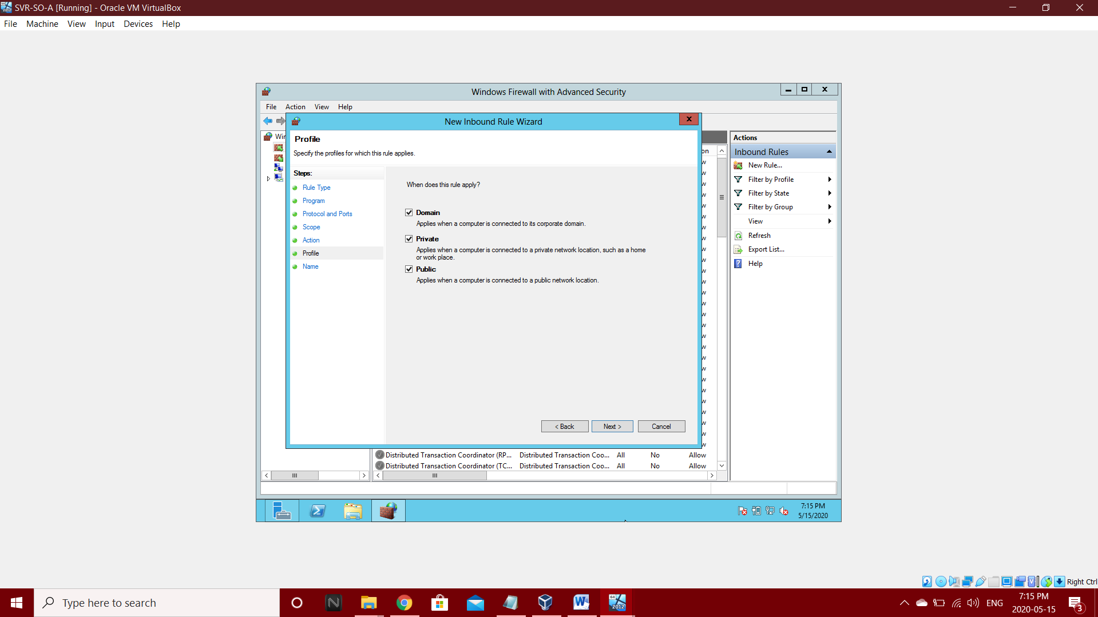Step 9: Select Domain, Private, and Public in profile and go to next.

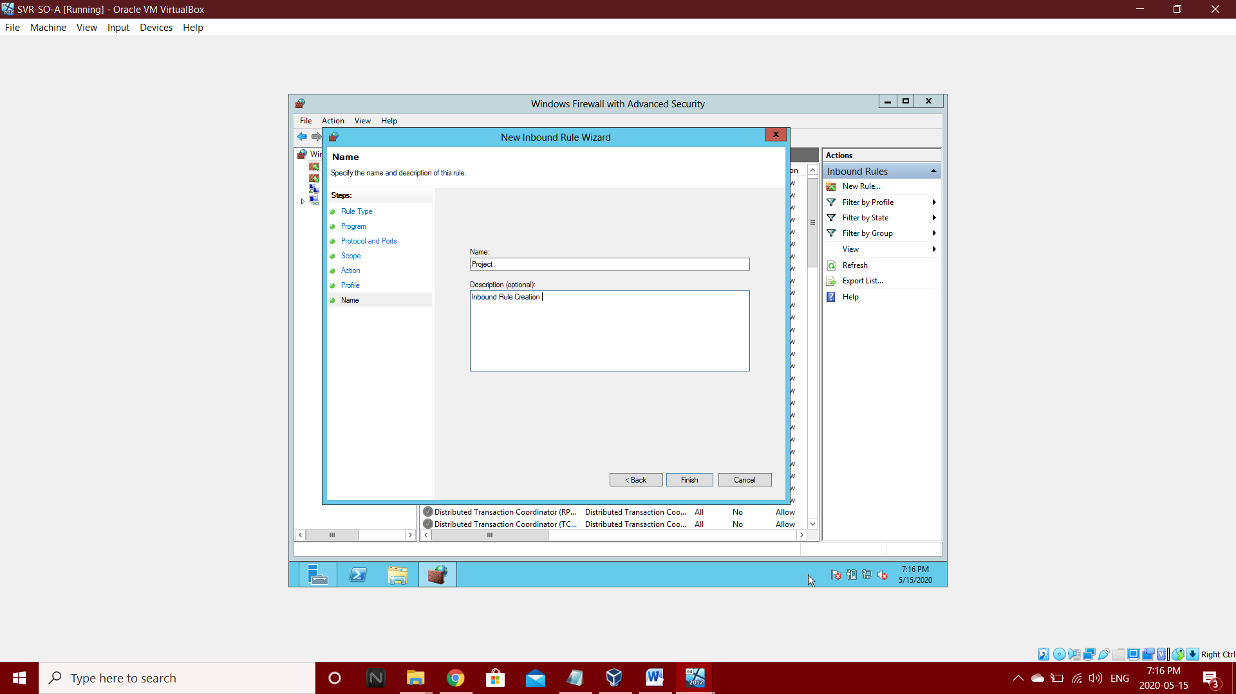Step 10: Create Name Project and then Finish

**3.2.1.3 Add Outbound Rules:**

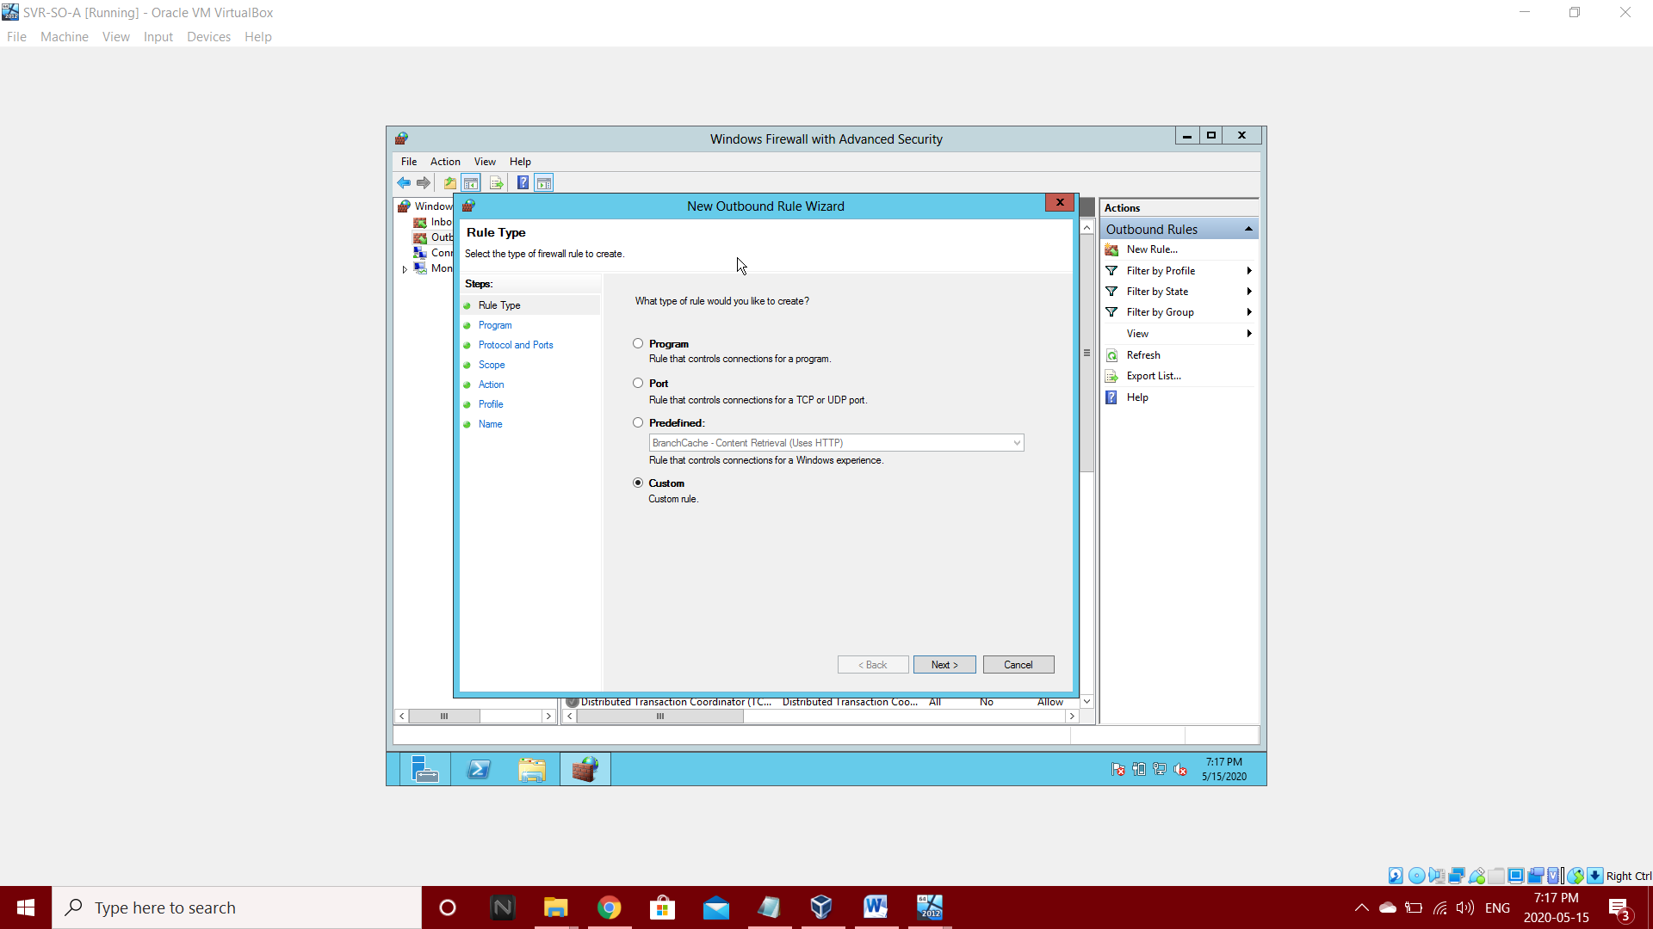Step 1: Go to Outbound Rules and select custom

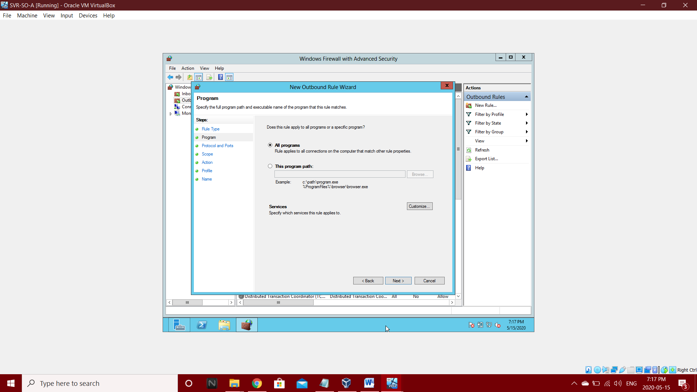Step 2: In program select all program and go to Next

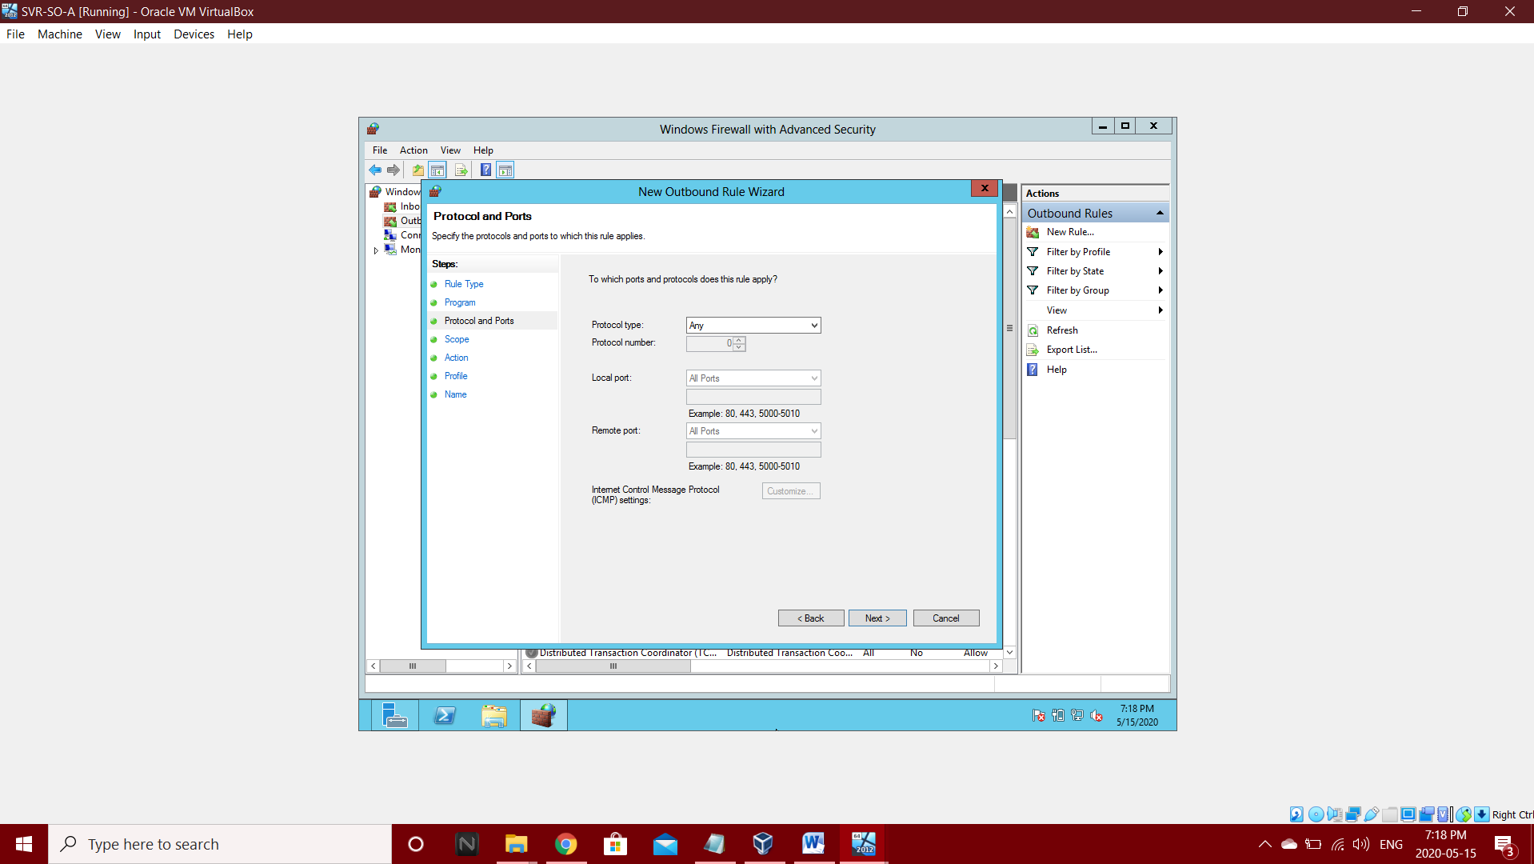Step 3: Go to next in protocol and ports

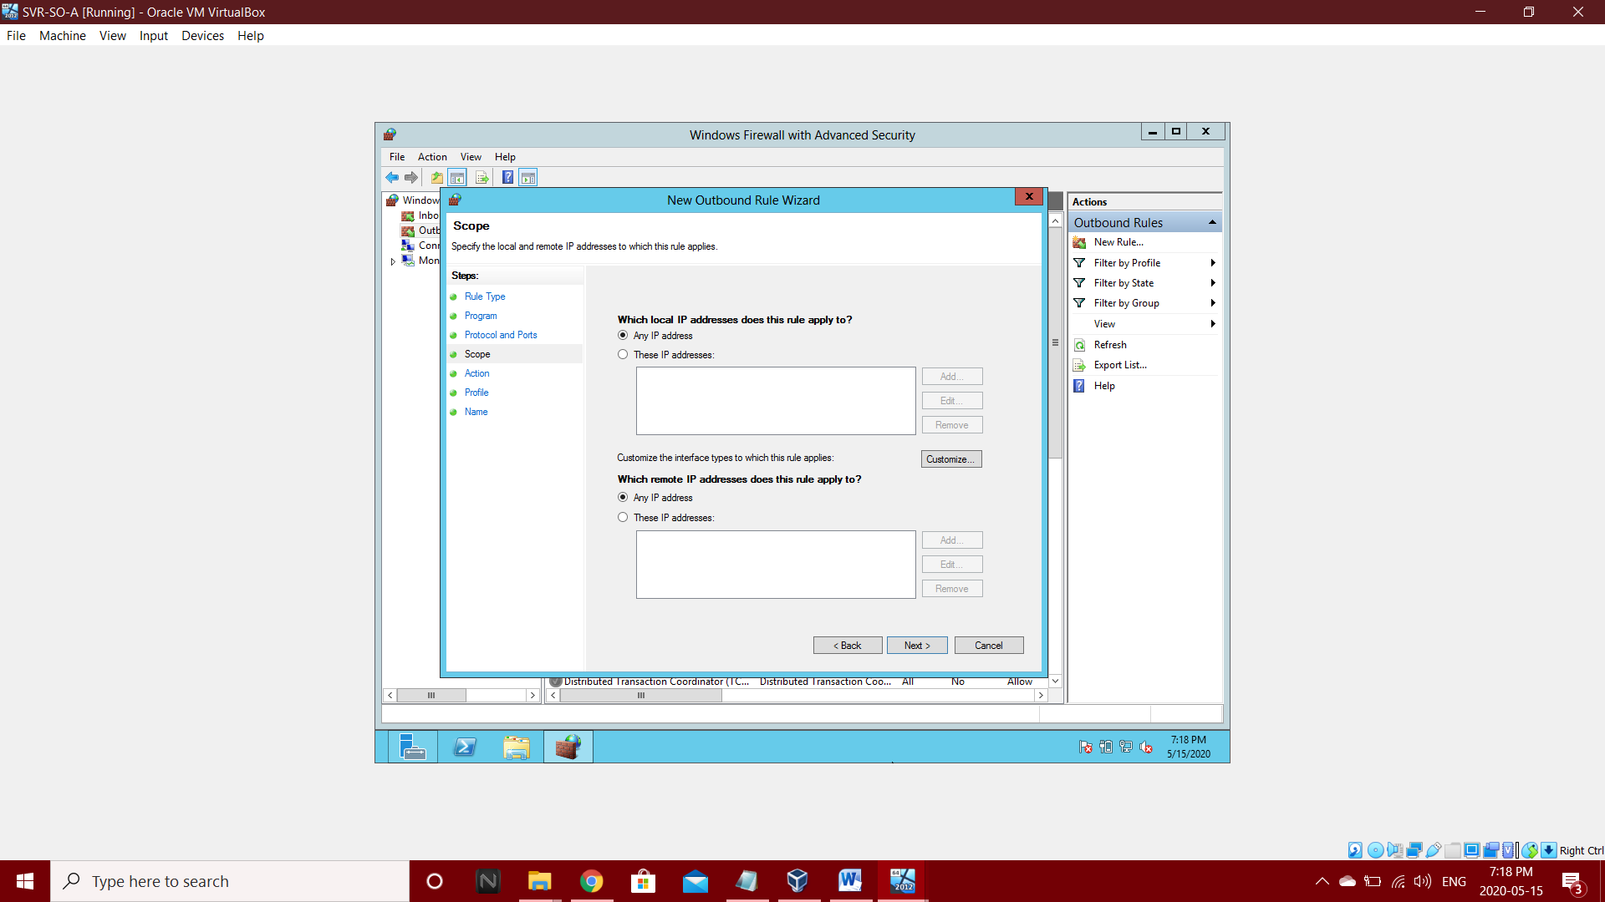Step 4: In Scope Select Any IP address and go to next

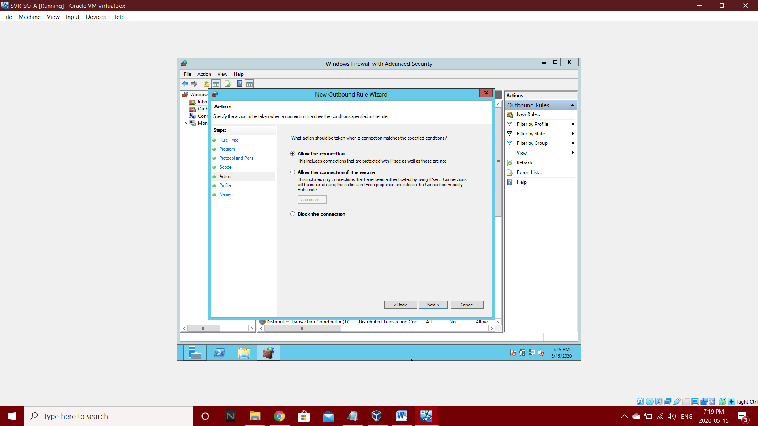Step 5: Allow the connection in action and go for next.

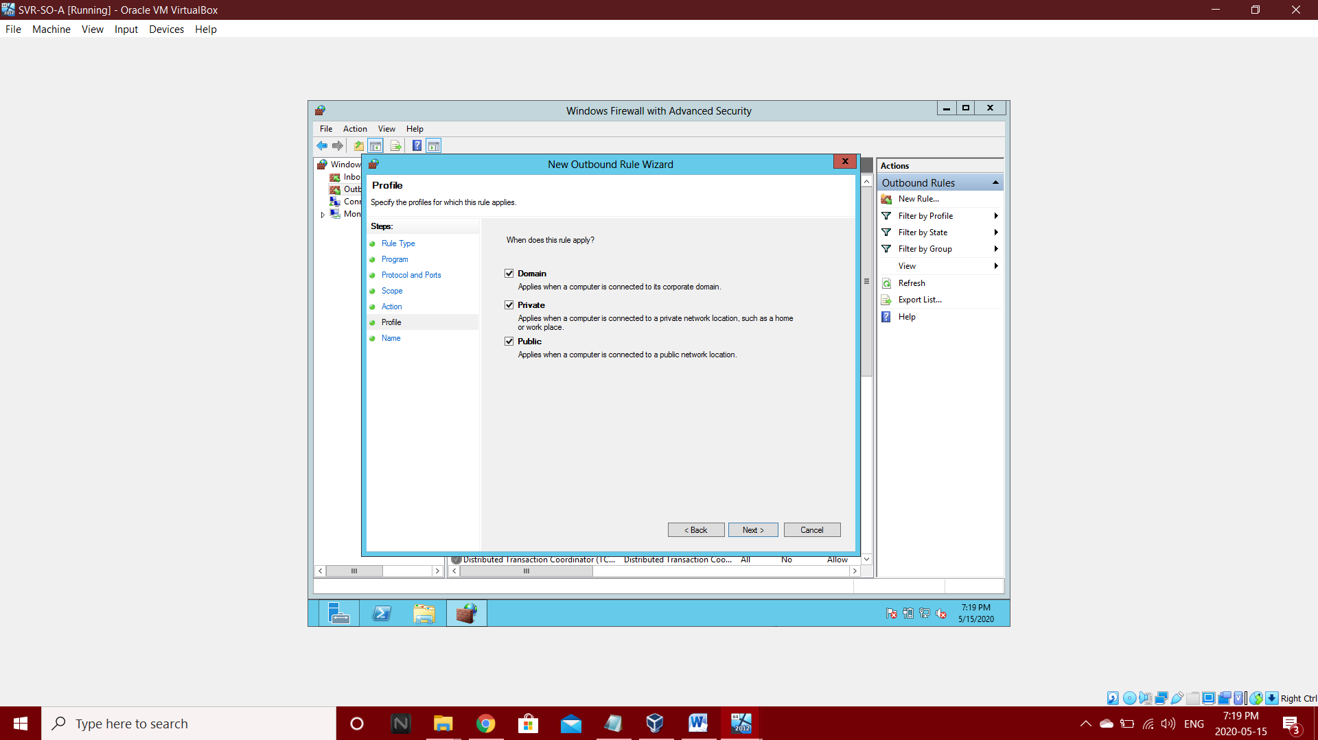Step 6: select Domain, Private and Public in Profile

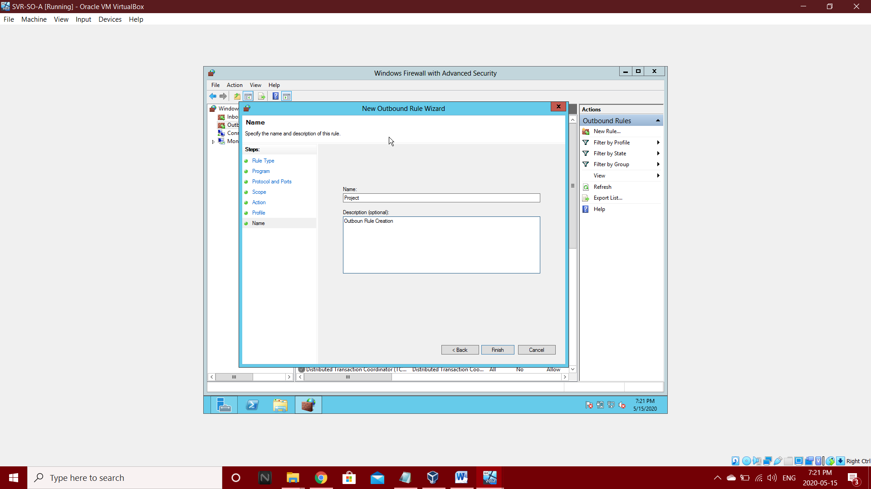Step 7: Create Name Project and then Finish

**3.2.1.4 Add Routing and Remote Access:**

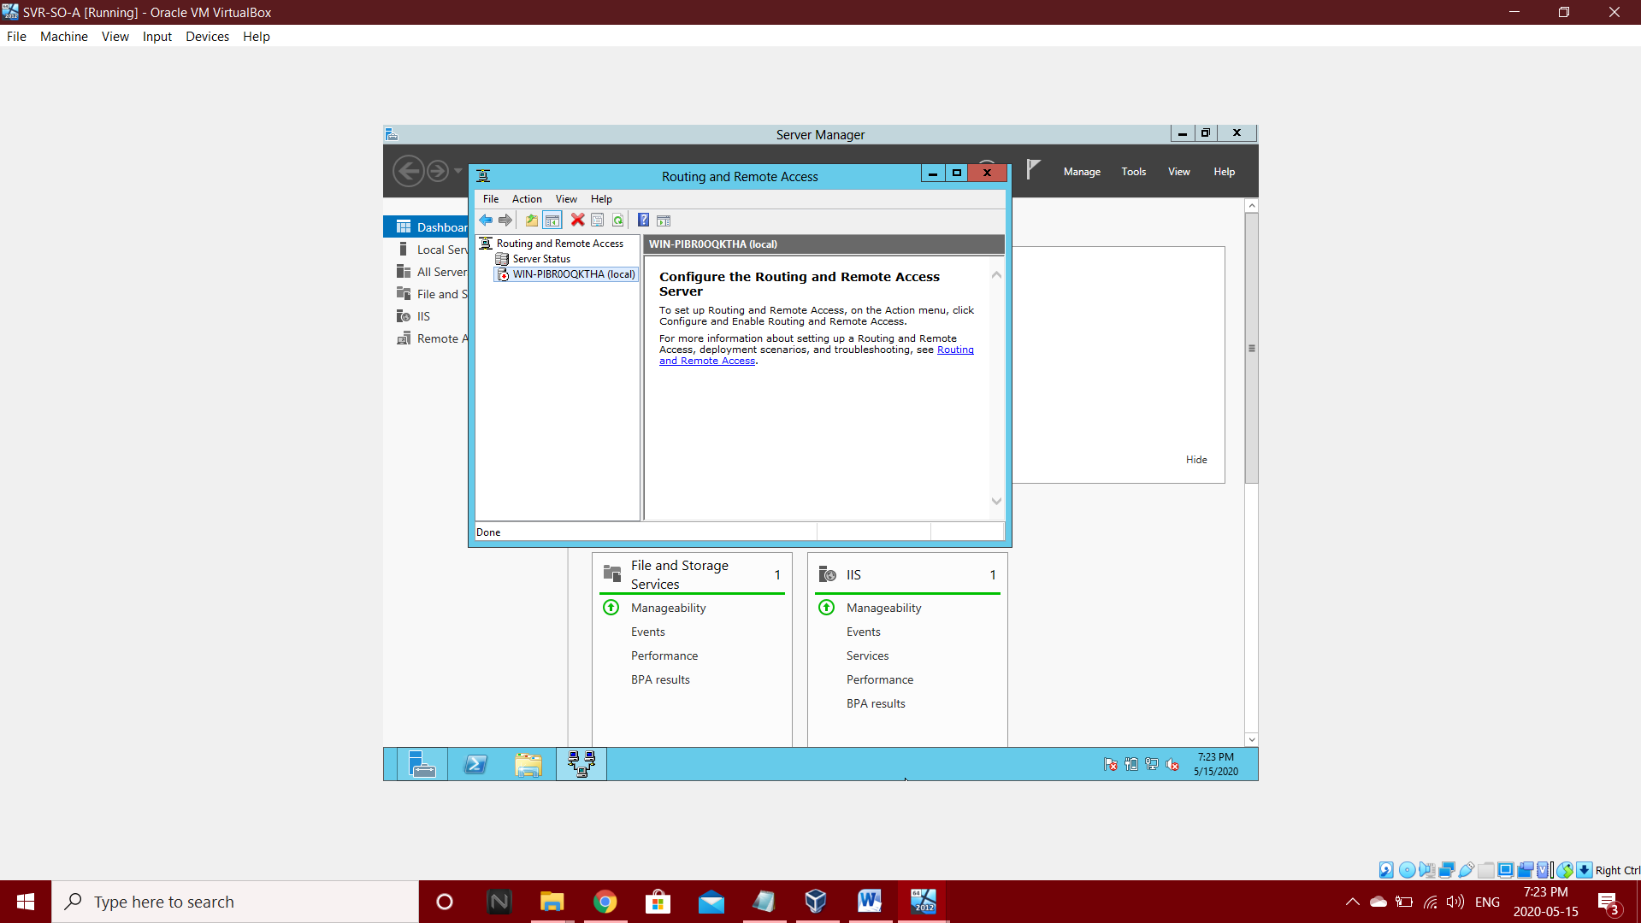Step 1: Go to Routing and Remote Access

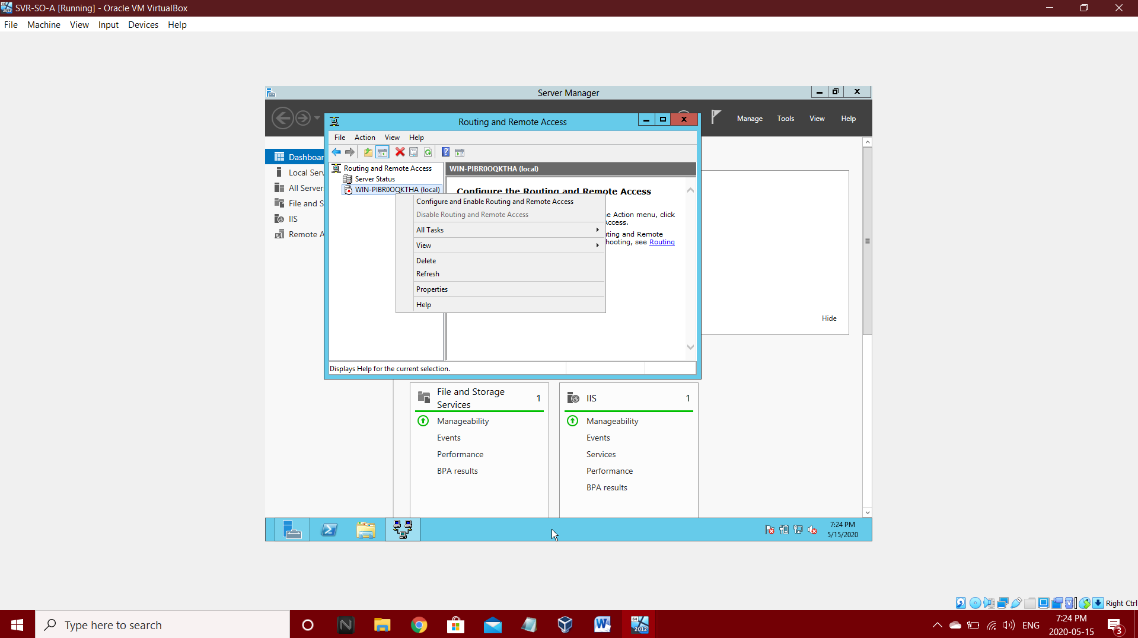Step 2: Select WIN-PIBR0QKTHA and press right click

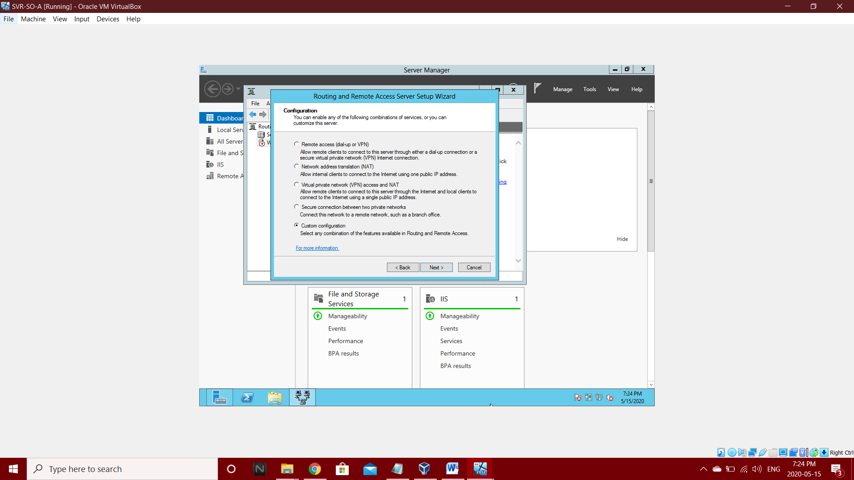Step 3: Go to Configuration and select custom Configuration

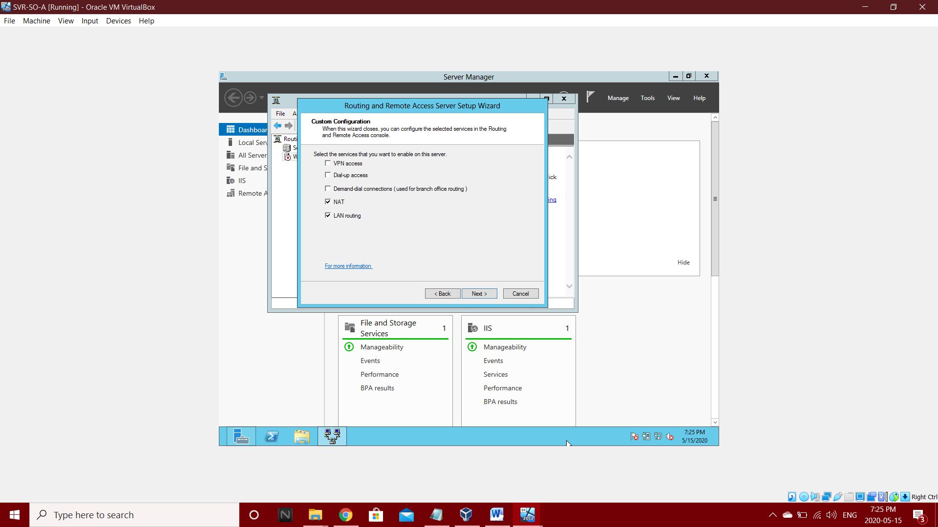

Step 4: In Custom Configurations select NAT, LAN routing.

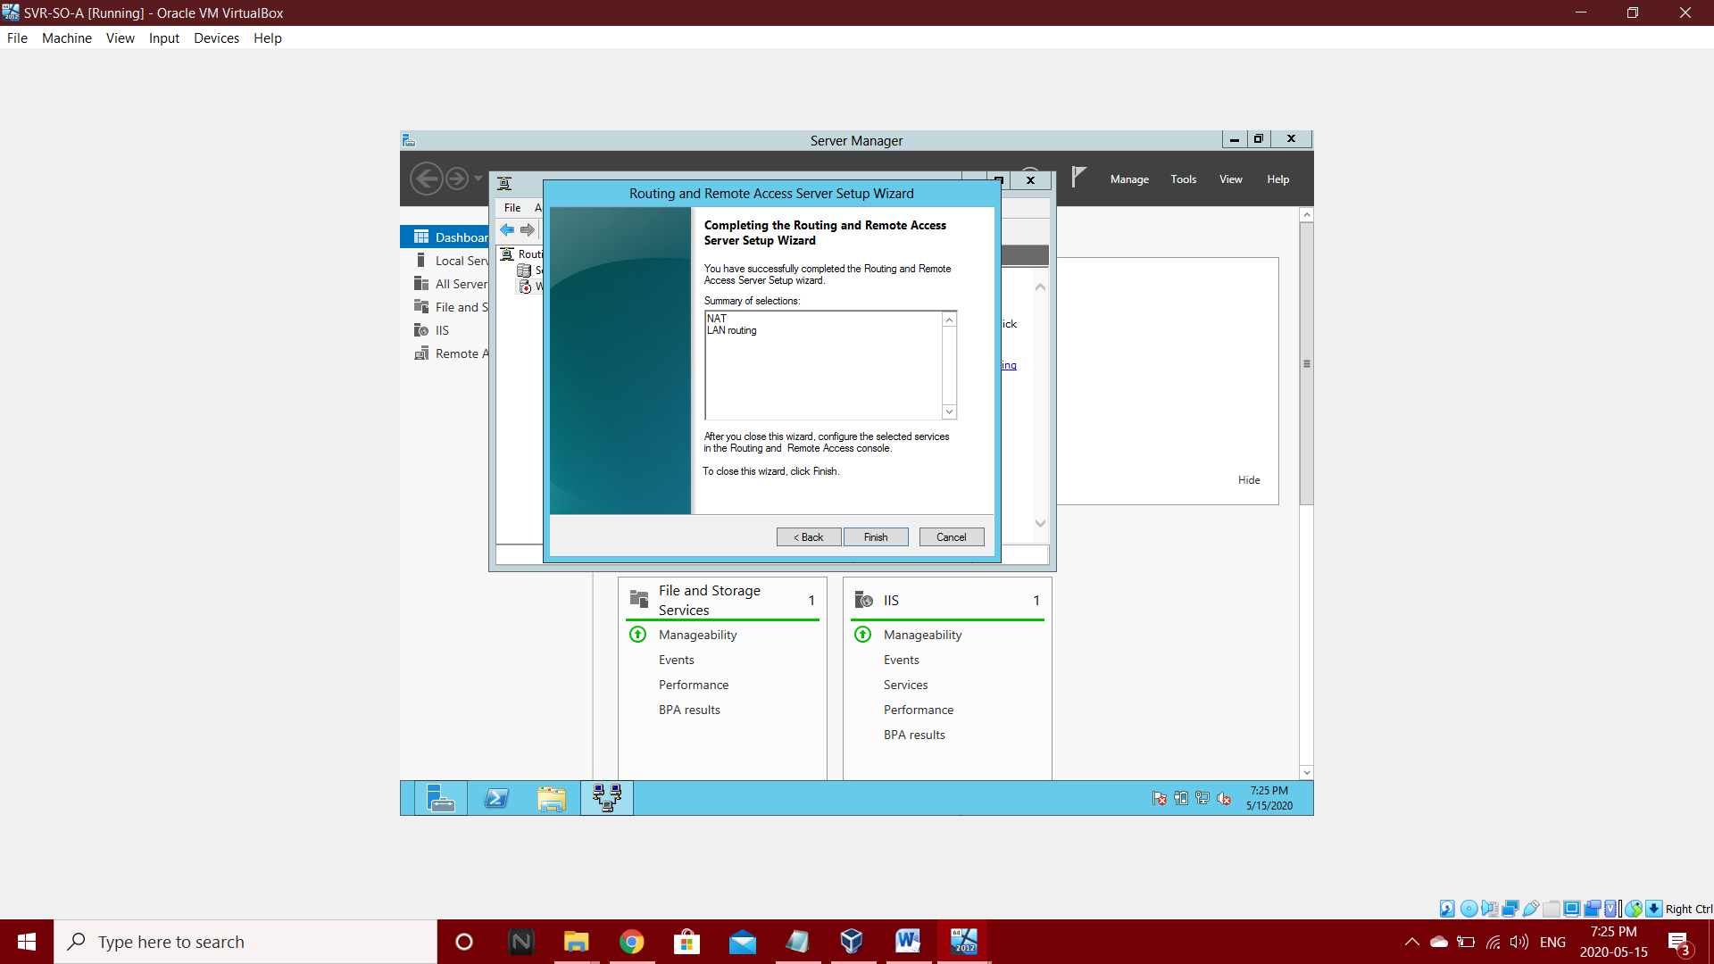Step 5: After completing the Routing and Remote Access and Go to select.

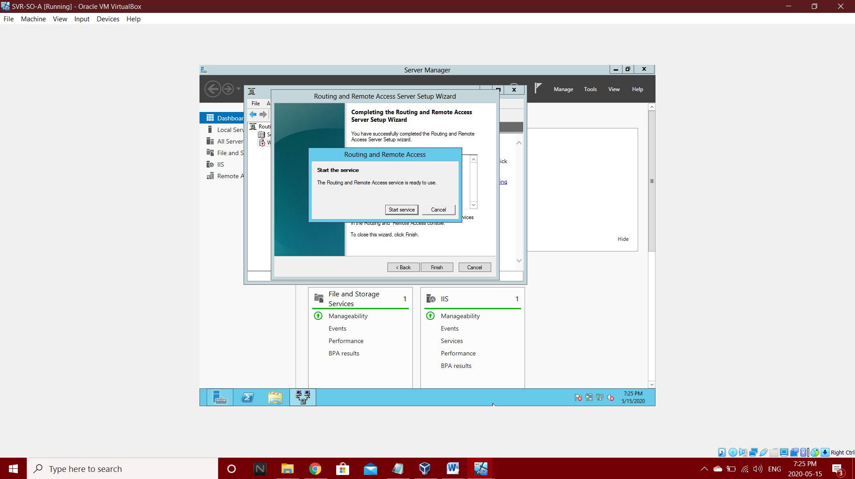Step 6: Start the service and select start service.

Step 7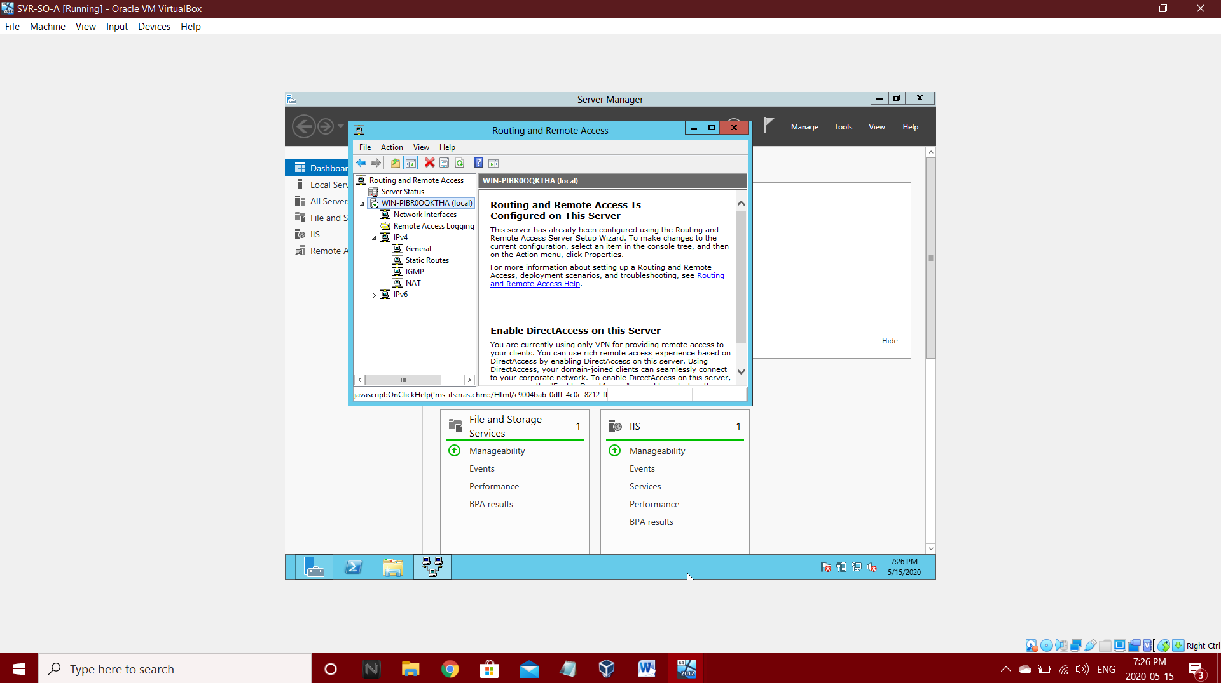: Go to IPv4 and select NAT

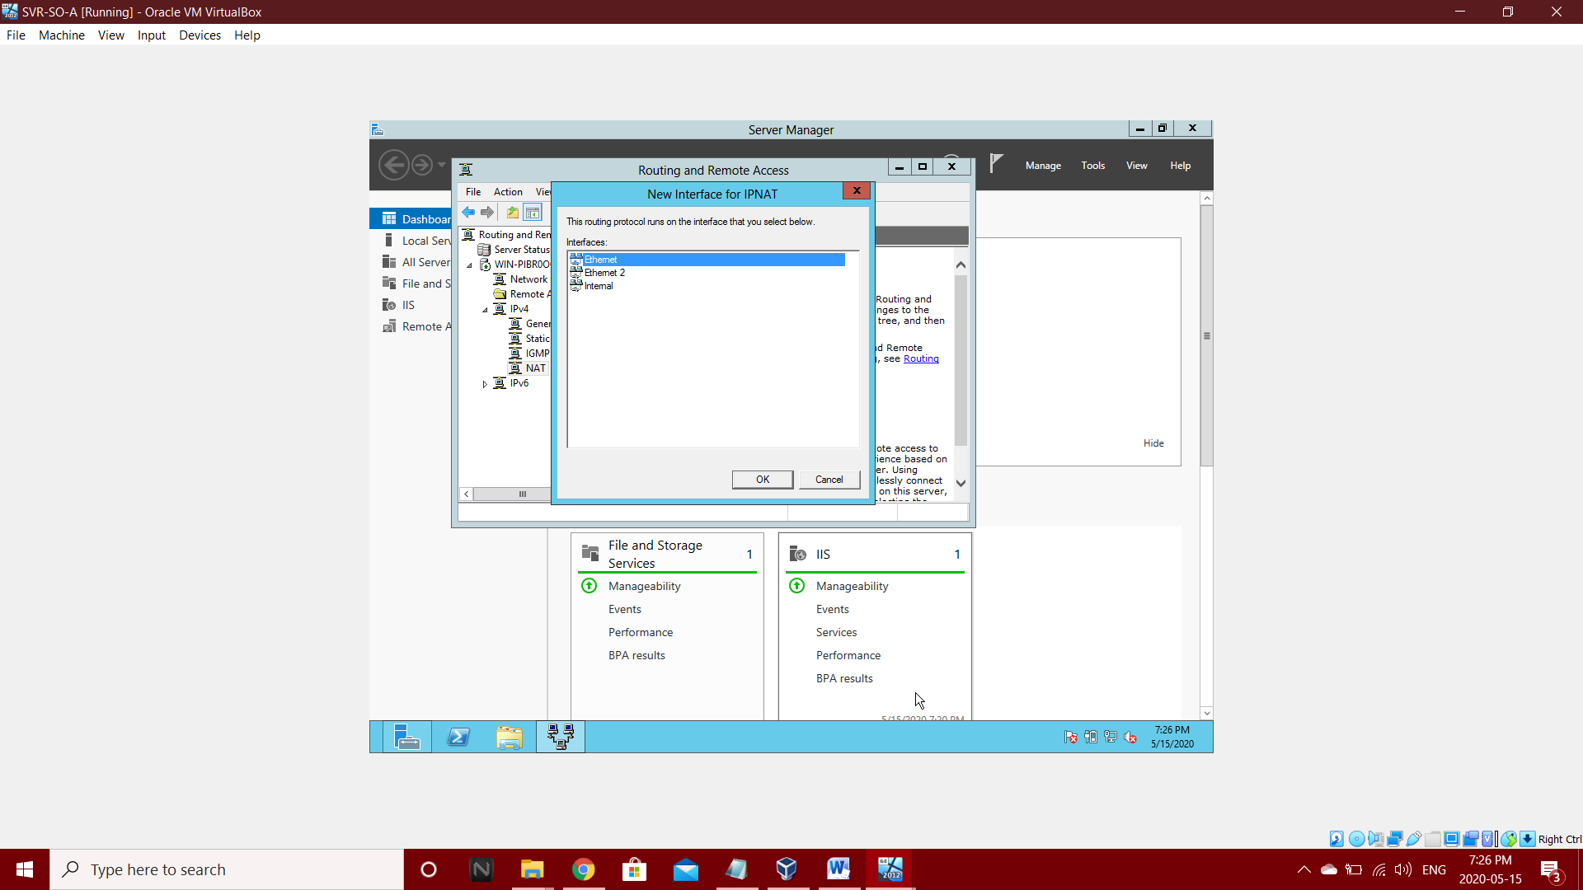Step 8: Select Ethernet and select OK

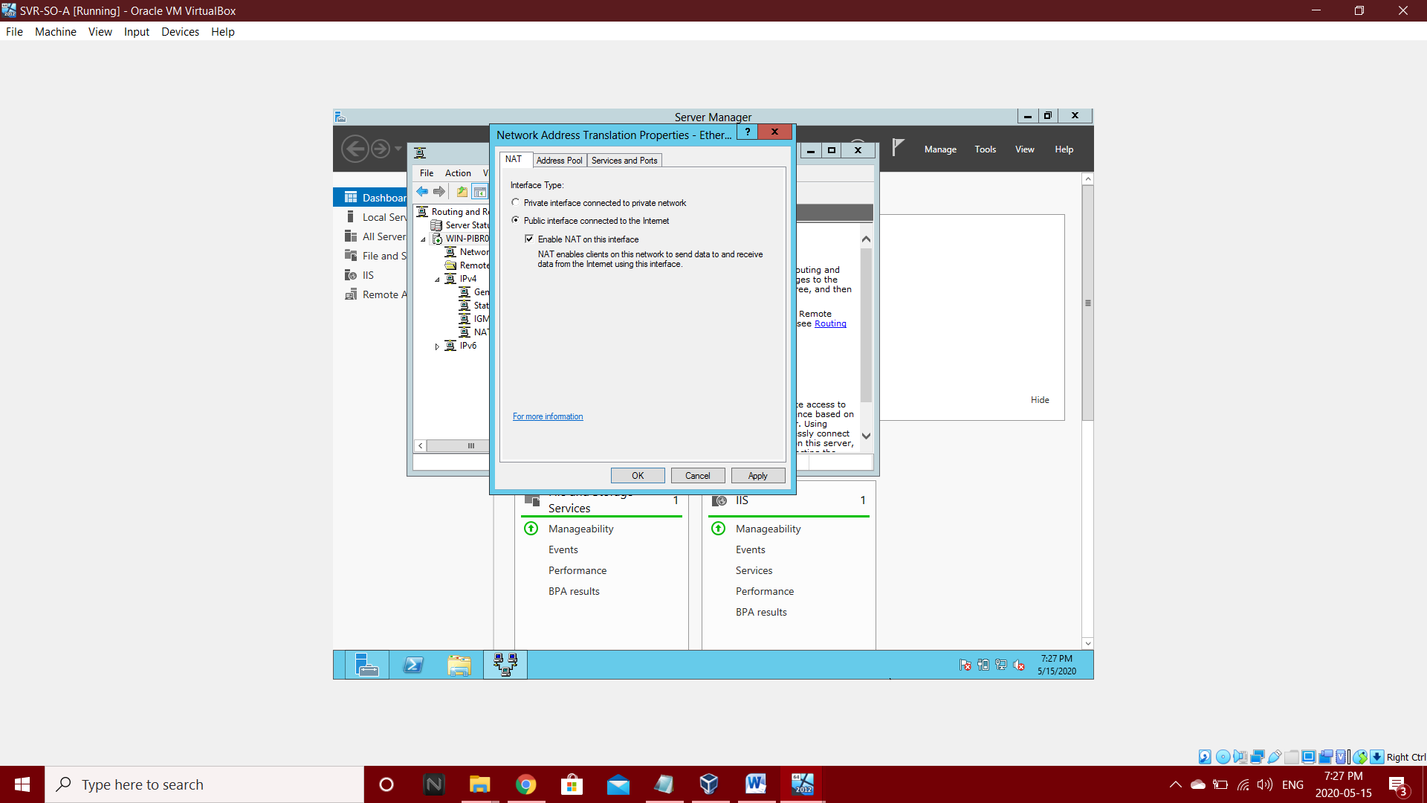Step 9: In NAT Select Public interface and also enable NAT on this internet.

**3.2.2 Network Setup and Configurations of Web-Server (SVR-WS-A)**

As we did in SVR-SO-A same we should in SVR-WS-A too

**3.2.2.1 Add Roles and Features**

As we did in SVR-SO-A same we should in SVR-WS-A too

**3.2.2.2 Add Inbound Rules**

As we did in SVR-SO-A same we should in SVR-WS-A too

**3.2.2.3 Add Outbound Rules**

As we did in SVR-SO-A same we should in SVR-WS-A too

**3.2.2.4 Add Routing and Remote Access**

As we did in SVR-SO-A same we should in SVR-WS-A too

**Chapter 4: Network Utility**

**4.1 Ping Operations in Router**

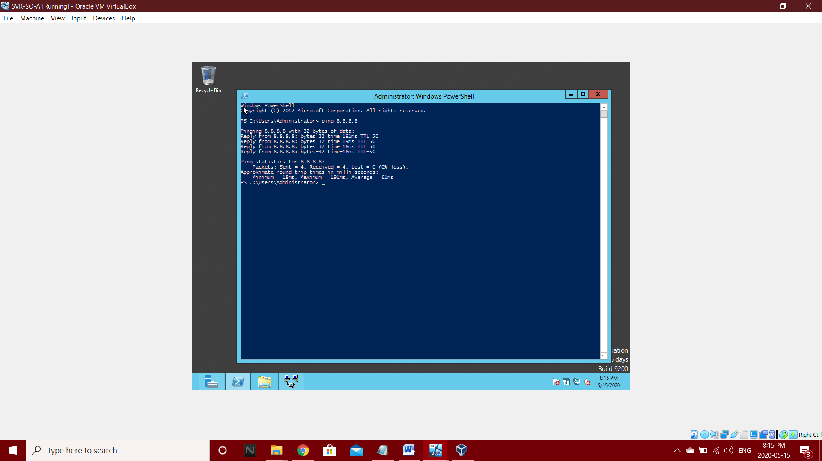1) PING 8.8.8.8 for internet connection.

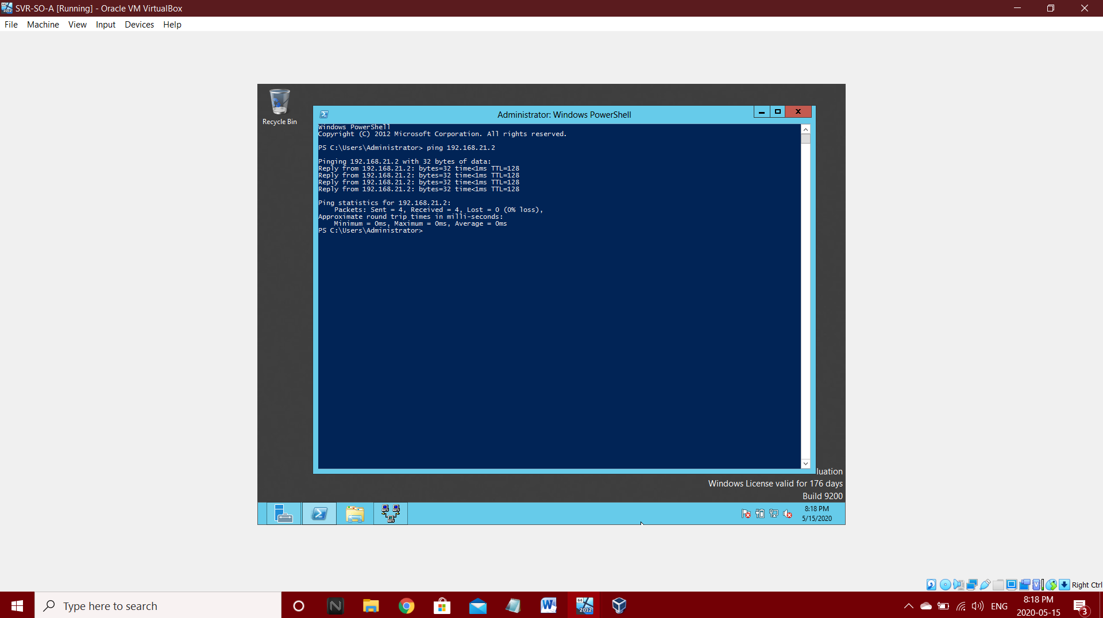2) PING SVR-WS-A (192.168.21.2) from SVR-SO-A (192.168.21.1)

3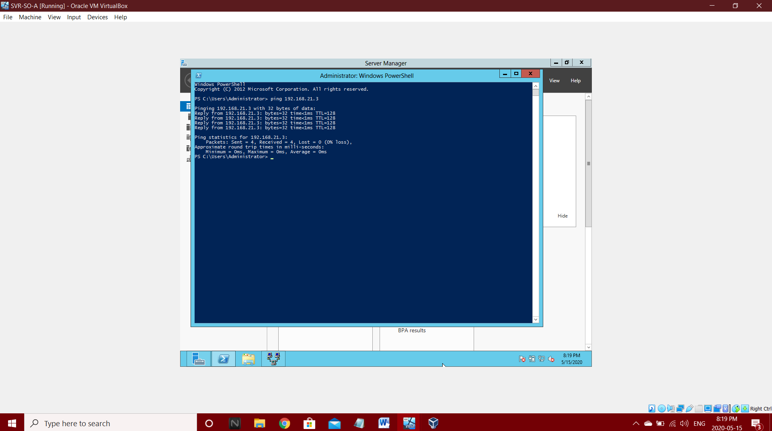) PING Client Machine (192.168.21.3) from SVR-SO-A (192.168.21.1)

**4.2 Ping Operations in Web-Server**

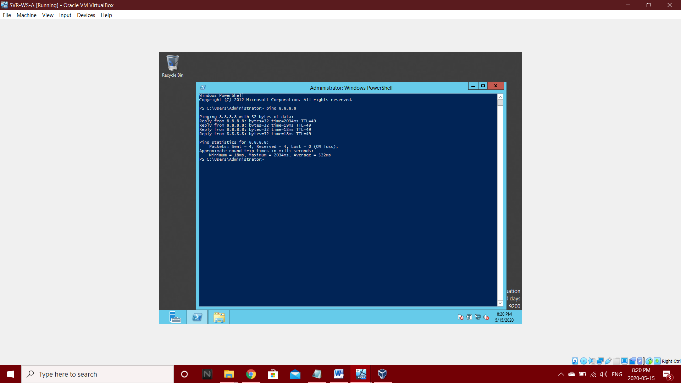1) PING 8.8.8.8 from SVR-WS-A (192.168.21.2)

2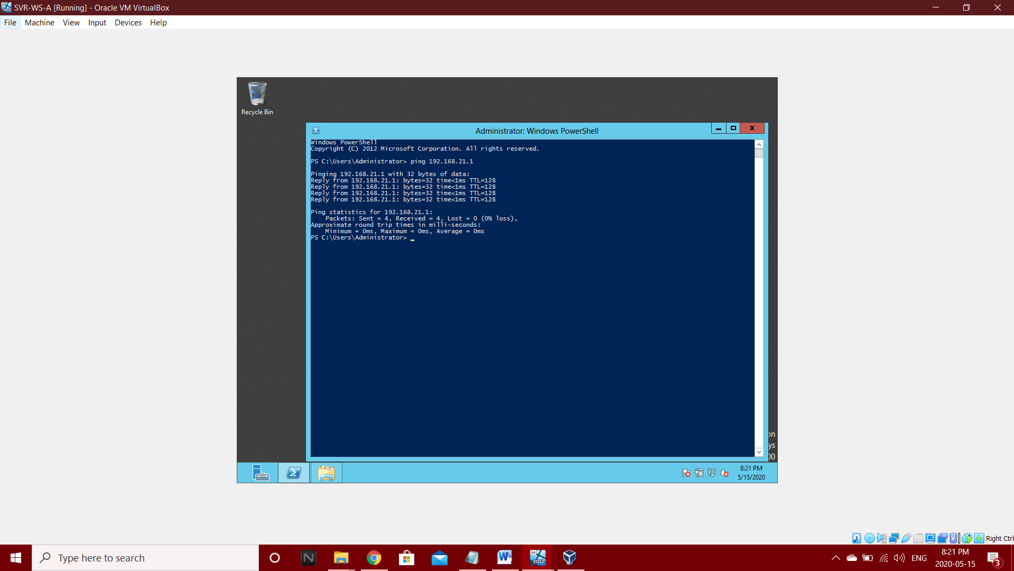) PING SVR-SO-A (192.168.21.1) from SVR-WS-A (192.168.21.2)

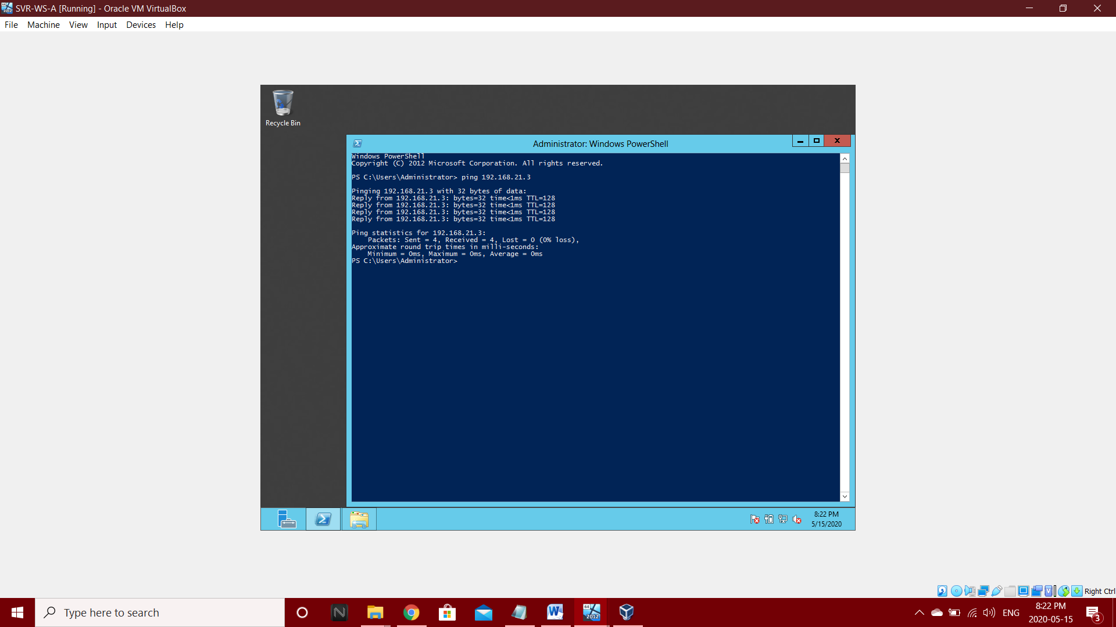3) PING Client Machine (192.168.21.3) from SVR-WS-A (192.168.21.2)

**4.3 Ping Operations in Client Machine**

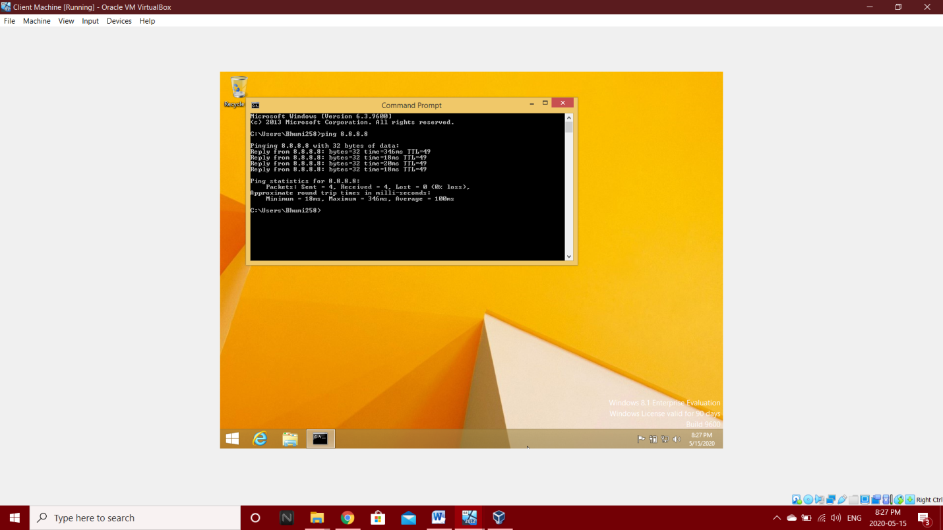1) PING 8.8.8.8 from Client Machine

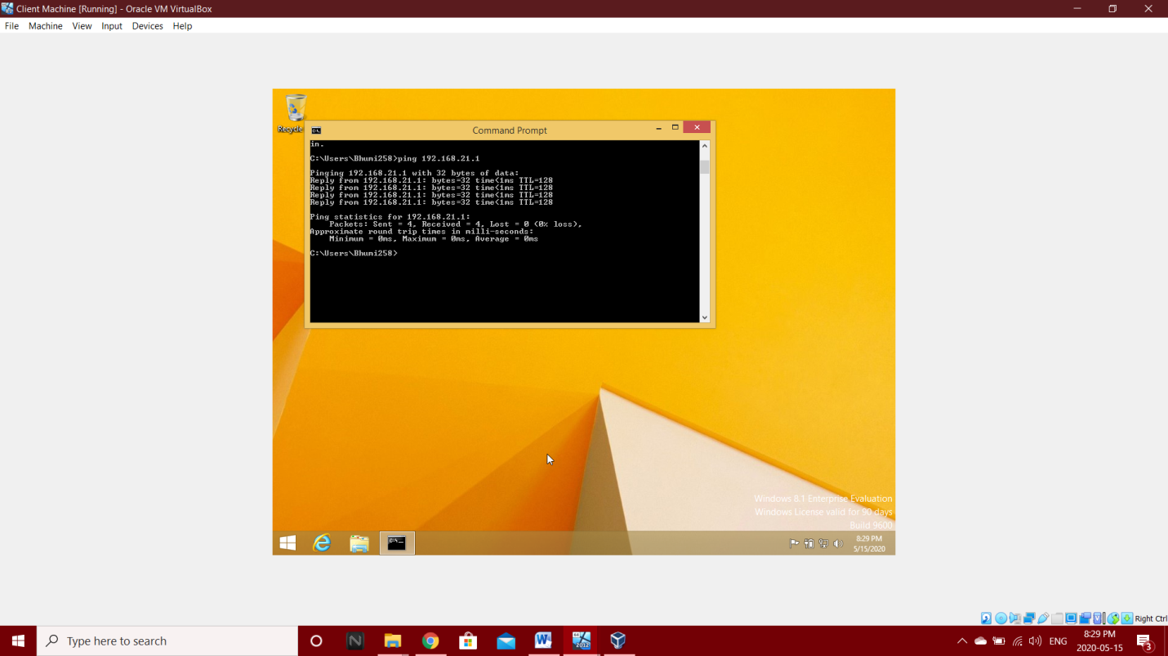2) PING SVR-SO-A (192.168.21.1) from Client Machine

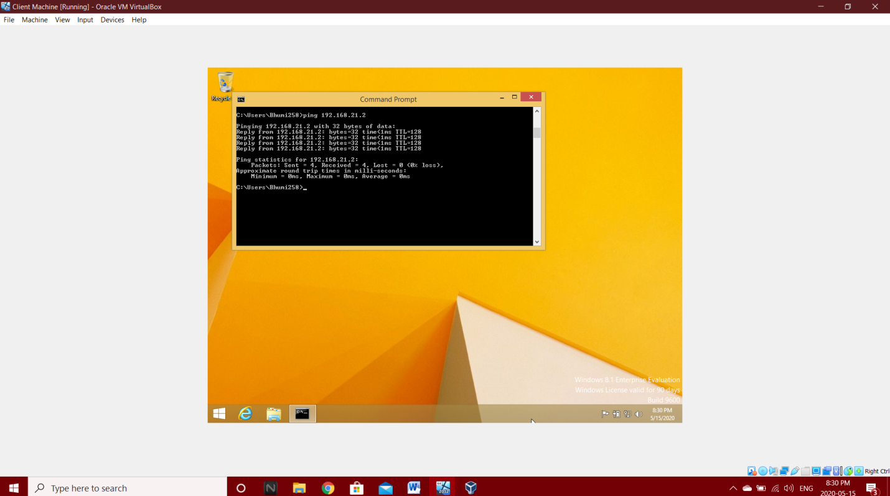3) PING SVR-WS-A (192.168.21.2) from Client Machine

**Chapter 5: Web Platform Installation**

**5.1 Install Web Platform**

Step 1: Install Web Platform.

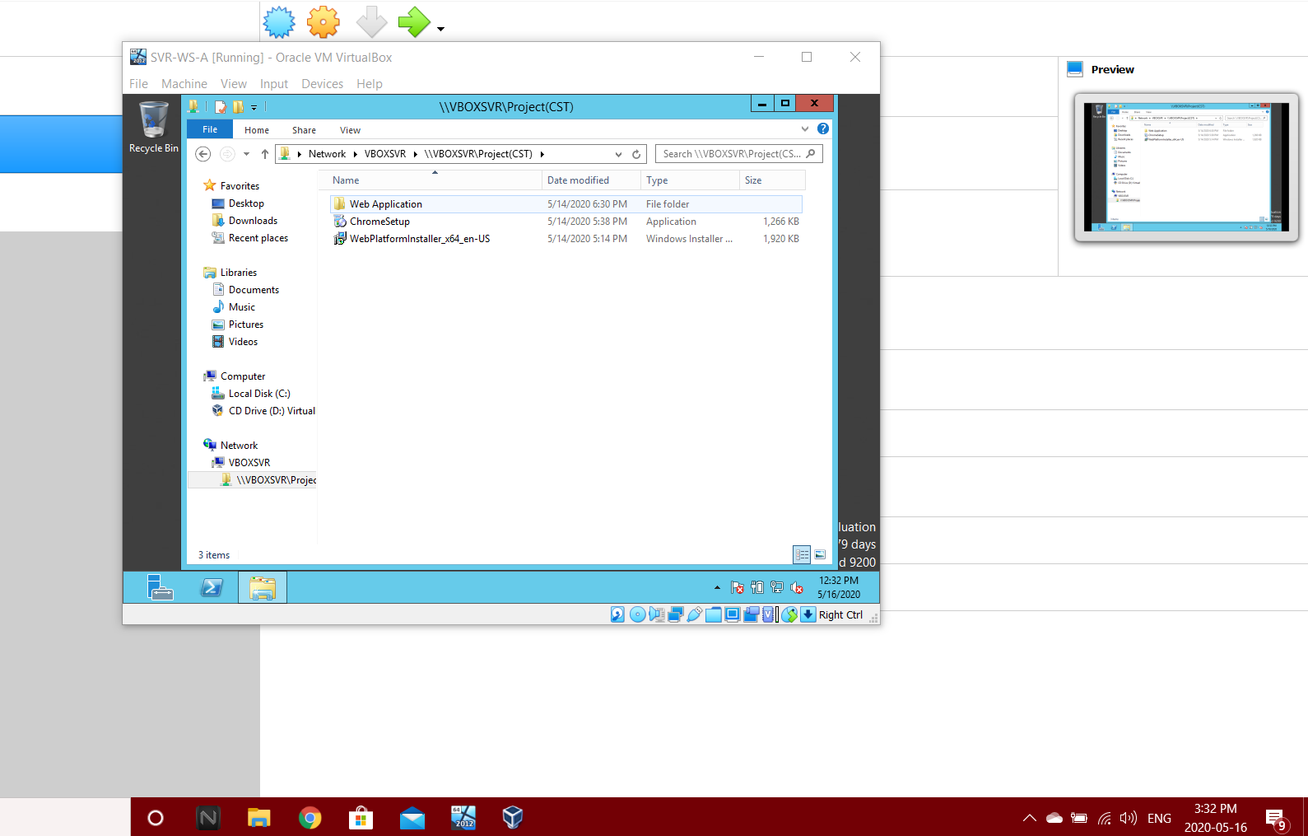

Step 2: Run the Setup

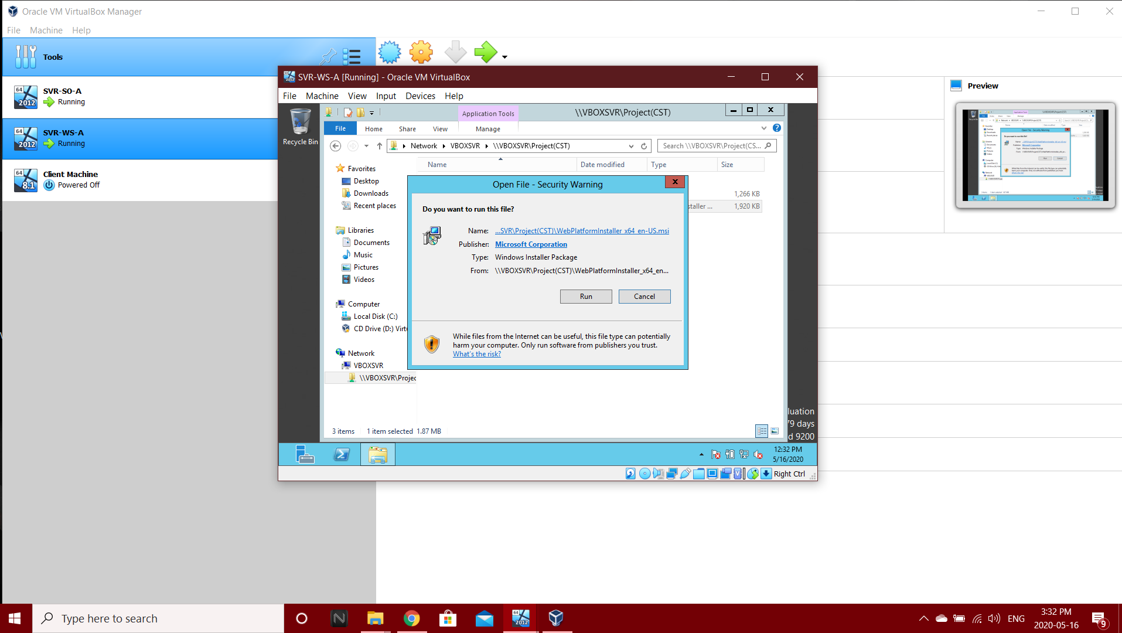

Step 3: Accept the term and license agreement and click on install.

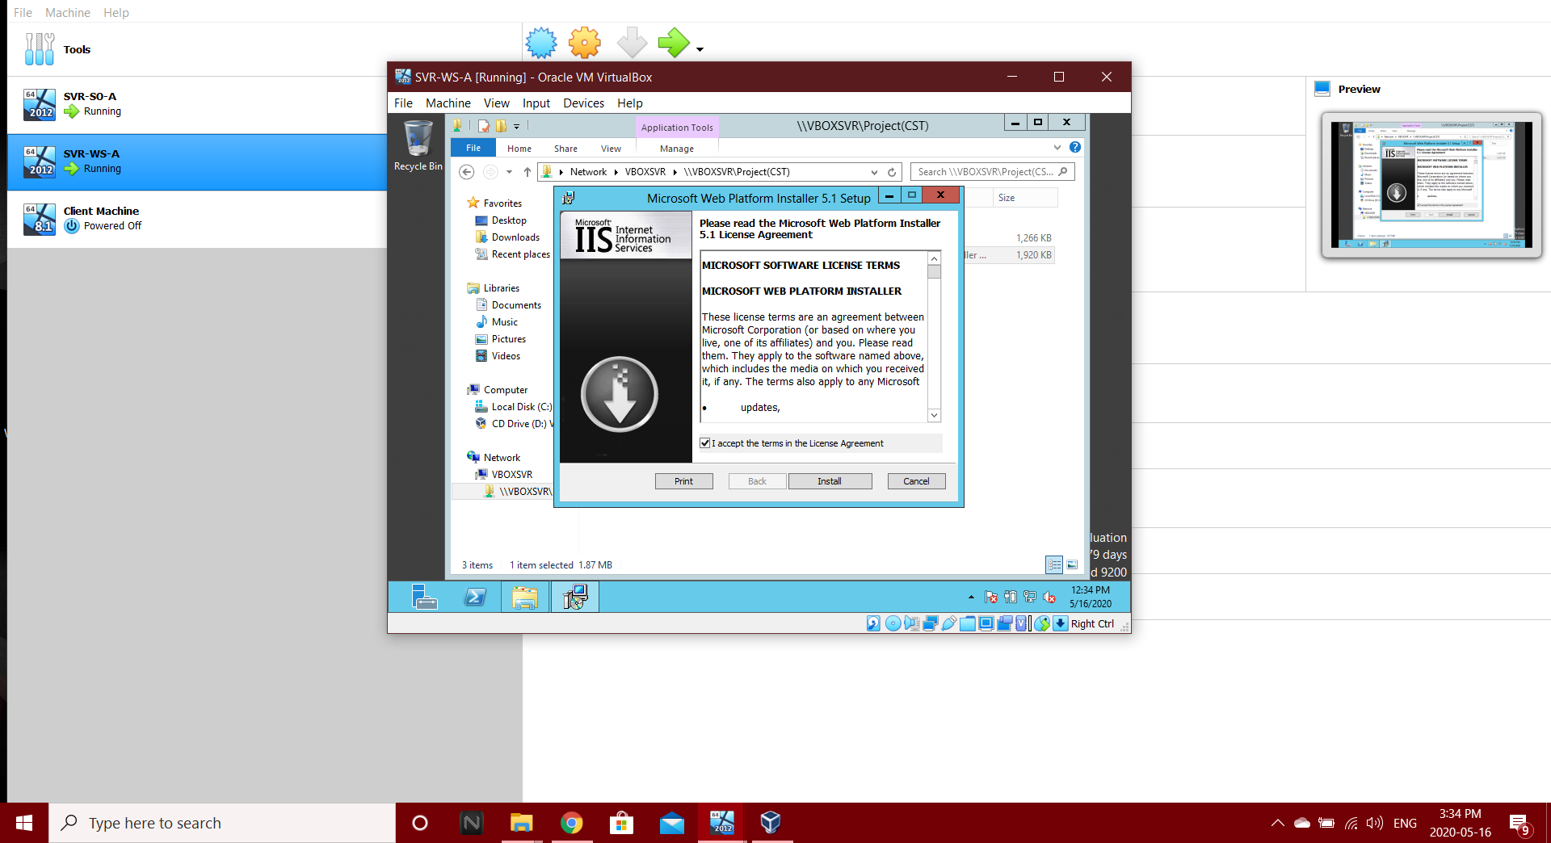

Step 4: Click on finish.

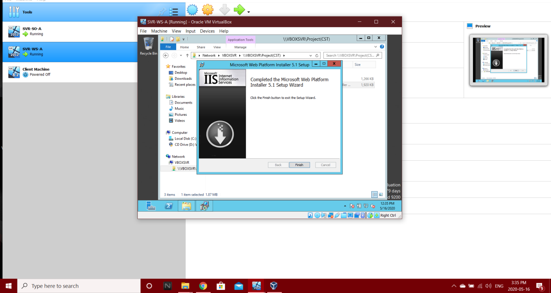

Step 5: Successfully installed Web Platform

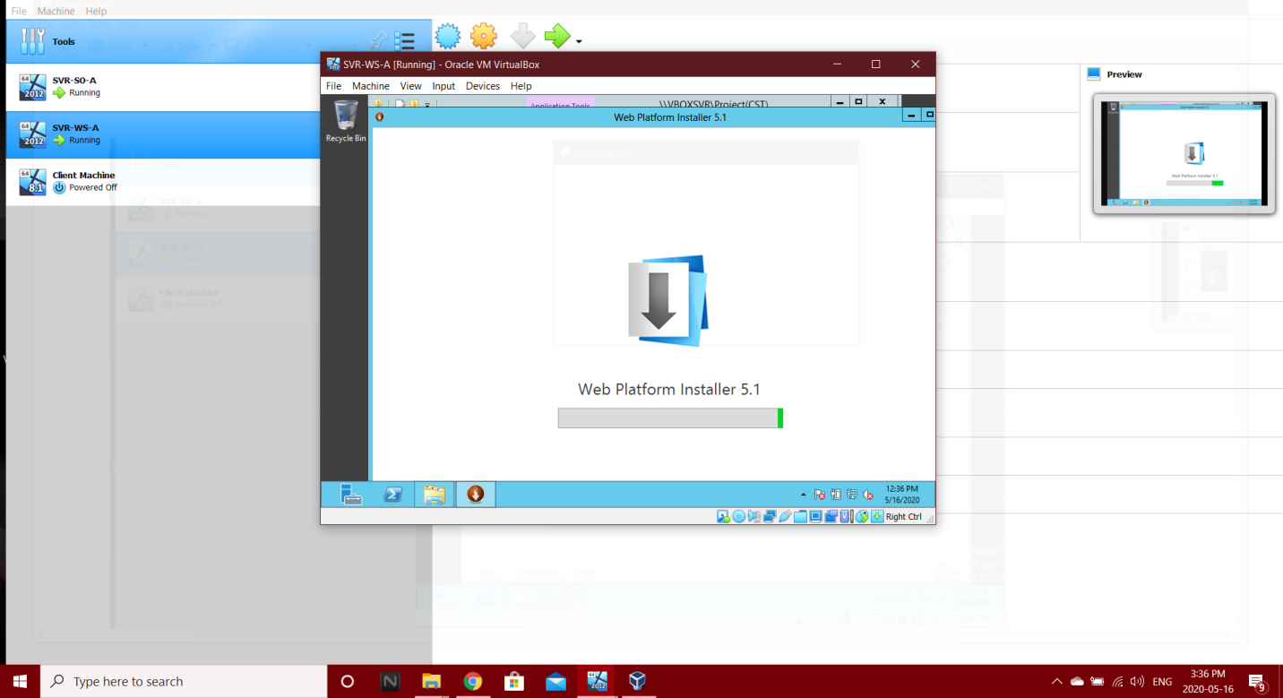

Step 6: Install PHP from Web Platform.

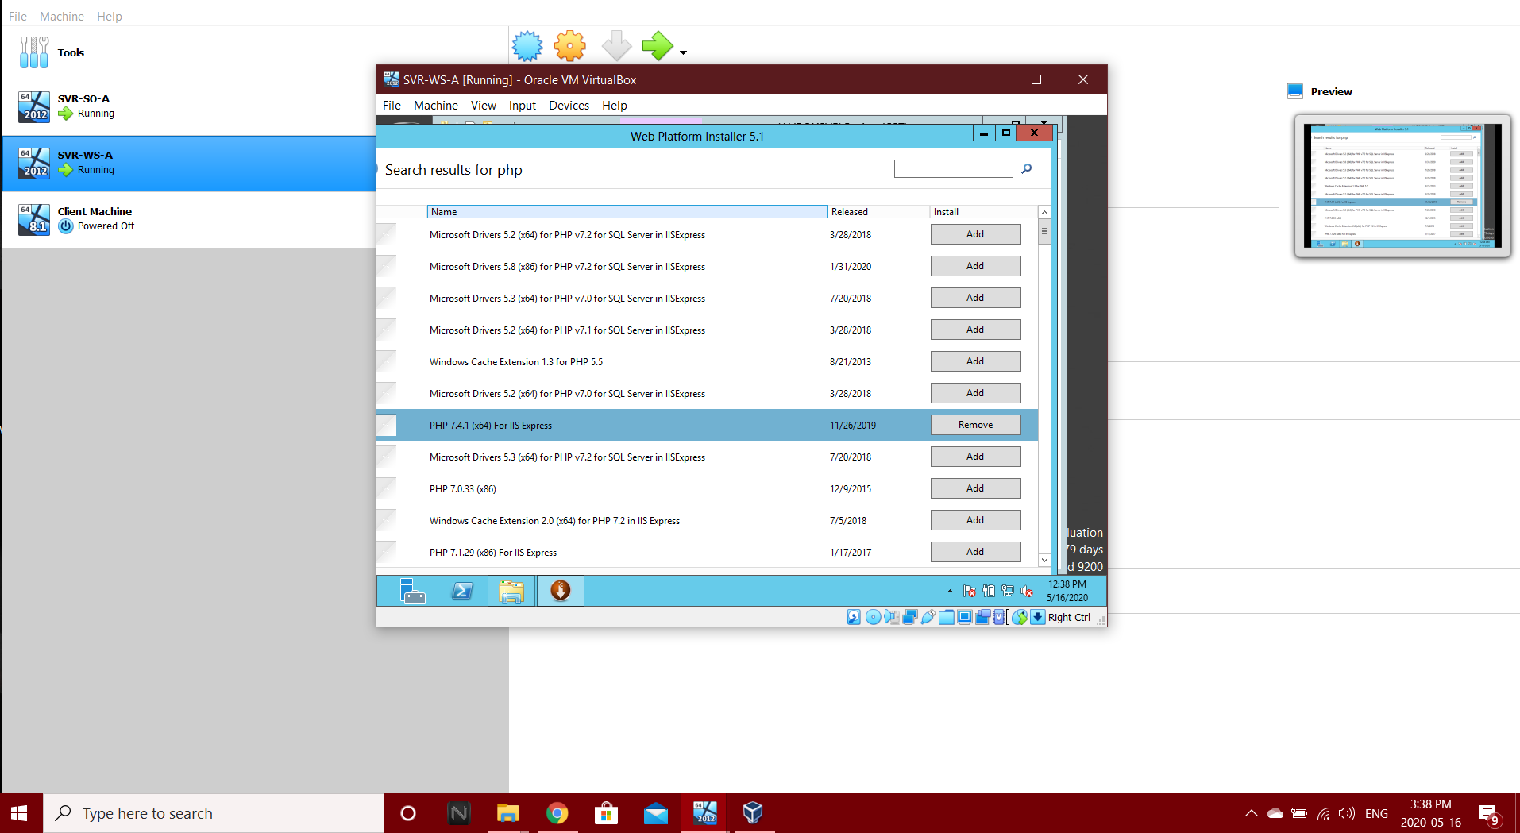

Step 7: Install MySQL from Web Platform.

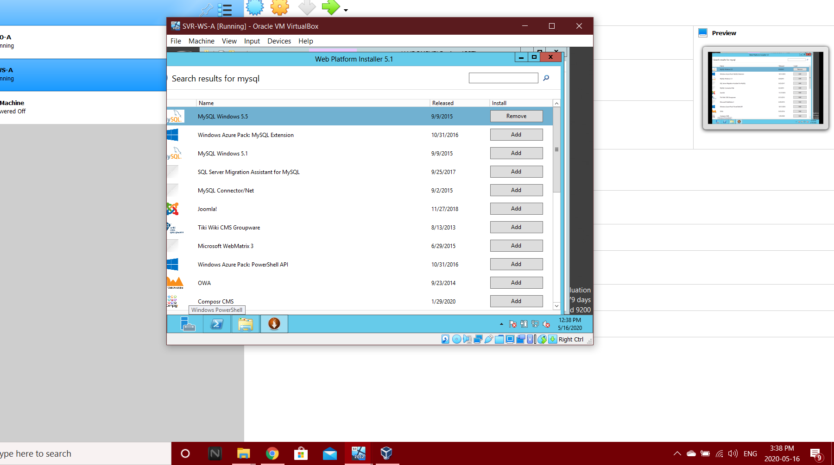

Step 8: Create a password. (Example: “ROOT”)

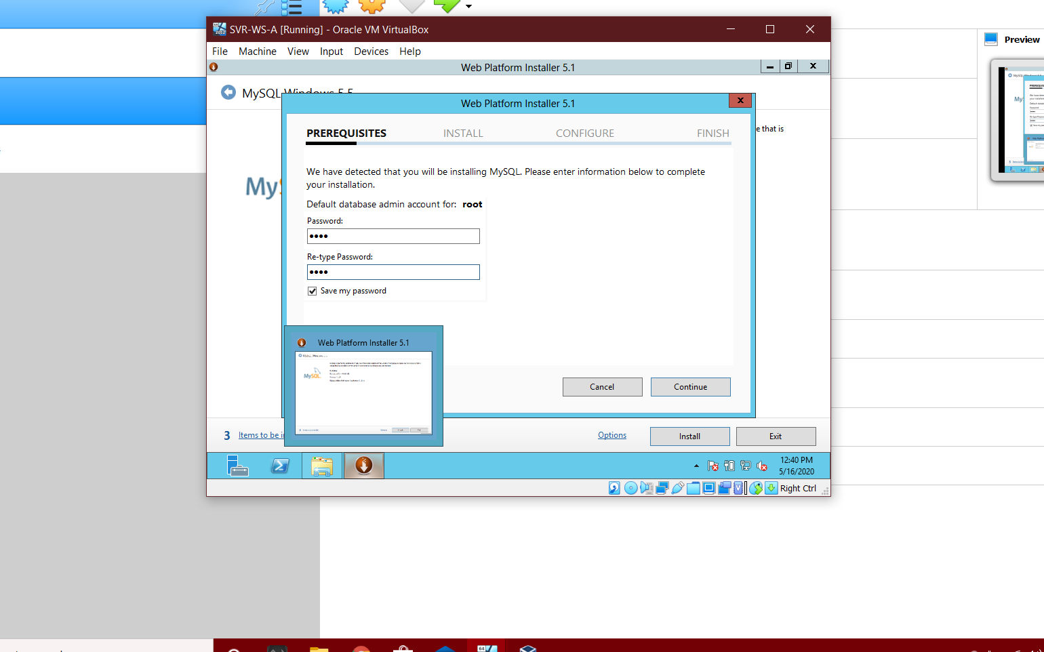

Step 9: Installing MYSQL.

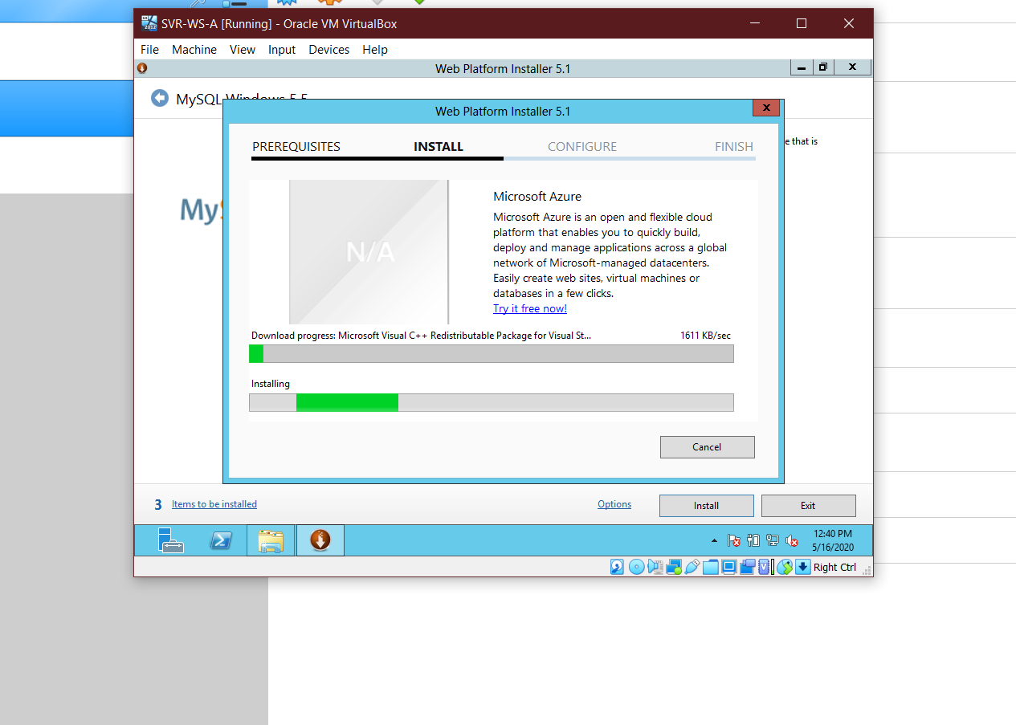

Step 10: Successfully Installed MySQL.

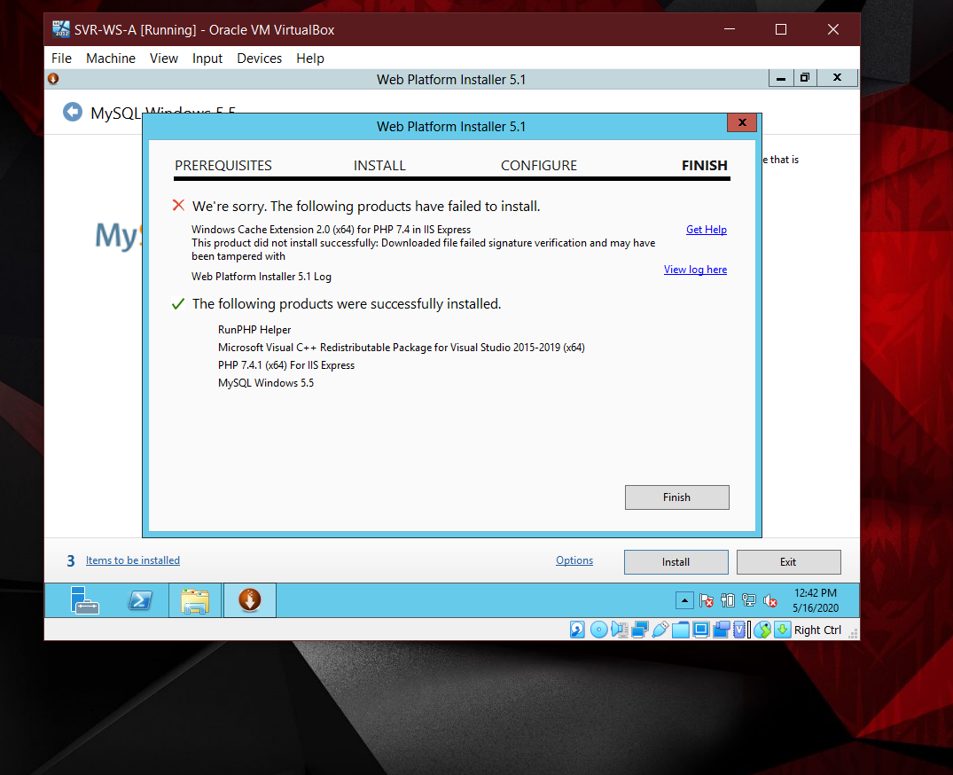

**5.2 Add Roles and Features**

Step 1: Click on View and add Roles and Features

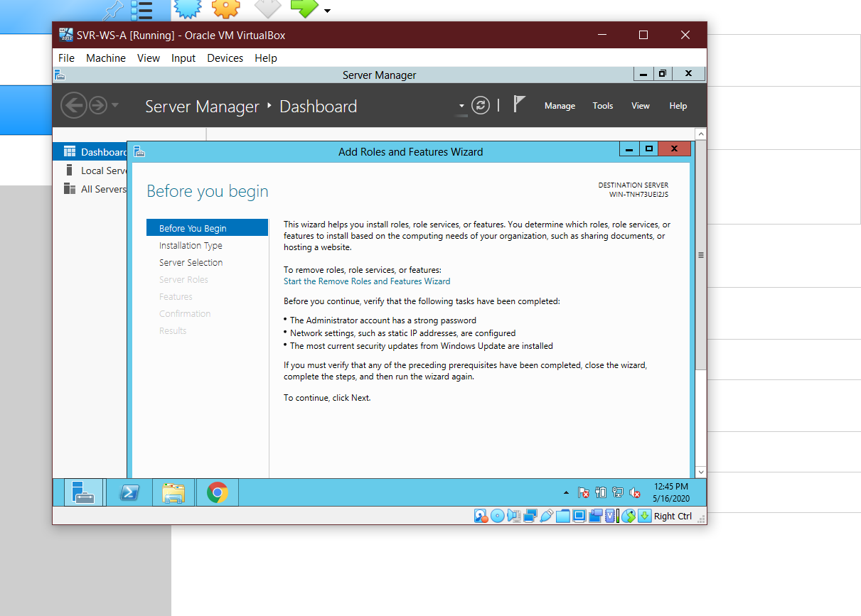

Step 2: Select role based or Feature-based Installation

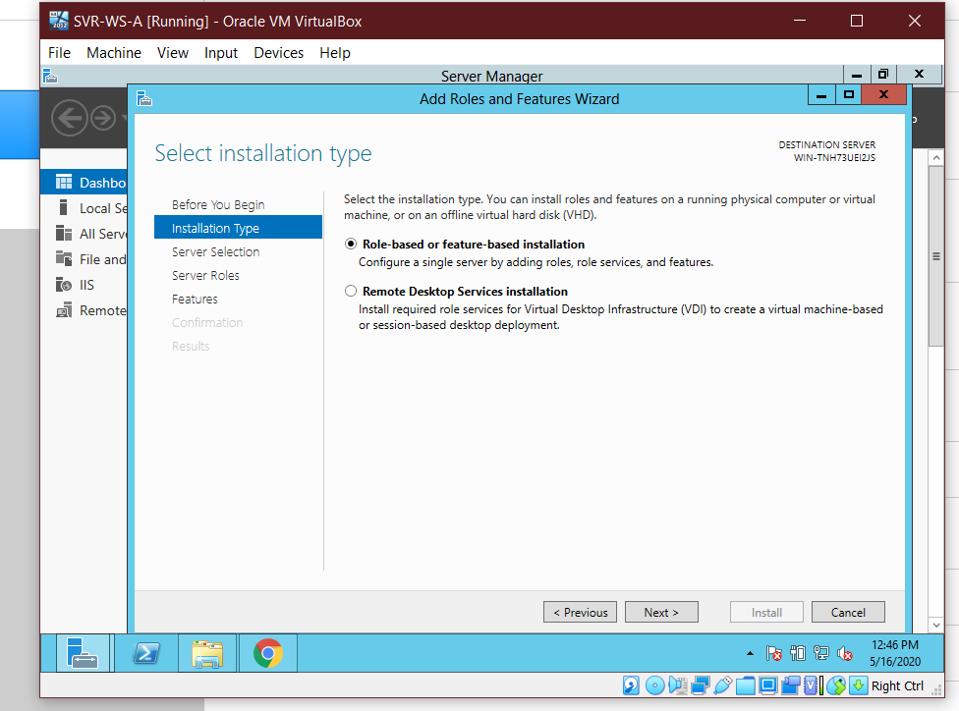

Step 3: Select sever from the server pool.

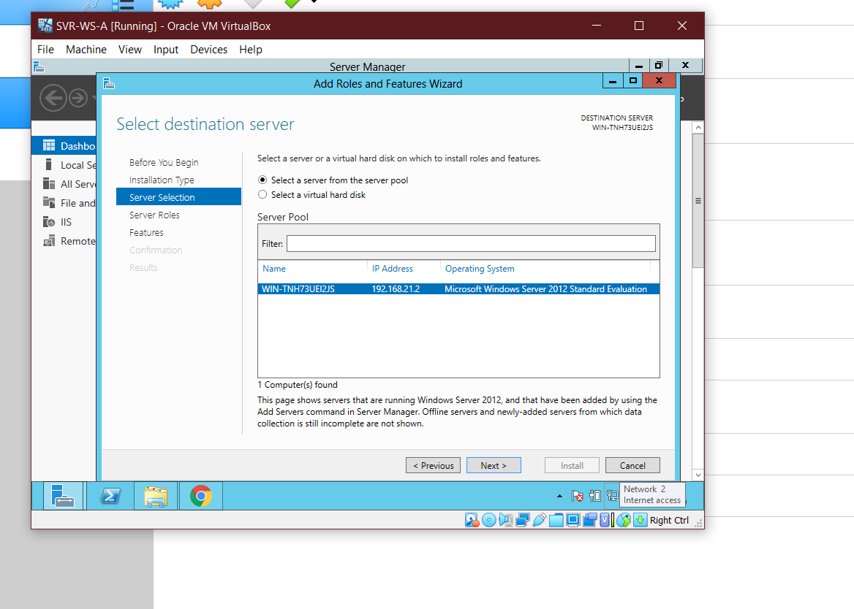

Step 4: Select ASP.NET 4.5, .NET Extensibility 4.5 and CGI from Server Roles.

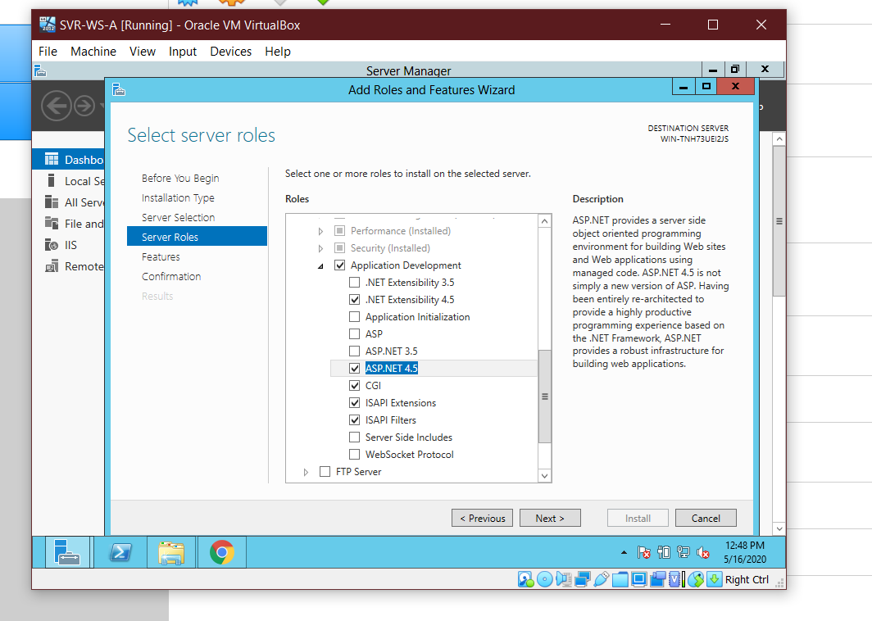

Step 5: Add application server from Server Roles

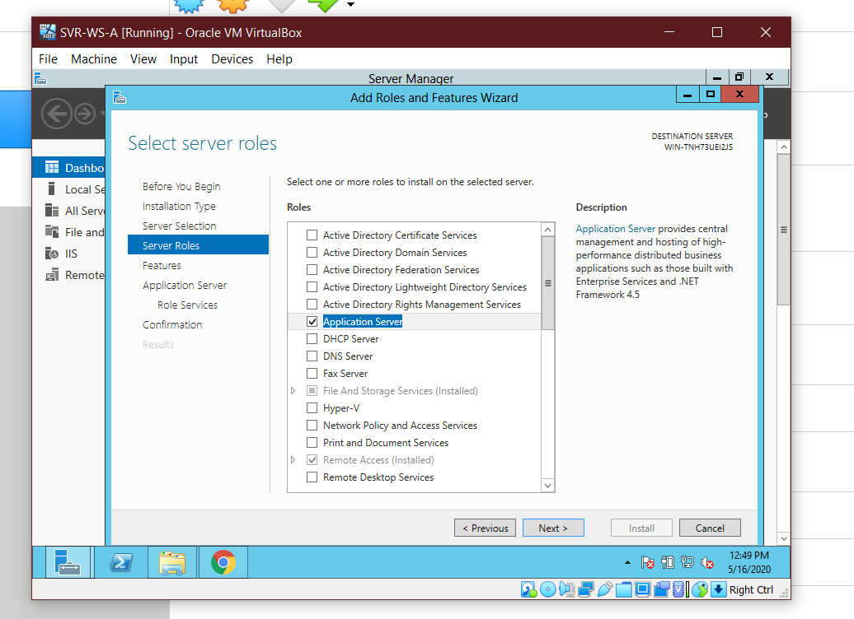

Step 6: Add HTTP activation from Features

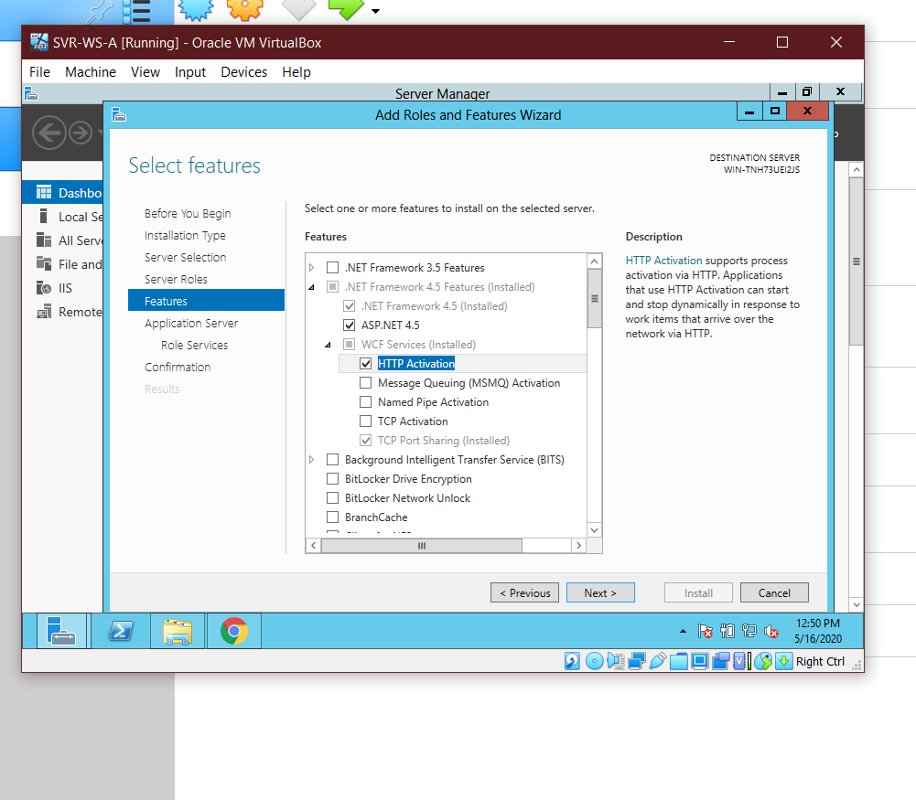

Step 7: Starting installation

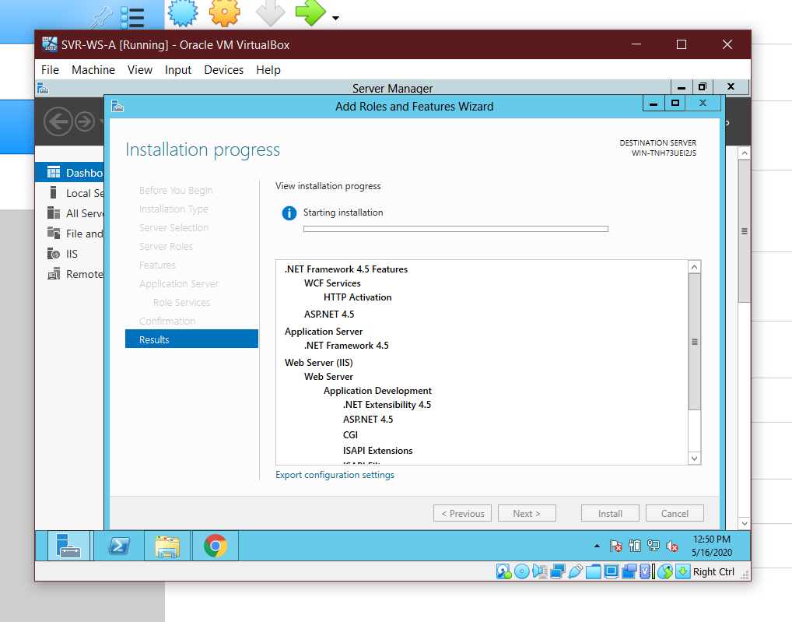

**5.3 Download phpMyAdmin in Web-Server**

Step 1: Download phpMyAdmin from its official site:

<https://www.phpmyadmin.net/>

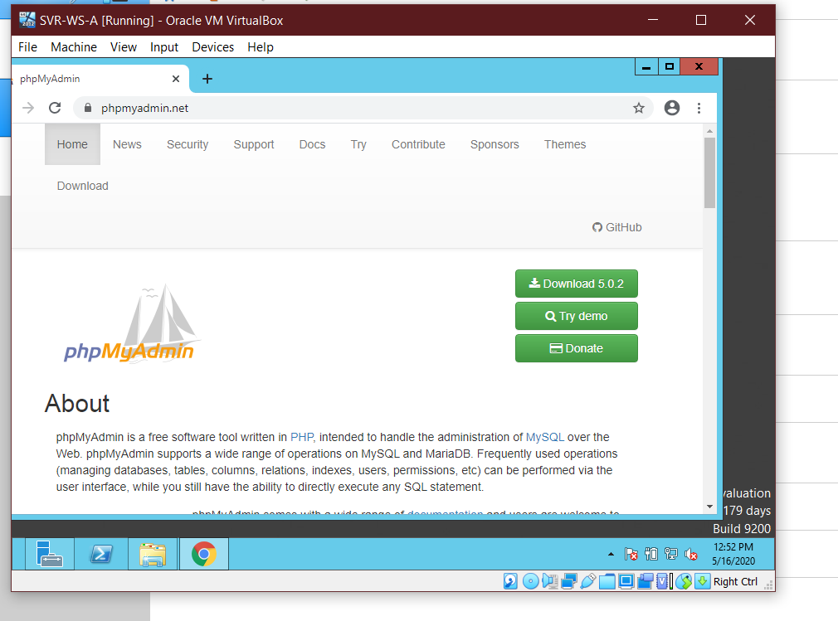

Step 2: Navigate to Local Drive c/interpub/wwwroot/phpMyAdmin.

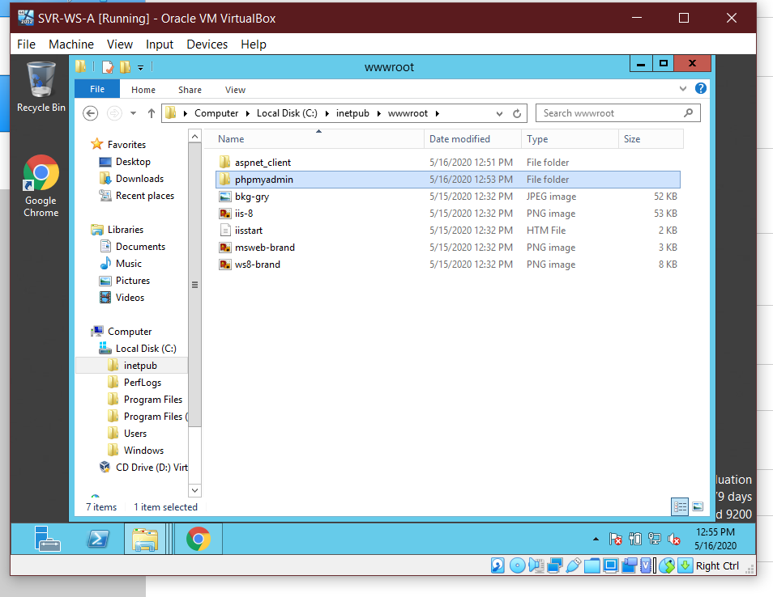

Step 3: Content of phpMyAdmin.

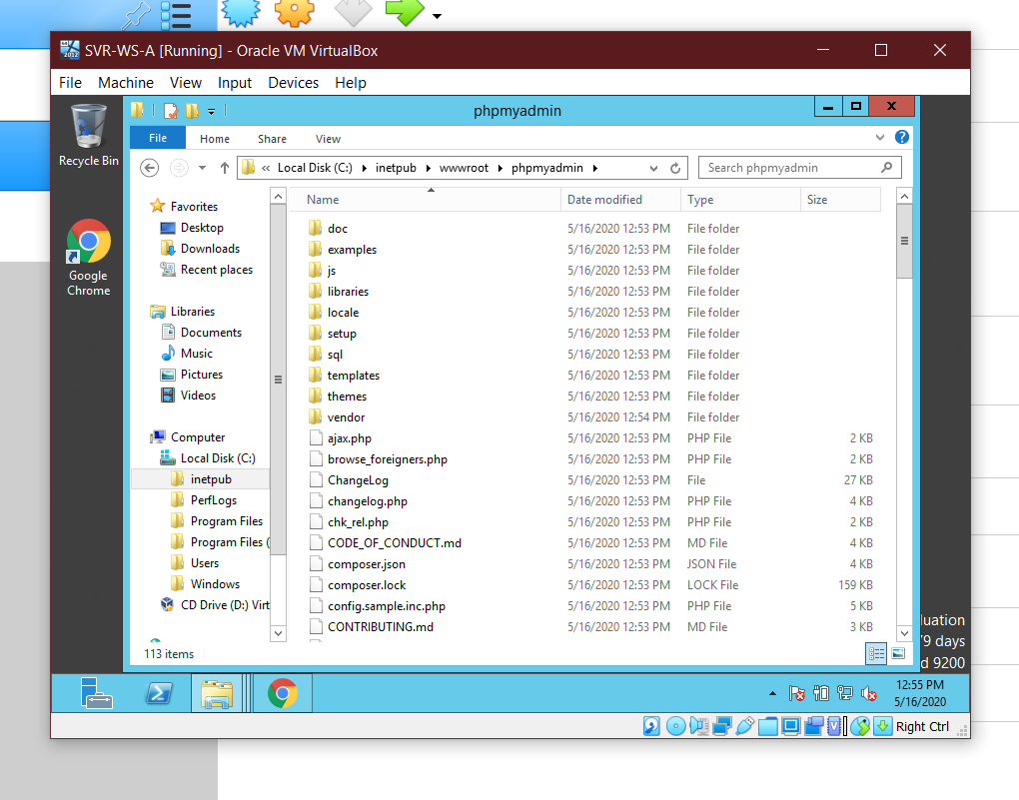

Step 4: Add Final Project folder in Drive c/interpub/wwwroot/ folder.

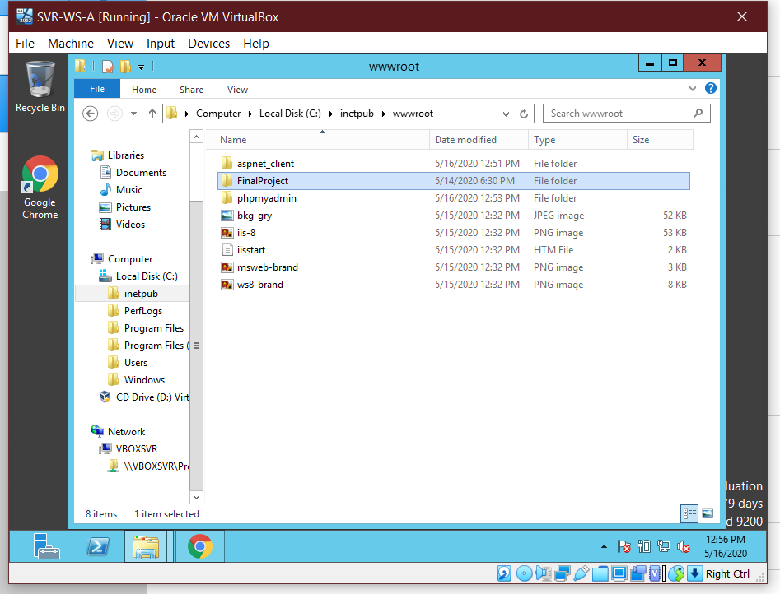

Step 5: Content of Final Project.

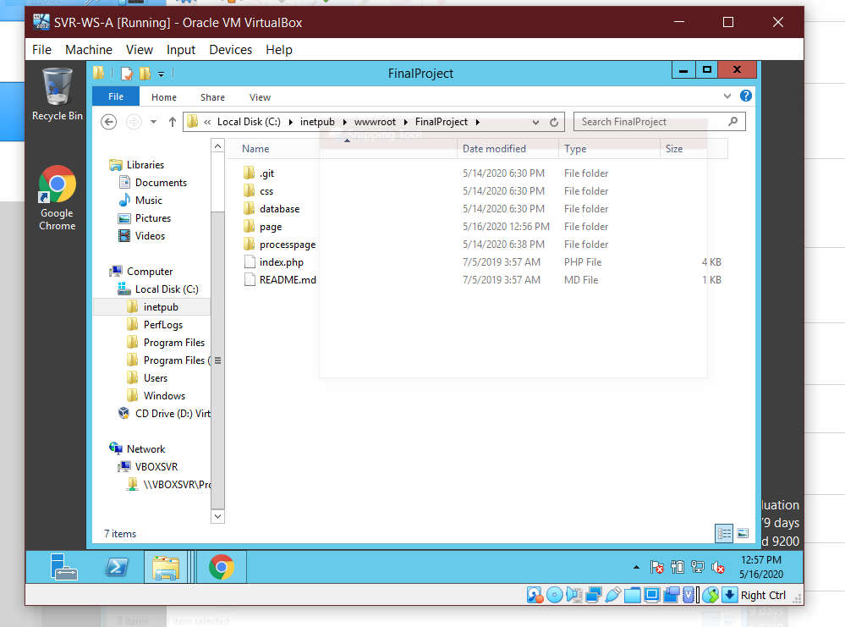

Step 6: Open the FinalProject by typing localhost/phpMyAdmin/ in browser.

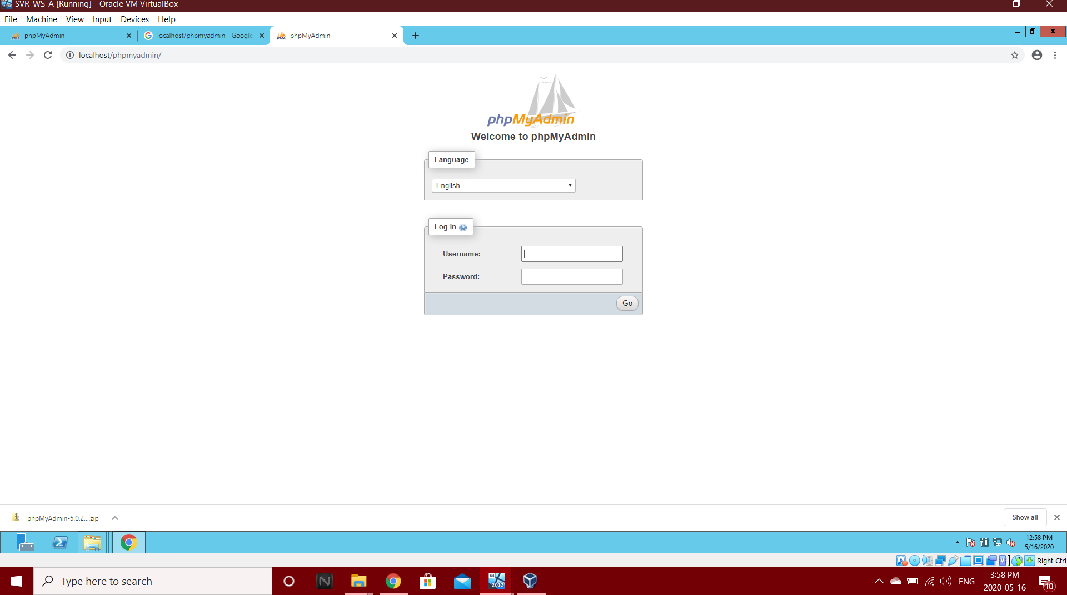

Step 7: PhpMyAdmin

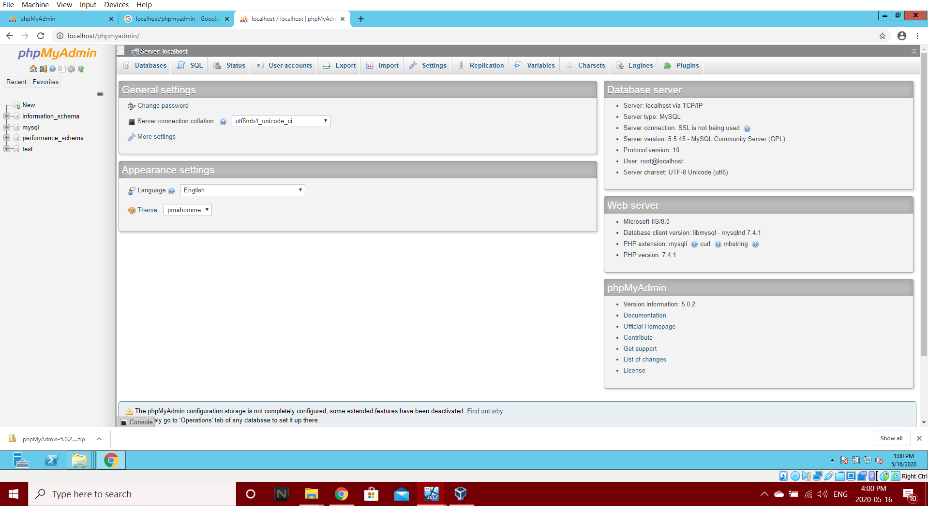

Step 8: Create database called as “system_installation”.

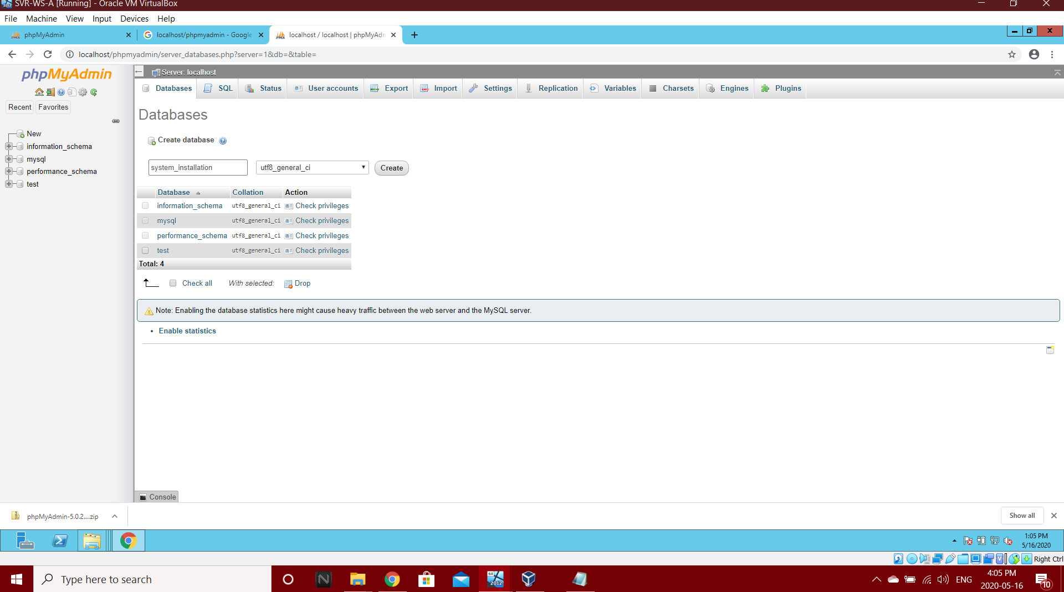

Step 9: Import the SQL file.

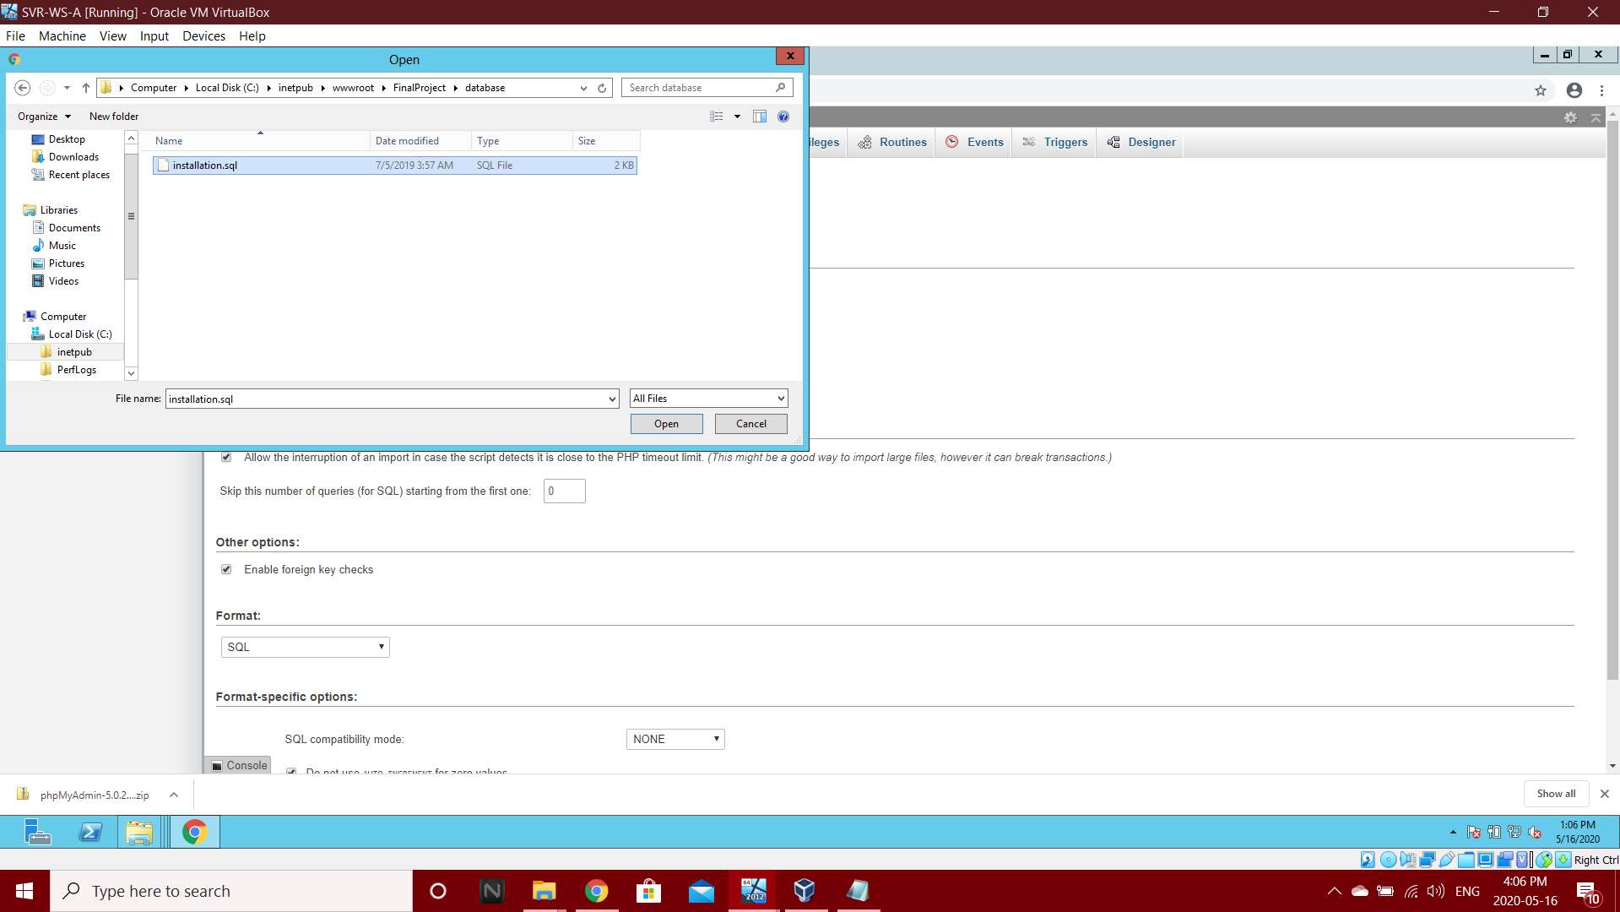

Step 10: Records of Table named as “Installation”.

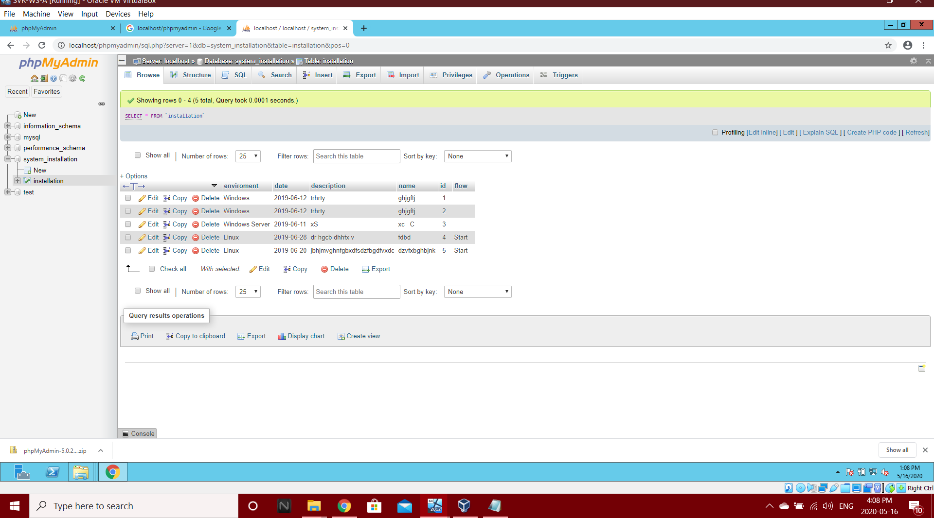

**5.4 Accessing the Web Application**

Step 1: Open Web application by writing 192.168.21.2/FinalProject in Browser of Client Machine.

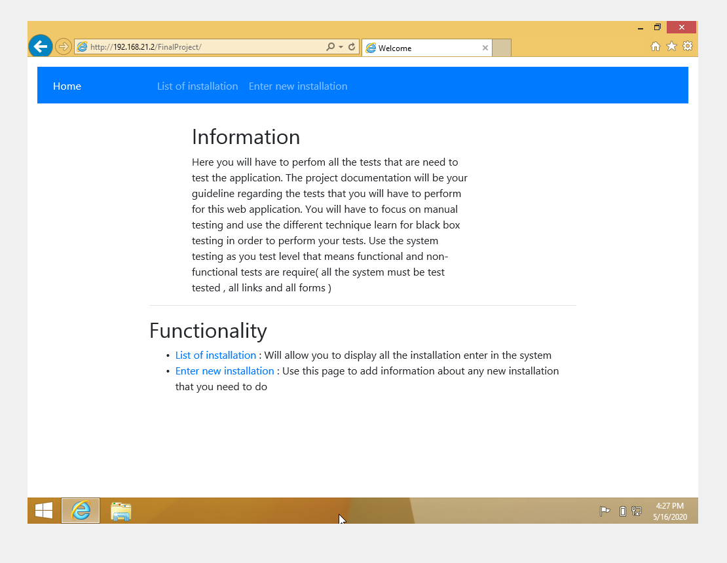

Step 2: Check webpage “Enter New Installation” by clicking “Enter new Installation” Button on Navigation bar.

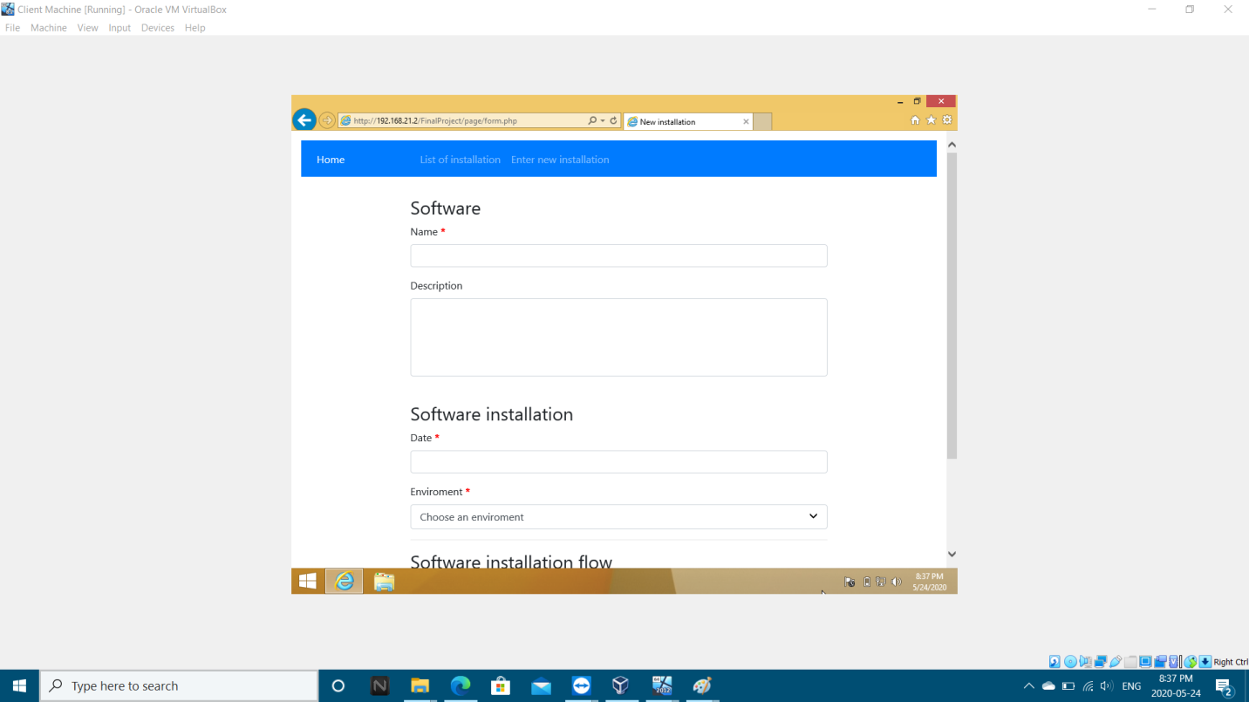

Step 2: Check webpage “List of Installation” by clicking “List of Installation” Button on Navigation bar.

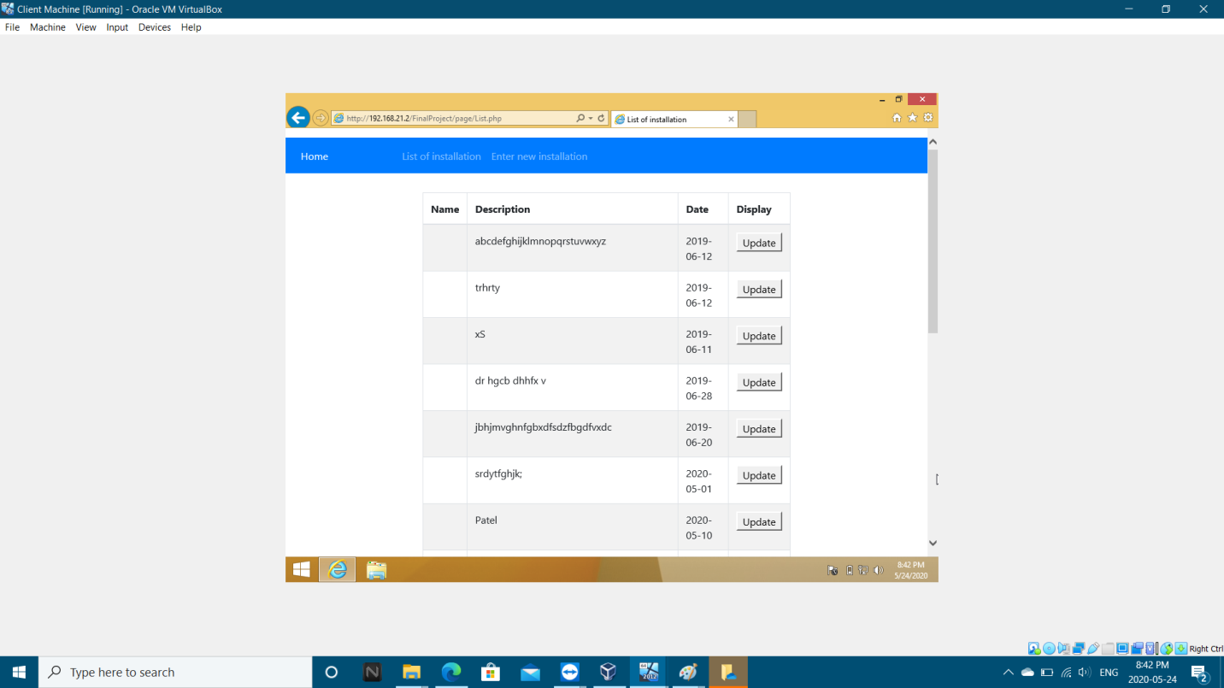

**Chapter 6 : Test Cases**

**6.1 Positive Test Cases**

1) Test case is about checking the functionality of Home Page.

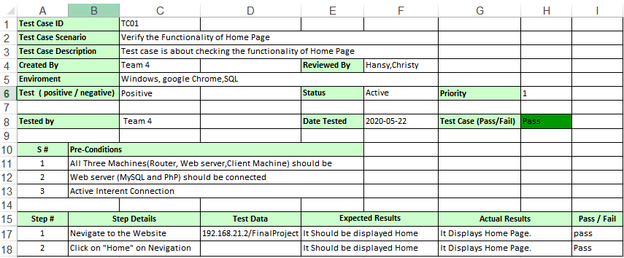

2) Test case is about checking the functionality of Home Page.

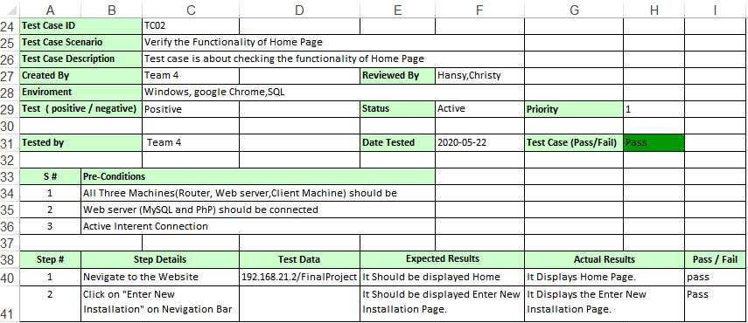

3) Test case is about checking the functionality of Home Page.

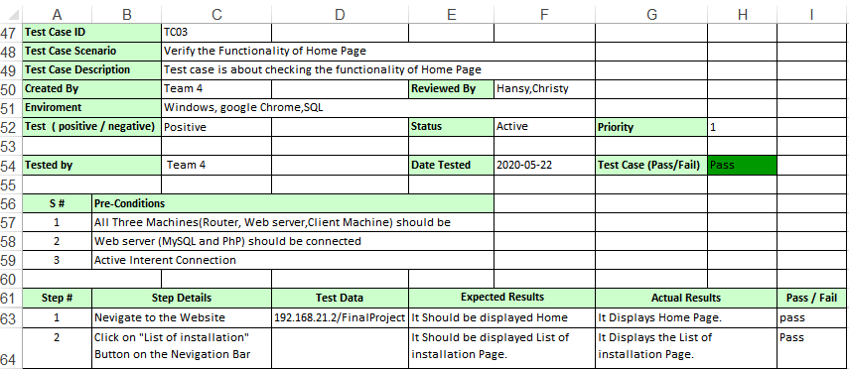

4) Test case is about checking Name field by Entering Valid Data. 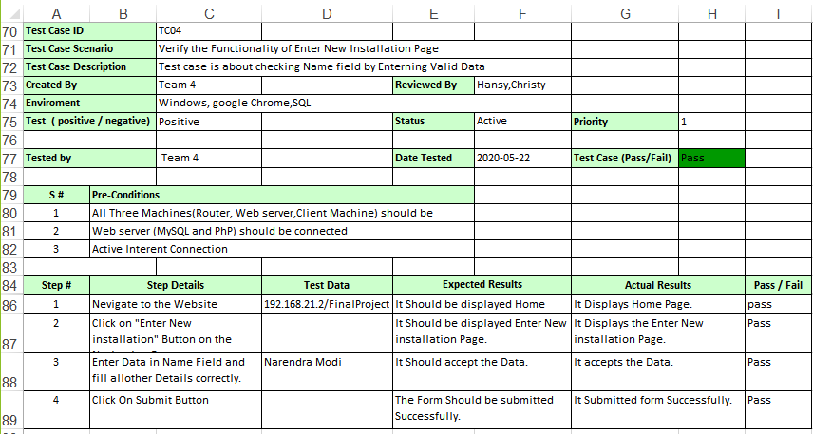

5) Test case is about checking Description field by Enterning Valid Data.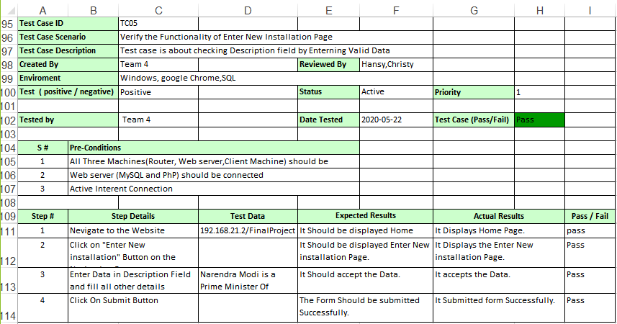

6) Test case is about checking Date field by Entering Valid Data.

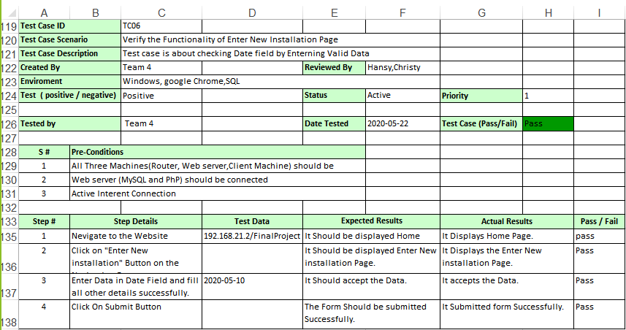

7) Test case is about checking Environment field by Entering Valid Data.

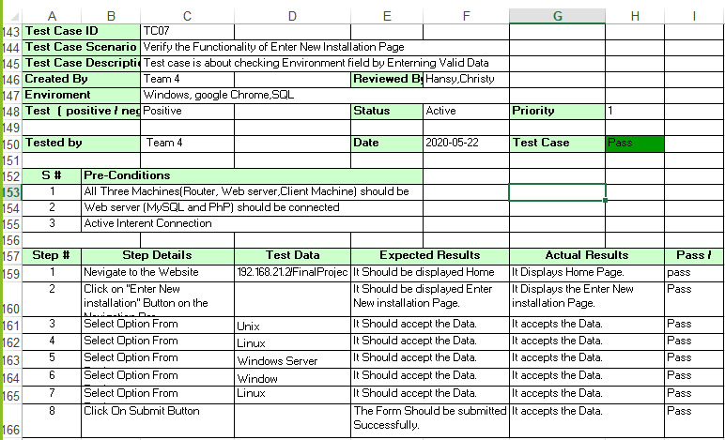

8) Enter More than 250 Characters in Description and it should not be accepted.

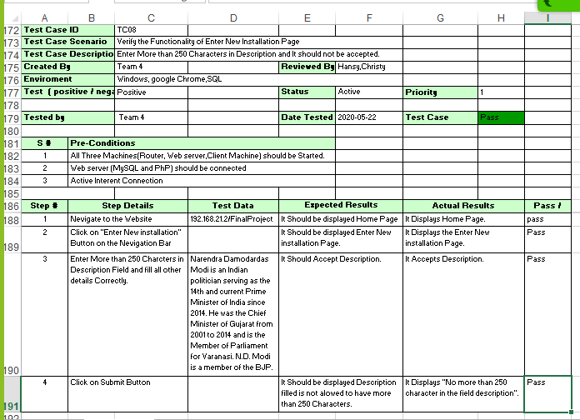

9) Enter Future date in Date filled and It Should not be Accepted.

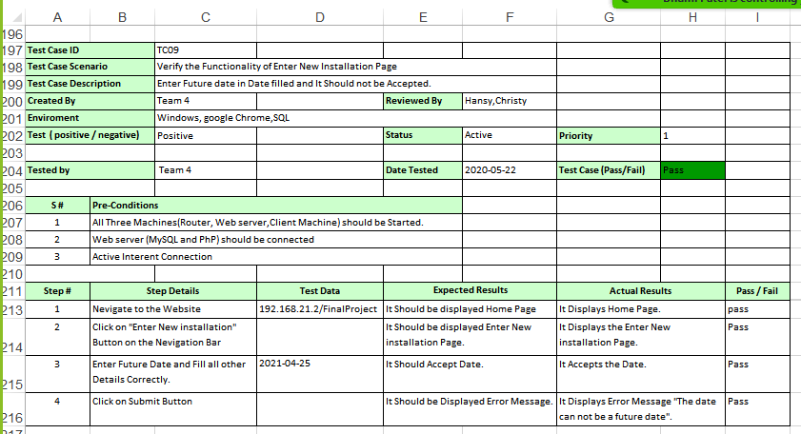

10) Test case is about checking the functionality of Update button.

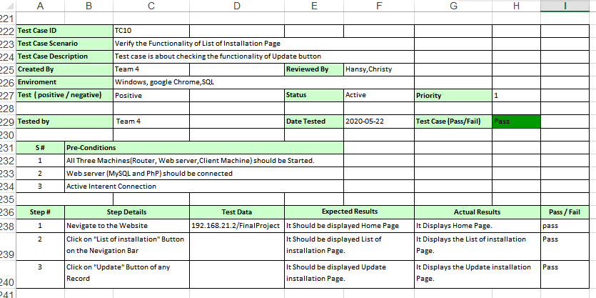

11) Test case is about checking Name field by Entering Valid Data.

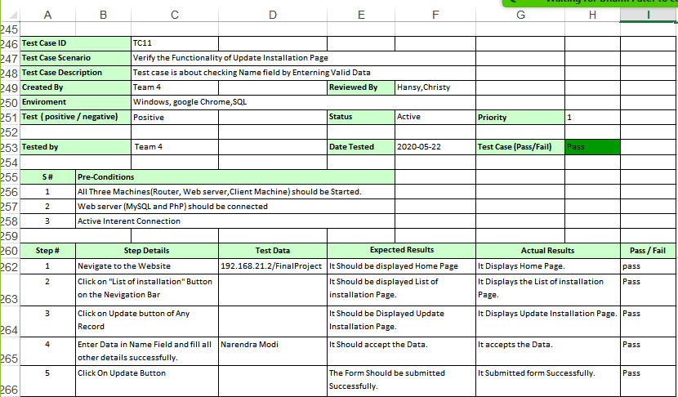

12) Test case is about checking Description field by Entering Valid Data.

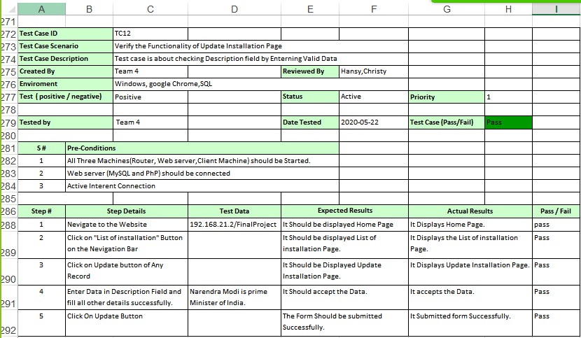

13) Test case is about checking Date field by Entering Valid Data.

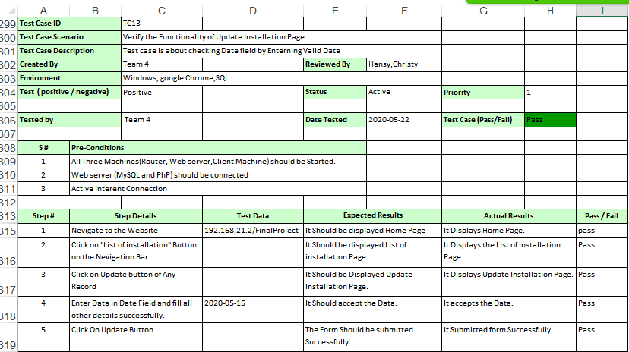

14) Test case is about checking Environment field by Entering Valid Data.

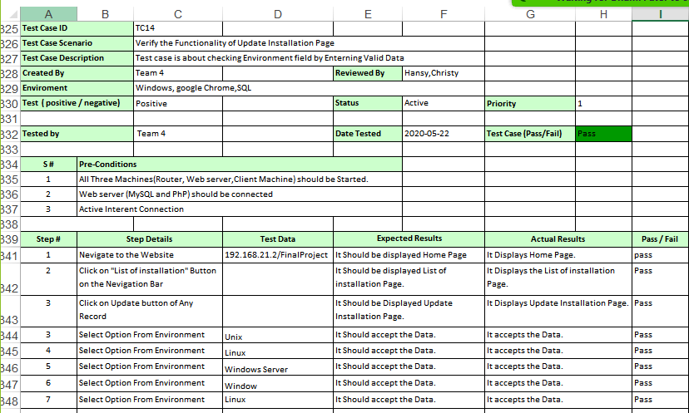

15) Enter Empty Name and It Should not be Accepted.

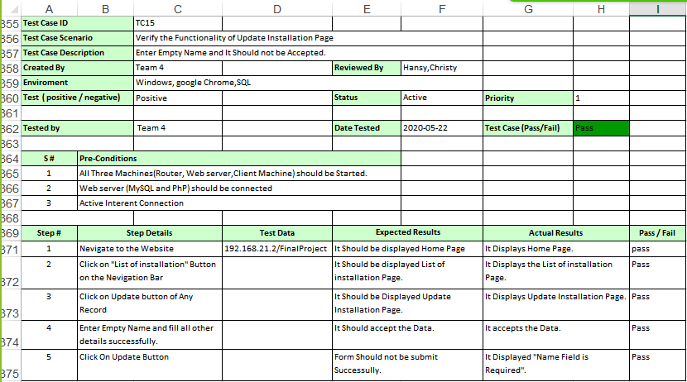

16) Enter Empty Date and It Should not be Accepted.

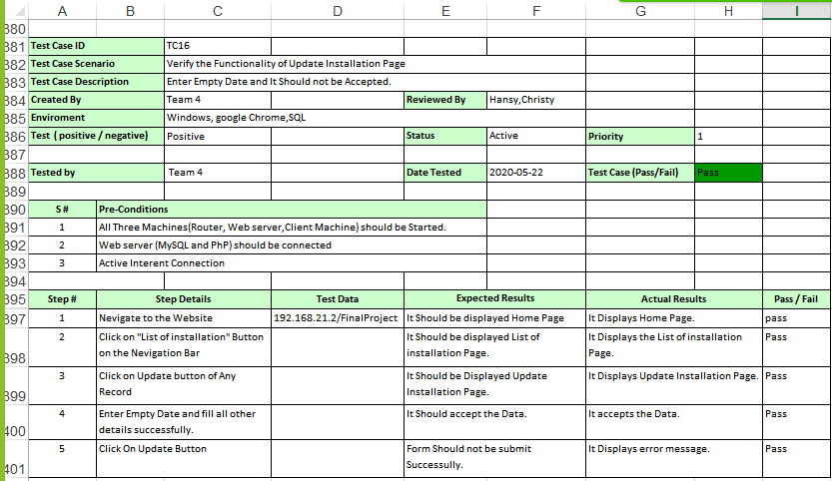

**6.2 Negative Test Cases**

1) Test case is about checking the functionality of Home Page.

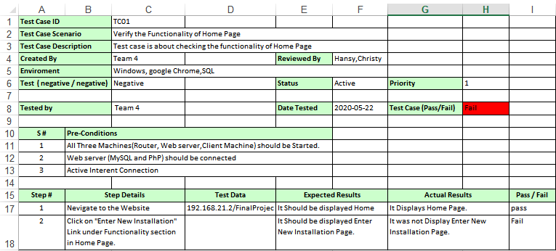

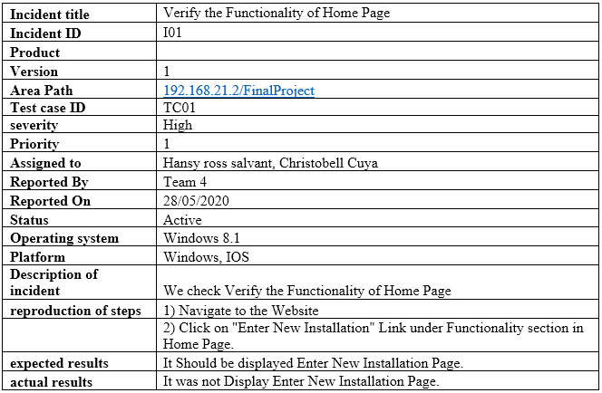

2) Test case is about checking the functionality of Home Page.

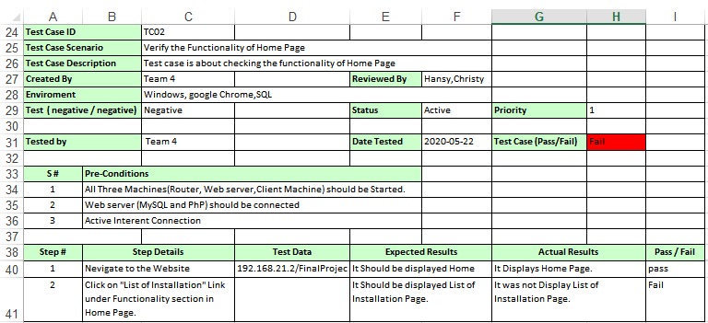

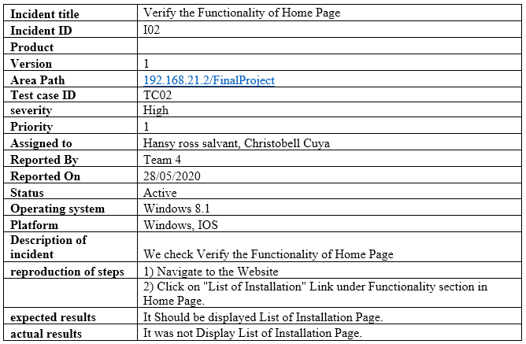

3) Enter Empty Name and It Should not be Accepted.

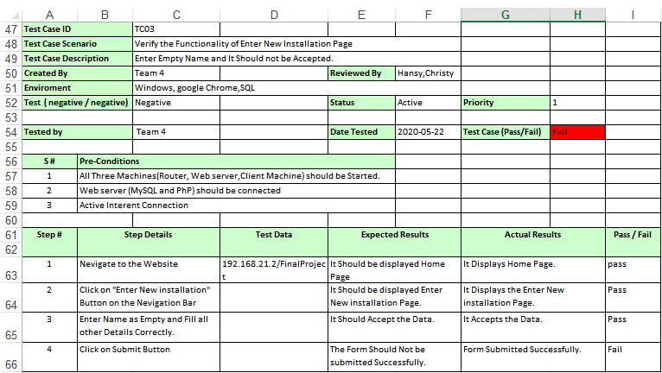

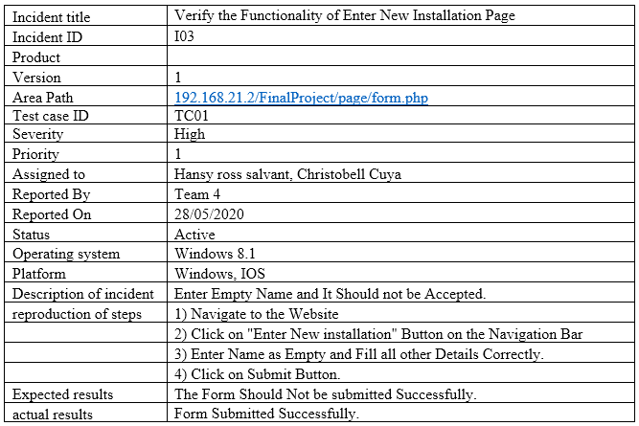

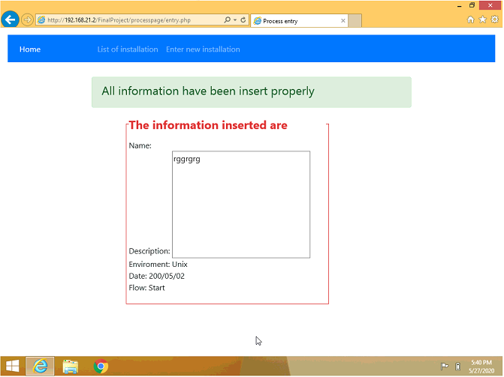

4) Select Finish in Software Installation Flow and It Should Be Accepted.

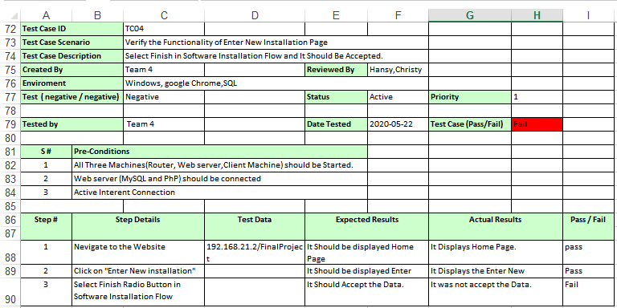

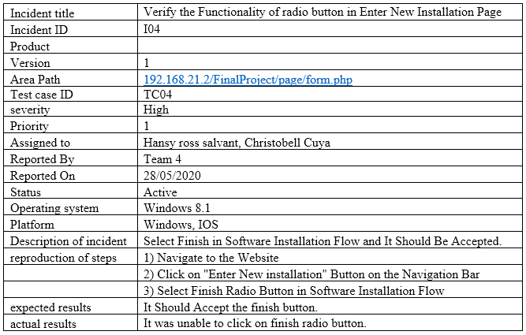

5) It should Display All the Field while clicking on list of installation Button.

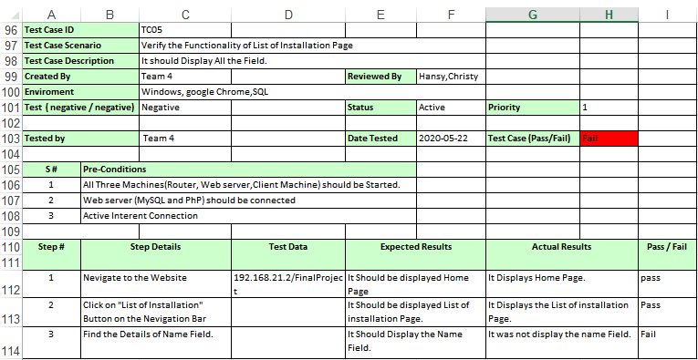

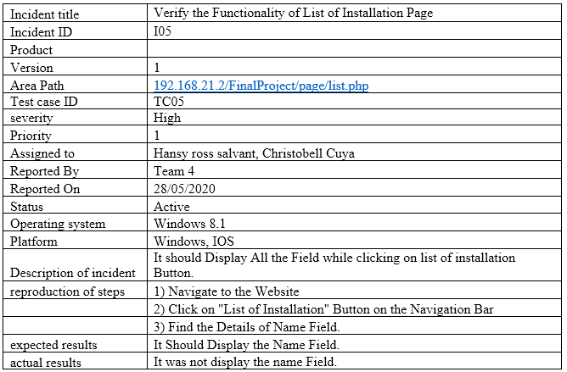



6) We should select Finish Radio Button in the Software Installation Flow.

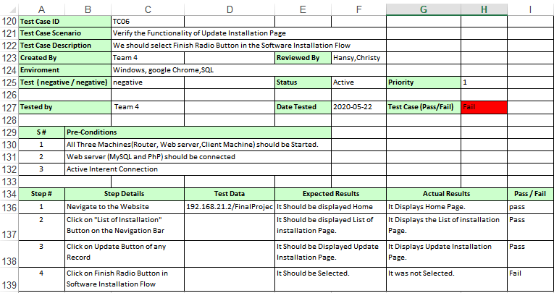

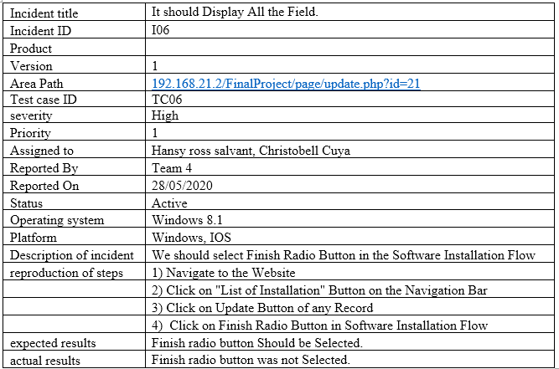

7) Test case is about checking Name field by Entering Numbers.

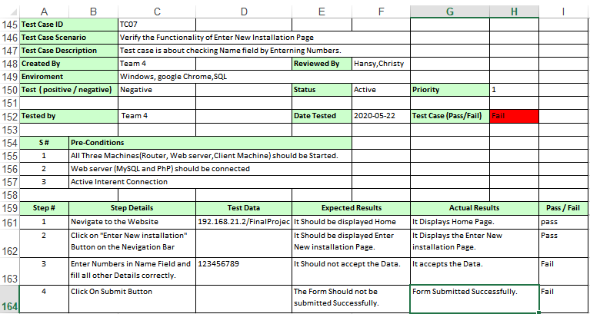

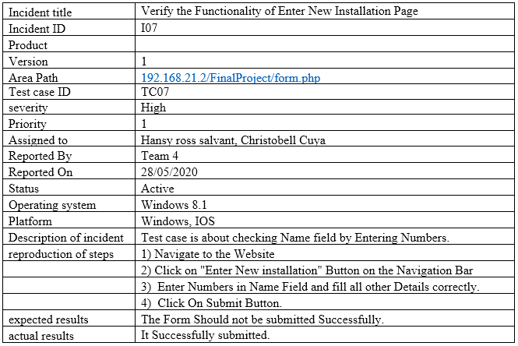

8) Test case is about checking Name field by Entering Special Characters.

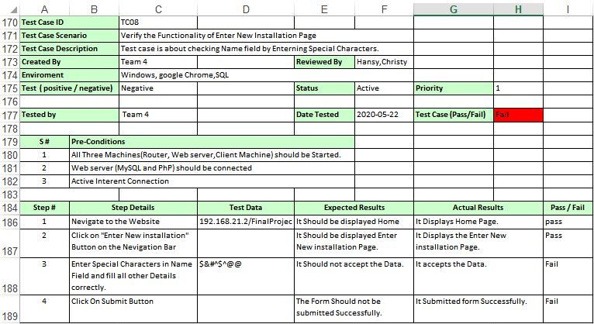

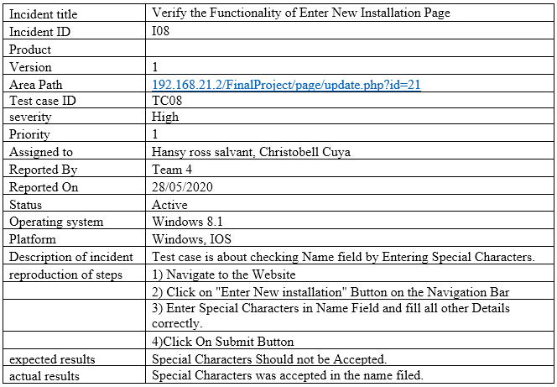

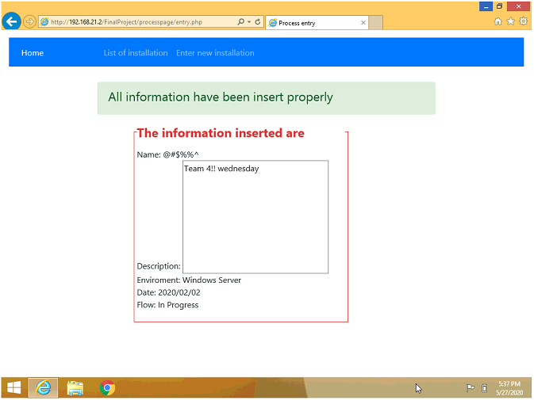

9) Test case is about checking Name field by Entering Special Characters.

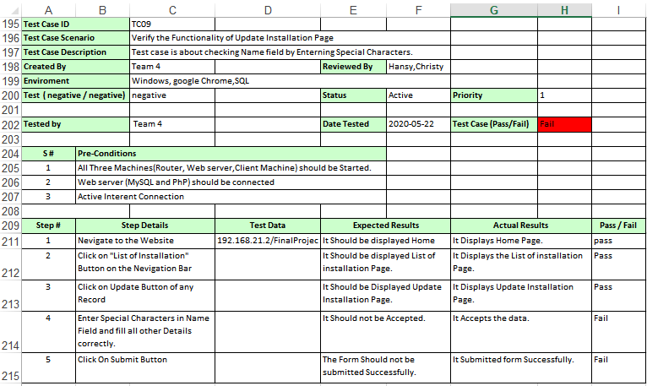

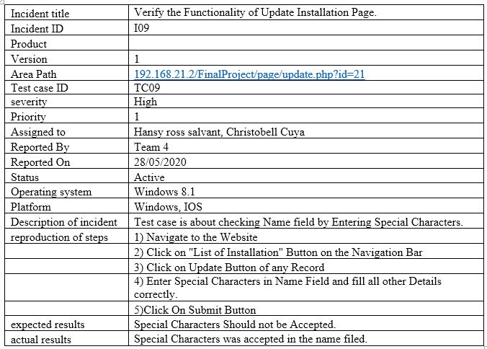

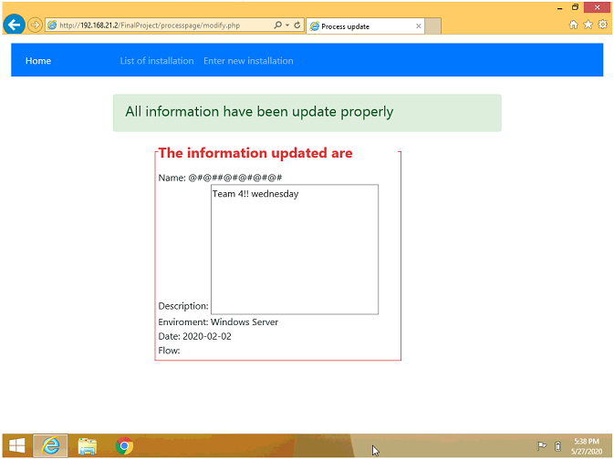

10) Test case is about checking Name field by entering more than 50 characters.

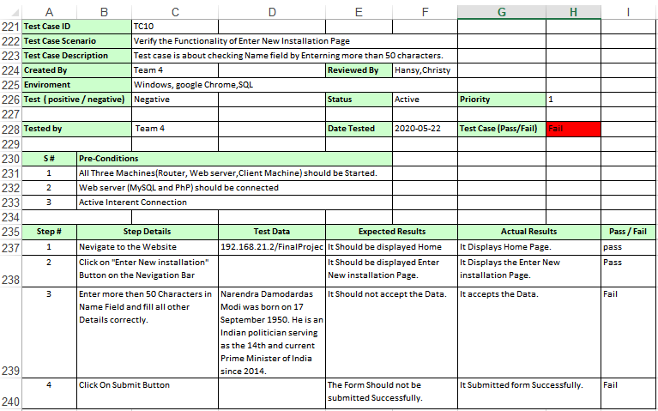

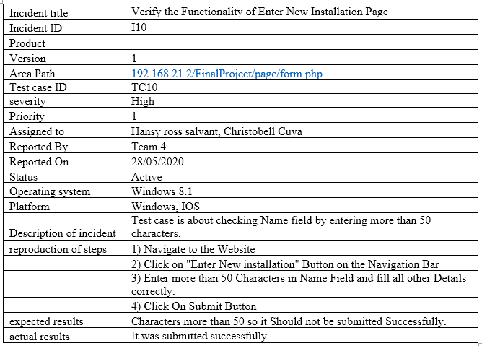

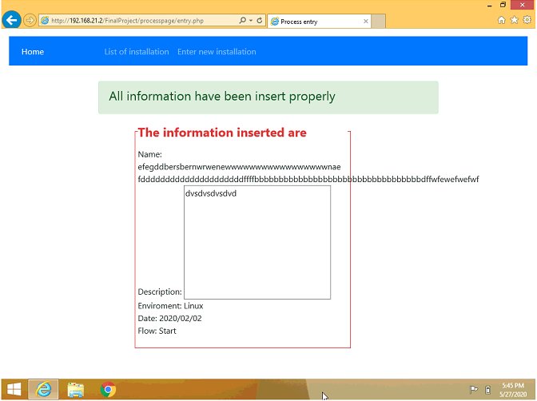

11) Test case is about checking Name field by entering more than 50 characters.

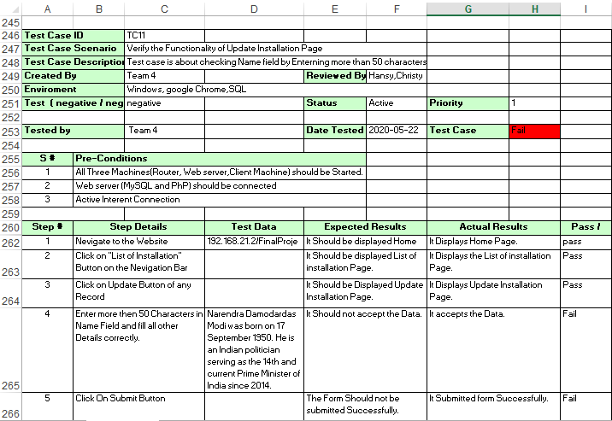

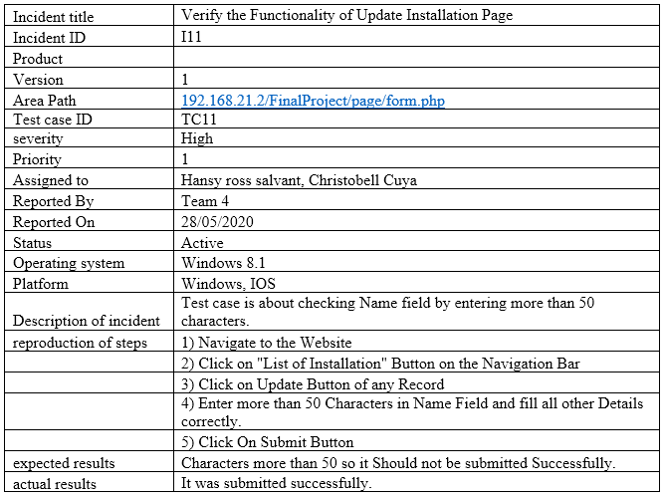

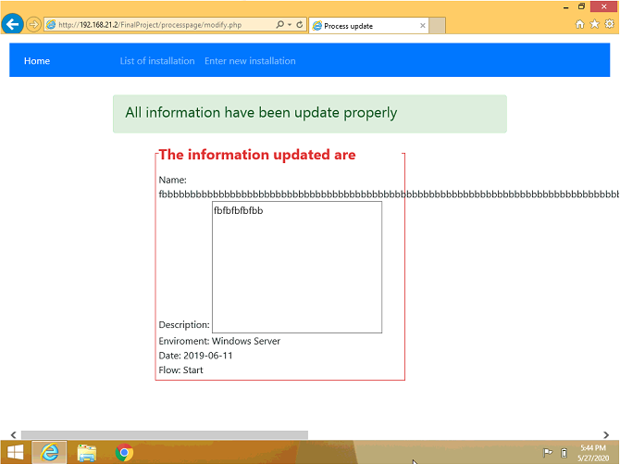

12) Test case is about checking Name field by Entering Blank Space.

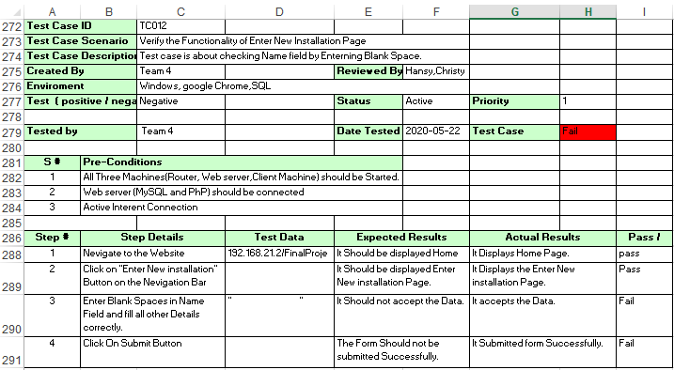

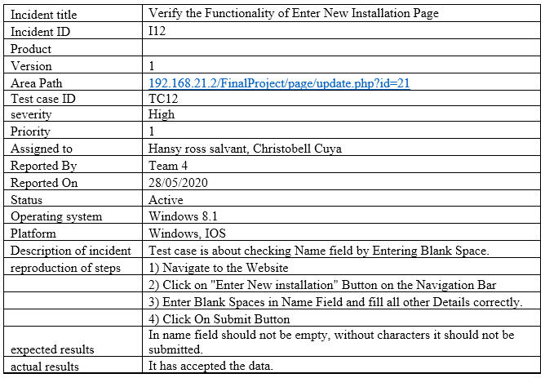



13) Test case is about checking Name field by Entering Blank Spaces.

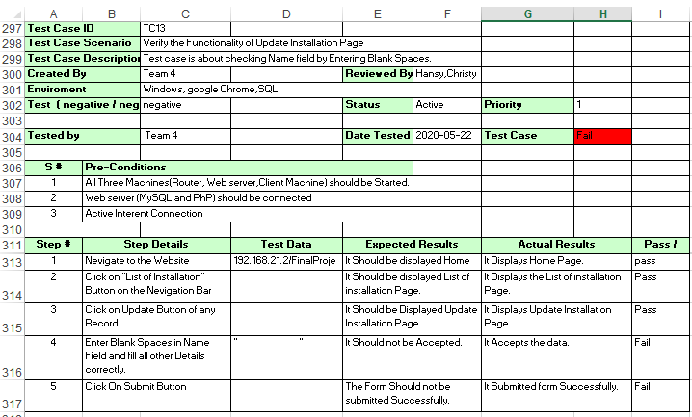

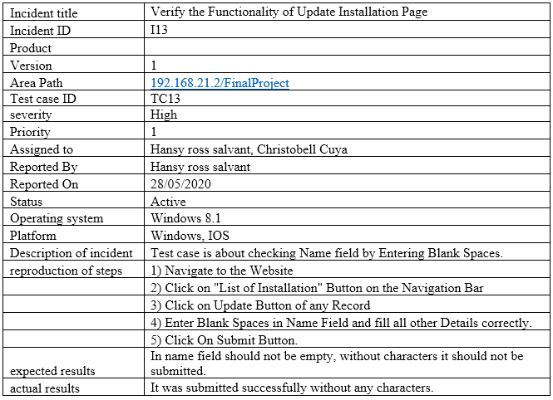

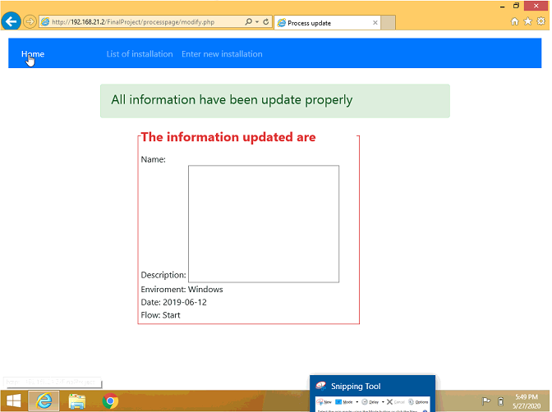

14) Test case is about checking Date field by Entering Invalid Data.

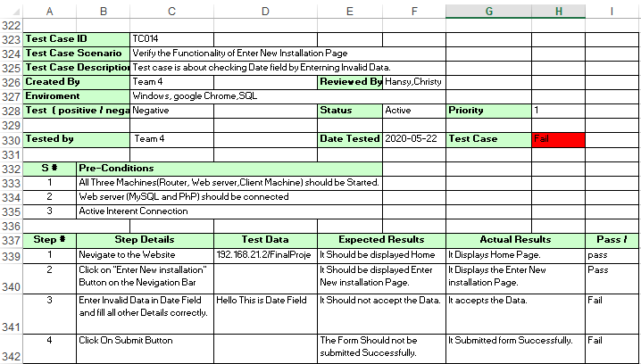

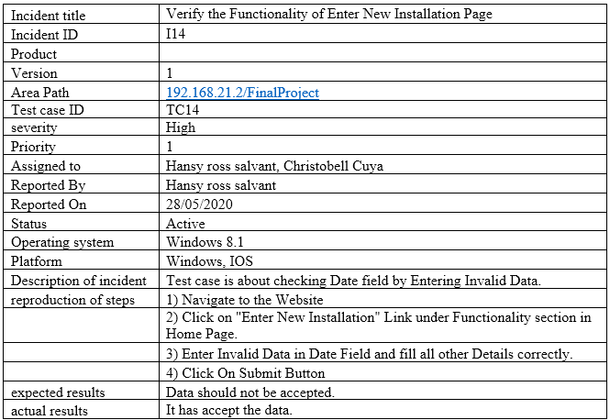

15) Test case is about checking Date Field by Entering Invalid Data.

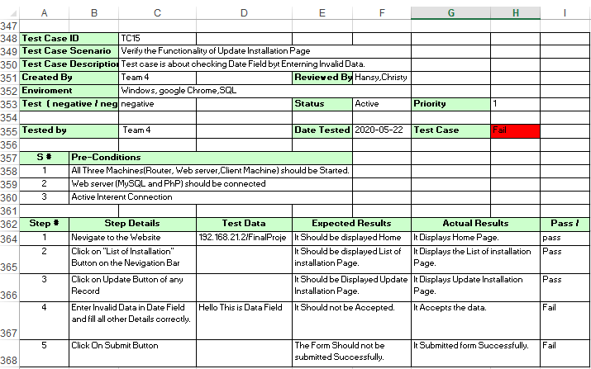

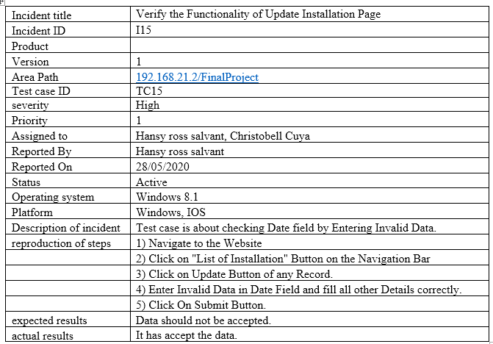

16) Test case is about checking Name field by Entering First character as a Space.

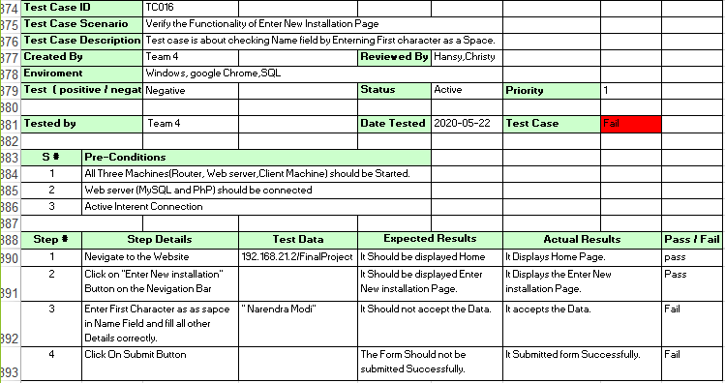

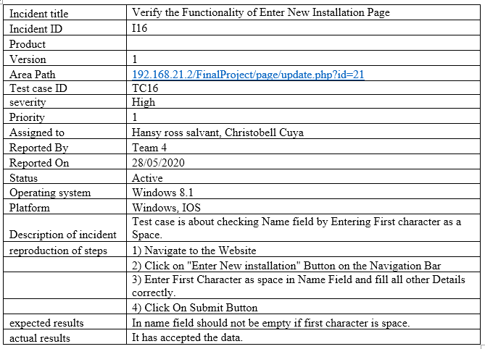

17) Test case is about checking Functionality of Software Installation Flow.

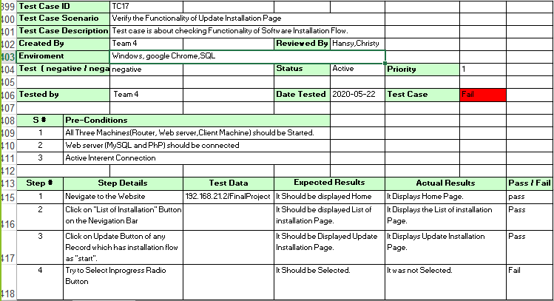

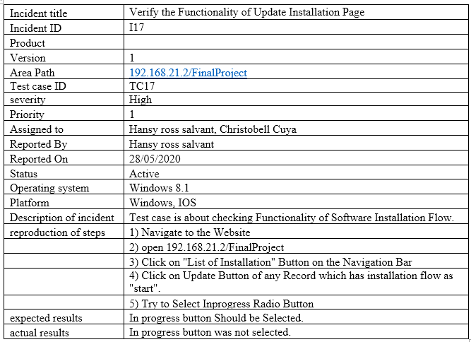

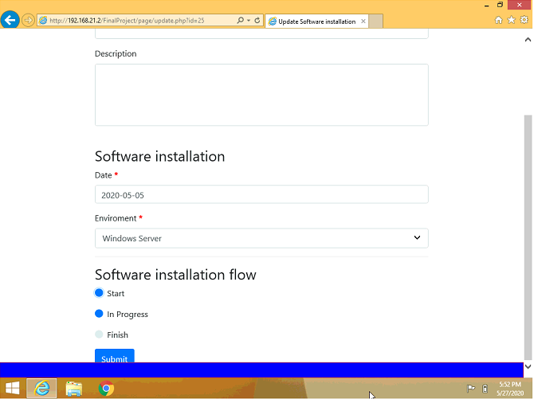

**Conclusion:**

* Our project “Virtual Network/Test Web Application” taught us the detailing of virtual platform, Network configuration and Web Platform.
* We understood the internal working of Router, Web-Server and Client Machine and its connectivity.
* All three systems installed in virtual environment are connected to each other with IP Configuration.
* At last, after installing web platform, we have done testing on web application along with the positives and negative test cases.

To put in nutshell, we have created virtual environment with three systems. All systems are connected to each other with IP Configuration. After that we have setup the web application and done Testing following by test cases.

**Reference:**

**YouTube Links:**

<https://www.youtube.com/watch?v=AHQDnBPvhHY&feature=youtu.be>

<https://www.youtube.com/watch?v=GKBZ_fU4qw0>

<https://www.youtube.com/watch?v=63_kPIQUPp8>

<https://www.youtube.com/watch?v=oPO1zpyNDpA&t=121s>

**Other Links:**

<https://www.ibm.com/support/knowledgecenter/en/SS8H2S/com.ibm.mc.doc/ce_source/tasks/ce_vpn_install_routing_role.htm>